Concept Paper

for pathway design and capacity development of the NAF for the employment of the working age and healthy beneficiaries

Pilot design evaluation

Activity 1.4.1

(final document under this activity)

December 2018

developed by Tibor Bors Borbely-Pecze, Ph.D. NKSE-International
Reviewed and approved by: Luba Pavlovova, Key Expert4/Component4

23/12/2018, Amman-Budapest

Abbreviations

ALMM Active Labour Market Measures
ALMP Active Labour Market Policy
EUD EU Delegation to Jordan
DoS Department of Statistics
HEIS Household Expenditure and Income Survey
JICA – Japan International Cooperation Agency
MoL Ministry of Labour
MoSD Ministry of Social Development
NAF National Aid Fund
UNICEF United Nations International Children's Emergency Fund
VTC Vocational Training Company of the Jordanian Government
TVET Technical and Vocational Education Training
OECD Organisation for Economic Co-operation and Development
PES Public Employment Service
WB World Bank

Table of Content
Abbreviations 2
Rationale 5
Goals setting for the institutional reforms 7
Branch offices assessment for an employment pilot 9
Selection criteria for the pilot at the NAF and MoL offices, assessment of the officers and the local labour market situation 10
Detailed assessment of the NAF and MoL branch offices possible places for an employment pilot 12
MoL / branch office in East-Amman 12
One of the NAF branch office in East-Amman 13
NAF branch office in Irbid 14
MoL branch office in Irbid 15
NAF branch office in Al-Zarqa 16
MoL branch office in Al-Zarqa 17
Customer pathways towards employment 18
profiling/ risk assessment and segmentation 20
Case managers at the supply and demand sides of the labour market 23
Cross-institutional cooperation 27
Way forward 27
Key issues need to be tackled in any scenario 28
References 29
Annex 30
job-seekers entry form for NEES 30

Rationale
The National Aid Fund (NAF) has been dealing with high number of active age and healthy beneficiaries. They may be ready for labour market activation and the task of labour market placement was given to the NAF trough the MoSD. However the NAF back in the 1980’s was originally designed as an institution to assess households and save them from poverty. It means that all of the internal institutional processes of NAF are based on this mission statement (see Analysis Report from October 2018). The concept of labour market activation requires a full reboot of the NAF structure, the way as the Fund has been making its business case. This need for change was very strongly underestimated when the decision about the NAF new task was made. In top of this the role of the MoL run employment offices also need to take into consideration for the development of a new labour market activation policy of the country.
Between the two missions (October and December 2018) under Component 4, Activity 1.4.1 we requested data from the NAF and MoL active age clients whose are in a good health conditions so according the national rules are ready to take a job. The outcome of the data set shows that in January-October 2018 the NAF had 70 624 active age clients (age 18-45) out of them more than 79% (56 451) were in a good health condition. In the current scale this is equivalent with 6% of the employed Jordanians in the labour market (DOS, Q2 2018) where only 67% of the employment is coming from Jordanian wage-workers the rest is covered by foreigners. It is also clear that there are local branch offices, 15 of it, where the concentration of registered active-age clients is high (more than 1800 in the analysed period). This doesn’t necessary means that these district offices are also served with employers. The matching point of the two, a) high level of registered active age beneficiaries in a good health condition and b) available jobs need to be combined for a NAF employment pilot. Amman Governorate itself hosts 1/5 of the registered active age citizens (Table 1). Most of the healthy and active age clients have been concentrated in 11 offices of the NAF (has more than 2000 registered). In January-October 2018 only 4% of these beneficiaries were activated and sent towards different services (Table 3). The services are not followed up systematically and the NAF does not collect controlled data about the activation and the sustainability of these interventions (long-time employment, i.e. over 3 months).
Although the political rhetoric highlights the role of activation of the active age and healthy unemployed Jordanians the Jordanian economy does not create sufficient number of new and decent jobs. The prognosis is 2,4%-2,5% GDP growth for 2018 and 2019 (OECD, 2018). “Jordan’s labour market continues to face significant vulnerabilities. The unemployment rate remained elevated at 18.5% in the fourth quarter of 2017 (Q4-2017), while unchanged compared to Q3-2017, it is a deterioration from Q1 and Q2 levels (which stood at 18.2 and 18.0%, respectively). Unemployment rate in 2017 stood at 18.3% for the year. Meanwhile, the labour force participation rate averaged 38.1% in Q4-2017, declining from 39.2% in Q3-2017. On an annual basis labour force participation rate averaged 39.2%, exposing significant marginalization of females, youth and bachelor degree holders. Poverty is likely to have risen in Jordan given rising inflation, unemployment and sluggish growth. Jordan has not released poverty estimates since 2010 due to issues with data quality for the 2013-14 Household Expenditure and Income Survey (HEIS). The 2017-18 HEIS, which will be representative of Jordanian, Non-Jordanian and Syrian Nationals was initiated in August 2017” (OECD, 2018).
TABLE 1
Number of registered active age and healthy beneficiaries of the NAF (Jan-Oct 2018)

(source NAF, own editing , based on the NAF self-declared data January-October, 2018)
Based on our analysis there are eleven offices (Table 2) where (set as an artificial baseline) there are more than 2000 registered active age and healthy clients (job seekers). Comparing with the healthiness of the local labour markets these local offices may be needed to be selected for a pilot. These registered active age clients can be seen as a further labour reserve of the country. Although it was also very clear from the field visits (East-Amman, Irbid and Al Zarqa NAF offices) that these clients are not interviewed and profiled against the needs of the labour market. For example only the level of education of the client is kept in a Excel sheet and there are no information about the former formal or informal employment, occupied jobs etc. It makes the matching almost impossible from the supply side of the labour market unless the NAF has been sending big groups of unchecked and non-classified job-seekers towards employers. The full model of the NAF as well as the MoL employment offices (EO) has a low level of effect. For several reasons; first of all the Jordanian economy does not create new jobs under the current circumstances and many of the available working opportunities are far from decent work and are in the informal economy. Secondly, the labour market activation services of the Jordan Government are in a weak institutional setting. The additional mandate was given to NAF in labour market activation policy but this did not clear the situation but made it even more complex. Finally the institutions themselves deal with the lack of clear management targets, professional internal process management, proper staff training and staff as well as infrastructural shortages.
TABLE 2 “Hot spots” NAF offices with more than 2000 registered active age and healthy Jordanians
 | Amman Governorate | No. Of cliens
1 | East Amman branch | 2948
2 | Marka branch | 2179
 | AL Balqa Governorate
3 | AL Zarqa branch | 4128
4 | AL Rosaifah branch | 3106
 | Irbid Governorate
5 | Irbid branch | 3909
 | AL Mafraq Governorate
6 | AL Mafraq branch | 2105
7 | North - East Badia branch | 2957
8 | North - western Badia branch | 2018
 | Jerash Governorate
9 | Jarash branch | 2221
 | Al Karak Governorate
10 | South Aghwar branch | 2365
 | Ma" an Governorate
11 | Maan branch | 2140

TABLE 3: Number of referred active age health NAF clients
Institution | Referred number of clients
to MoL local branch offices | 136
to VTC | 693
to NET | 0
NGOs (non-governmental organisations) | 865
PREs (privet recruitment agencies) | 572
TOTAL | 2266 (4% of the total client group)

Goals setting for the institutional reforms
The beginning of an institutional reform must start with political goal settings. In case of Jordan the low activity rate in the formal labour market plus the high level engagement of the foreign labour force (3 of 1 foreigner employed DOS, Q3 2018) alongside with high level of informal economy (27% based on the IMF estimation, UNDP, 2013) create an unsustainable situation. The speed of the job creation is relative slow, in the second half of 2019 only 17.k new jobs were created (DOS, 2017). Therefore policy reforms in the labour market are needed. The country has been working on these reforms for a while but focal points of the reforms are still missing. In this paper we concentrate only on the basic PES service design for the active age and healthy clients of the NAF.
- STEP Political commitments and goal setting
- STEP Planning and designing the services
- STEP implementing a service
- STEP monitoring and follow up (EC/PES Network, 2018)
The second step is to plan and design the services. As a possible part of the employment reforms the NAF must take care for the active age and healthy social beneficiaries as start the activation process. Frankly speaking these fundaments have been missing in the country. A gap analysis should be made to make distinction between the policy level reforms which are needed and the shop-floor level service design. In this paper we are focusing on the NAF service level design only.
The hired step is the implementation of new services. As NAF has no experience with labour market service design and delivery but has difficulties with staff allocation and resources we are suggesting a low-scale pilot as part of this TA project.
Finally every policy initiative needs to prove to be successful therefore referring the NAF clients towards different destinations is not enough unless a well-established monitoring system is also part of the package.
The current barriers against labour market activation differ in their nature. There are institutional, internal barriers such:
- as the lack of process management for employment. It includes the case management and the segmentation
- the outcome-based approach is also missing and information for labour market services and active measure are weak and accidental
Also there are external barriers;
- it primary means the weak performance of the Jordanian labour market
- high level of foreign workers in the market
- and lack of public transportation
- as an external issue we are also listing the badly established cross-institutional relationship and the lack of cross-institutional case management between institutions, mainly NAF and MoL
CHART 1
Institutional and external obstacles against labour market activation of the NAF active age and healthy clients
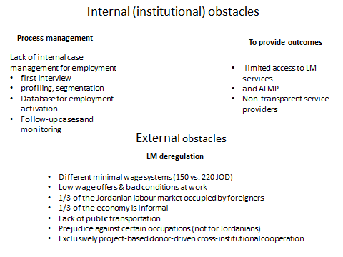

Branch offices assessment for an employment pilot

Based on the number of the registered active age and healthy clients we assessed three local branches of the NAF and also visited the local employment offices in East-Amman, Al-Zarqa and Irbid. These offices were visited in December 2018. We requested the NAF and MoL to visit both offices the NAF branch and the local employment offices in the designated regions. These three branches of the NAF host 1/5 of the active age healthy beneficiaries.

Visited offices for the pilot assessment (NAF)
Amman Governorate | No. of clients
East Amman branch | 2948
AL Balqa Governorate
AL Zarqa branch | 4128
Irbid Governorate
Irbid branch | 3909
total | 10 985

For the review of the local offices we preliminary agreed on certain criteria. These are the indicators of the labour market as an external item and the indicators of the internal process management, quality and number of the staff and equipment/databases within the organisation. Because of the nature of the labour market activation and the divided role of NAF and MoL local branches we also mapped out the cross-institutional cooperation.

Selection criteria for the pilot at the NAF and MoL offices, assessment of the local staff and the local labour market situation
- structure and quality of the local labour market and the number of healthy active age registered in the local offices
- staff size and allocation in the offices plus the internal process management of the office
- equipment and database for labour market activation
- cross-institutional cooperation

TABLE 4 Assessment of the three plus three branch offices for a possible labour market activation pilot in Amman, Al-Zarqa and Irbid
evaluation criteria/ location | quality of the local labour market and quality of the active age registered | staff and institutional process management | equipment, IT and database | cross-institutional cooperation
East-Amman/ NAF local branch | - bad quality jobs, vacancy offers for the minimal wage  - 2900 active age registered, 1500 < in MS-Excel mainly low skilled women  - in Amman a minimum of 350-400 JOD is requested  - lack of transportation | - out of 10; 2+local director work in employment partly  - no training for interviewing, selection and placement  - centrally controlled connection with employers | - stopped using the NEES, Excel sheet with 1500 job-seekers, limited information for placement and ALMPs | - no cooperation with MoL LO  - ad hoc actions
East-Amman/MoL local branch | - poor labour market,  - 3500 registered, 706 placement  - lack of job offers since the Autumn  - citizens are even visiting them from the villages for jobs  - lots of complain for the low-wage Syrians | - 11 staff members, 2 for employers  - 7 deal with job-seekers  - no detailed first interview of profiling  - immediate referral for placement or NEES registration | - NEES as a customer system | - ILO staff  - one staff member was trained by JIAC for career counselling
Al-Zarqa/ NAF local branch | - 4000 active age healthy registered but only 150 based on the local records, majority of JS are semi-skilled | - the office has one part time employment and training officer  - the “first interview” based on the household and the NAF data not on personal skills and previous employment records  - the placement/training selections are ad hoc  - they visit factories | - there are 150 jobs-seekers in MS Word format | - only annual meetings with MoL  - active cooperation with the city Chamber of Commerce
Al-Zarqa/MoL local branch | - 103 vacancies were reported in November,  - 155 job-seekers were place,  - bad quality jobs for minimal wage | - 2 full time job agent (advertising officer)  - the office main service is to post the vacancy on the Facebook and let the employers to check the database for candidates and organize the interviews in the employment office | - the primary system is NEES but it is not used for matching, local FB is the primary resource for advertising jobs | - no active cooperation with NAF branch office in the city  - 4 years ago was the last active cooperation  - the feedback arriving back from the employers after the job interviews need to be personalized as there is no individual level feedback only group letters
Irbid/ NAF local branch | - the labour market is weak, there are only a few vacancies,  - out of the 3000 beneficiaries only 100 has paper notes | - the office has 16 staff members, out of them 10 are social workers, they have 9000 clients,  - nobody is responsible for employment  - no internal process for employment, they refer clients to MoL | - no use of NEES  - no IT backup at all, just paper notes | - cooperation with MoL is not structured but not negative either  - employment office sends fax with vacancies at an non-regular base
Irbid / MoL local branch | - most of the NEES registered do not show up in the office  - the office has a low traffic, 15-20 clients come per a day  - once 1.000 showed up for a fake job advertisement  - the labour market is mainly sessional  - most of the jobs are for minimal wage  - better paid jobs rarely appear in the office | - 8 staff members, 4 trained by JICA  - 2 full time employer agents  - no car for the office | - most of the daily traffic of the local office is generated via the local FB  - NEES is used | - NAF has been transferring clients but the recruitment method and purpose is unclear for the MoL  - ILO has a local officer since 6 Dec 2018 in the local office (3rd since the start)  - GIZ also active here

Detailed assessment of the NAF and MoL branch offices possible places for an employment pilot

MoL / branch office in East-Amman
- Local Labour Market / clients
  - it has 3500 registered in 2018 (Jan-Nov)
  - 706 were placed in 2018
  - vacancies are usually for the minimal wage of 220 JOD without transportation, it cost 50 JOD for the individuals, the highest offers are for 350 JOD
  - in the last three month some of the factories were closed down, in November 2018 only one single vacancy was reported. Even outreach activities had almost zero effect.
  - the office is in a neighbourhood of an industrial park but there are lack of vacancies
  - the Civil Service Bureau starts to send the client to the MoL as there are no jobs within the national administration for them
  - Syrians has been refusing UN benefits so they accept jobs for 150-160 JOD , they provide a strong competition for the low-skilled Jordanians
- staff and internal institutional processes
  - the office has 11 staff members
  - there are 2 officers only deal with employers’ outreach
  - 4 are responsible for job-seekers, one them is also responsible for the branch office of the local office in another city
  - The office has a career adviser trained by JICA, she believes that the clients were able to find vacancies individually in a more successful way in the last 3 years.
  - ILO is also cohabited in the office; they have 2 full time employees focusing on Syrian refugees mainly.
- equipment /IT/database
  - the office has a car to reach employers and a full t-time driver
  - one staff member is only responsible to register the job-seekers’ data to the NEES
  - there is not enough PC for the staff
  - there is no self-service for job-seekers as there is no extra PC
- Cross-institutional cooperation
  - The NAF has 3 sub-branches in the area
  - the referral between NAF and MoL is ad hoc, happened only once in 2018,
  - there is no real cooperation between the NAF and MoL local branches
  - overlaps between the local NAF and MoL registry is unknown
  - even during the first registration job-seekers are not asked about their NAF status
  - if there are job offers the MoL staff does not register the job-seekers in the NEES system
  - as a professional estimation of the local staff that 40% of the registered are illiterate/ computer illiterate and are not able to follow-up their NEES profile or they have no access to ITC tools.

One of the NAF branch office in East-Amman
- Local labour market/ Clients
  - the NAF clients do not accept vacancies for minimal wage as the social assistance is based on household, the social benefits are not designed around labour market activation
  - in Amman a minimum of 350-400 JOD is requested as a monthly gross salary
  - many client has unfinished education
  - women are kept at home away from the labour market
  - employers do not provide transportation
  - for overeducated women clients there are no available jobs
  - there is also child labour in the local market
  - employers have prejudice against the NAF clients; they are afraid of the high fluctuation
  - as the Labour Code provides an opportunity not to make a written labour contract for 3 months many employers use this opportunity
  - Currently the local NAF office has 1500 job-seekers in an Excel Sheet, and 1.5 staff members full time to deal with them
- staff and internal institutional processes
  - the office has 10, one is a driver and the local director plus 2 officers deal with employment another 7 register the social aids, Nobody works full time in employment
  - Employment is not a core business of the local NAF office, acting as a mediating body takes extra burden on the staff
  - NAF has been losing its credibility since in employment was added to its portfolio
  - The staff has been using its personal connections to find jobs
  - employers must contact the head office of the NAF and there is no communication between the employers and the local branch
  - there are no protocols to select the candidates either
  - job-seekers are not interviewed no data stored about their employment related skills and no employment records are stored
  - the NAF head office delivers the list of vacancies to the local offices one a month
  - There is not enough information for job matching, in an Excel Sheet they only keep the name/ gender/ date of birth/telephone number/ level of education
  - in the NAF database is only a Y/N data for employment of the individual
  - there is a lack of sanctioning as well as in-work benefits in case of refusal of the job-offers
- equipment/IT/database
  - the Internet speed is very low for online systems
  - the office has a car and a driver
  - the NAF IT system has a module for employment, NAF uses this instead of NEES
  - the local NAF office has been developing its own customer data structure for employment activation
  - the local office makes its own Excel Sheet as a voluntary activity and keep the “job-seekers” in this way.
- Cross-institutional cooperation
  - The NAF local office uses the NEES, they have access but the contact details of the employers are weak.
  - They stopped working in the NEES as it was not effective
  - there is an East-Amman Investment Cluster was developed by USAID, it covers 3000 employers, GIZ also active with this cluster
  - there is no daily relation with MoL local office

NAF branch office in Irbid
- Local labour market/ Clients
  - the total staff member is 16; the office has 10 social workers responsible 9000 beneficiaries, 2 +1staff members for back-office duties, 2 heads and 1 director
  - most of the vacancies are for unskilled workers if any
  - beneficiaries are afraid from job-offers as they may lose the social benefits and minimum-wage jobs with long working hours are not realistic for them
  - beneficiaries would accept jobs for more than 300 JOD monthly
  - they referred app. 200 active age clients in 2018, no follow up of the placement
  - harassments in factories are frequent therefore families are reluctant to send their members to these workplaces
  - the work environment should be checked by the MoL for new vacancies by labour inspection
- staff and internal institutional processes
  - no protocol in place to screen and neglect job offers do not meet with basic decent work agenda
  - for any action the local office must receive a signed letter from NAF HQ in Amman
  - the vacancy notes are not detailed, mainly covers the age of the job-seekers and number of open posts
  - the other details of the vacancy are discussed directly with the employer after the MoL local office forwarded the announcement
  - within the office in the last 2 years there was an employment unit directly engaged with the employers this was cancelled
  - currently there is no FTE staff member for employment, they have no human resources for this
  - employed beneficiaries may stay in the NAF pay-list as no follow-up mechanism in place
  - the local staff keeps the records of the job-seekers in papers, they have now 100 names out of the almost 4000 active age registered…
- equipment/IT/database
  - there is no database about the job-seekers only the basic Excel sheet with name, gender age and phone numbers they even do not use it only paper notes
  - they do not use NEES
- Cross-institutional cooperation
  - there is a direct relation between MoL local office and NAF but it is restricted for vacancy announcements
  - NAF branch does not record the number of vacancies received from the MoL local office, there is no monitoring and follow-up
  - the MoL local offices sends a fax with the vacancy note to NAF branch office
  - the NAF refers the job-seekers to employment office not directly to the employers.
  - the Labour Office is 5 km from the NAF office, 15 mins by car, there is public transportation in the city, this often not affordable for the clients
  - the local office also cooperates with a foundation provides micro-credential

MoL branch office in Irbid
- Local labour market/ Clients
  - there is a high level of turnover rate in the labour market, usually people stays only a few months in jobs with minimum wage and bad working conditions
  - number of vacancies: 3658 in Jan-Dec 2018
  - number of employed 2232
  - 62% of the vacancies are closed with placement, the follow-up is based on phone calls to employers or to the individuals
  - the office has no access to the social security database any more
  - employers do not post administrative, better paid vacancies to MoL
  - employers sometimes also show up with specific needs where the MoL hard to answer
- staff and internal institutional processes
  - the branch office has 8 staff members; 1 directors, 2 heads of divisions, 2 for employers engagement
  - MoL has no internal policy and workflow about ALMM,
  - the local office has no information about ALMM activities in the district based on donor actions
  - JICA trained four of the staff members
  - the office has no car and driver since November 2018, the staff use their own car
  - there is a detailed form for vacancy announcement (the form contains only basic information: age, position, gender, work experience, additional notes)
  - vacancies are not coded unless it is in the NEES
  - the local staff doesn’t know the ISCO or other professional nomenclatures
  - the office transfers the vacancy announcement to a job advertisement
  - for the NEES registration system the work-readiness isn’t checked (e.g. question about availability for a job in the future)
  - most of the daily traffic of the local office is generated via the local FB site based on the vacancies posted there
- equipment/IT/database
  - the primary IT tool is the NEES
  - the office runs its own FB site, Jobs Island has 0,5 million followers, the office has 2,5K
- Cross-institutional cooperation
  - the two offices are geographically closed to each other
  - the cooperation was better with NAF, MoL local office received list of applicants, it is at a low intensity now
  - referred NAF beneficiaries often do not show up as they afraid about losing the social benefits
  - for example in January-February 2018 NAF sent 48 beneficiaries for placement

NAF branch office in Al-Zarqa
- Local labour market/ Clients
  - beneficiaries are afraid losing their social benefits
  - usually jobs are for the minimal wage
  - the gap between the social benefit and the minimal wage is app. 50-60 JOD monthly
  - often the wages have been increasing after a 1 year
  - the job-seekers are looking for at a minimum of 300-350 JOD
  - reality of the vacancies is low, job fairs provide high level of bad quality vacancies
  - low quality work environments is a constant challenge
- staff and internal institutional processes
  - there are only 8 employees in the office, 7000 households
  - no case management for employment
  - active age clients usually referred from the NAF social workers (responsible for mean testing) to the employment officer
  - the office also ordered training twice in hybrid car maintenance
  - free training courses are offered to women via VTC in self-employment
  - who is older than 18 must visit the employment officer or the branch office reduces/cuts the benefit
  - after the visits of the social workers the employment officer makes a call to the client to show up in the office
  - the “first interview” based on the household and the NAF data not on personal skills and previous employment records
  - there is only one staff member for employment in the branch office, works only partly with employment affairs
  - they post the job advertisement, sources are from job-fairs and personal relations with factories and the chamber of industry , the office has 30 employers in its network
  - the NAF pays 50% of the social contributions after the placed beneficiaries for maximum of 2 years
- equipment/IT/database
  - there are 150 jobs-seekers in MS Word format, even not an Excel has been used
  - after training VTC sends back the names of the trained in Excel sheet
  - NEES isn’t used in the local office, although they participated in a training
- Cross-institutional cooperation
  - no cooperation with MoL
  - NAF registered beneficiaries in the NEES but they stopped two years ago
  - there is an active cooperation with the city Chamber of Commerce, they provide names of the companies

MoL branch office in Al-Zarqa
We visited this office in October 2018 (see the detailed report under the Review Report activity 1.4.1.) Here we highlight the evaluation useful for a cross-institutional cooperation and for a possible pilot only.
- Local labour market/ Clients
  - the local NAF office and employment office estimation about the active job-seekers are different, NAF says 150 people are active, according the labour office is 300. Both data are very far from the official NAF and MoL/NEES data
  - In November 2018 the local office had 103 vacancies,
  - 155 were employed
  - 15-20 people visit the office daily
  - work permits for foreigners create a game between the office and employers
- staff and internal institutional processes
  - It has 8 employees including the local head of the office. 2 people are engaged with employers, 4 are employment officers
  - employment officers and career counselling (3+1) –also register the individuals to the NEES
  - marketing which is employers and NGO relation division (2)
  - plus local head of the office and a driver (1+1)
  - the office main service is to post the vacancy on the Facebook and let the employers to check the database for candidates and organize the interviews in the employment office
  - the feedback arriving back from the employers after the job interviews need to be personalized as there is no individual level feedback only group letter
- equipment/IT/database
  - the primary system is NEES but it is not used for matching, local FB is the primary resource for advertising jobs
  - MoL mediation system is not capable to profile and select candidates based on details requirements of the employers if it goes beyond age, sex, level of education, the NEES also contains the previous work experiences and other trainings
- Cross-institutional cooperation
  - the distance between the two offices is 15-20 mins. by car, with public bus needs to be changed once.
  - often the NAF clients arrive with a false concept that the MoL provides jobs in the government sector for the beneficiaries, NAF social workers need to be updated
  - no cooperation, high level of vast of the limited resources
Based on the field visits it is clear that the Jordanian labour market activation system significantly need to be improved. First of all as a policy level recommendation the two parallel institutions are insufficient for activation. Secondly the internal process managements are weak in both institutions and need to be improved. Thirdly the labour market does not create sufficient number of new jobs but it cannot be influence by these developments. Therefore we are suggesting the following items for consideration;
- design the customers’ pathway within the NAF regarding labour market activation not only the referral system
- as part of the customer pathway development draft, design and learn the role of employment related first interview and profiling of the clients
- develop the segmentation of the work-ready active age and healthy citizens according the available and suitable labour market services, active measure and job opportunities
- develop the way or set up a cooperation with the MoL employment offices to get engaged with employers in a proper way
- design the individual level monitoring of the placed customers

Customer pathways towards employment
The NAF referral system can be seen as a part of the customers’ (the job-seekers) journey towards sustainable employment. Addressing the referral system of the NAF only makes sense if we are also addressing the full registration-screening and activation plus monitoring protocol of the NAF. Based on the local visits it is clear that this institutional protocol has been missing. The key features of the employment activation agency, called Public Employment Service in the EU and ILO jargon was describe in the Analysis Report (October 2018, activity 1.4.1.). In the Concept Paper we describe the key elements for labour market activation which are the main element for a successfully redesigned referral system which is result oriented.
The two first elements are the:
- first interview for employment with the individuals (not family or household-based assessment)
- profiling – risk assessment: distance from the primary labour market
First interview for employment
The job placement first interview is a highly important step towards employment. The successful and sustainable placement starts with a well-established first interview and not with a referral system. This is the primary assessment tool in the EU 32 Public Employment Services for the evaluation of the client status quo and to evaluate the distance from the labour market. Every single step after the first interview must be developed based on the first diagnosis.
A public employment service is a government's organization which matches employers to employees. The primary goal of the employment service is to support employment.
Obviously many beneficiaries are far from the primary labour market for several reasons; e.g. they are young/ old, foreigners, low-skilled, uneducated, have no relevant work experiences, part of minorities, have an extended family to take care, there is a lack of transportation or simple because of attitudes, etc.
The role of the employment agency is to measure and evaluate these circumstances first. During the first assessment the following data need to be checked with the client (job seeker);
- Personal data (age, contact details, family situation, etc.),
- Education / Training information (academic qualifications, professional licenses and certificates, language proficiency, etc.),
- Professional information (professional level, work experience, etc.),
- Information on availability to work (mental / physical work ability, availability to travel, job expectation, etc.). (EU PES Network, 2016)

CHART 2 Assessment of the subjective factors (EU PES Network, 2016)
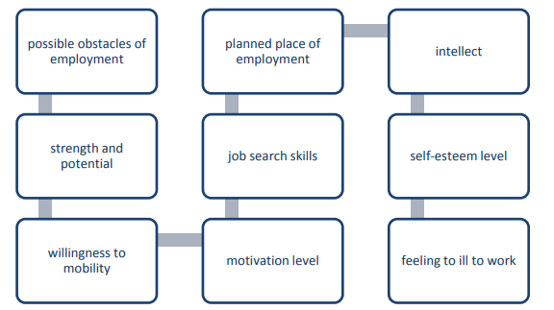
In Jordan also the local circumstances need to be taken into consideration so for example questions about home-based employment or family-based skill-development also need to be asked. Based on the local cultural and labour market context the following areas of questions need to be developed;
- work experiences based on informal economy or working abroad
- access to transportation and the cost of the transportation
- household / family-based work experiences which can be transformed to paid work activities

Profiling/ risk assessment and segmentation

The term “profiling” refers to the assessment performed by PES counsellors of an individual client’ ‘needs’ and their relative ‘fit’ to opportunities within the current labour market in order to provide a basis for allocating or targeting employment services, and for matching to appropriate/relevant vacancies. It is a combination of a customised approach within the context of the process-oriented organisation of PES service delivery. (EU PES, 2014)
CHART 3 why we profile jobs-seekers? (WB, 2014)
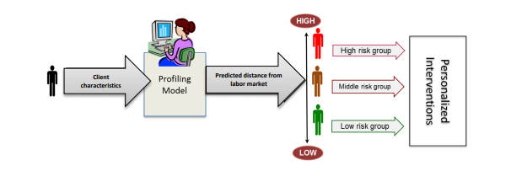
Job seeker profiling is a diagnostic method to assess the prospects of unemployed people to resume work (WB, 2014). It is also true, that learning how high-income countries operate their PESs can help emerging economies to improve their own interventions to help job seekers (WB, 2014). After heavily investing in social safety nets, middle income countries are grappling with how to “graduate” beneficiaries, and profiling can help meet this objective. This statement is very much true for Jordan.
Profiling tools have been typically used to:
- Diagnose individual strengths and weaknesses in regard to personal action planning with a final outcome to find employment in the labour market
- Assess the risk of long-term unemployment among unemployed individuals and those about to become unemployed.
- Segment jobseekers according to the level of assistance they are considered to require to successfully achieve (re-)integration.
- Target appropriate services, measures and programmes considered most suitable to meet the requirements of their particular “profile”.
- Match jobseekers to vacancies and to active measures and services.

The profiling can be a soft system, based on the assessment of the case worker or a statistical profiling where the assessment based on the statistical attributes of the clients. In the current Jordanian system a soft profiling can be introduced first with a strong desire that the NAF as well as the MoL database (NEES) and access to the Social Security Corporation will be improved significantly in the near future, that will create opportunities for the introduction of a statistical profiling system too.

CHART 4 Level of complexity of the information flow for profiling
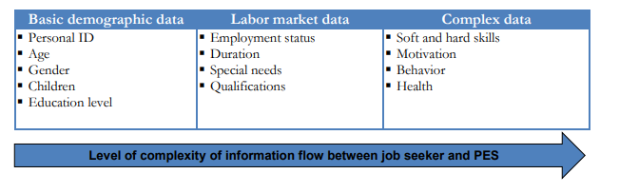
(WB, 2014 p.12)

The main reasons to use the job-seekers profiling is
- segment job seekers based on similar unemployment risk characteristics,
- assist with planning for, and sequencing of, interventions
- In addition, profiling can guide the resource allocation process for NAF

In the current Jordanian context the
- caseworker-based profiling or
- the rule-based profiling can be introduced

The caseworker-based profiling means;
This method, also known as the “caseworker discretion approach,” is based on the idea that caseworkers are principally responsible for evaluating the job seeker’s employment prospects, developing a plan for reemployment, and making the final judgment about the most appropriate intervention. Under this method, the caseworker represents the principal mechanism for conducting client segmentation, activity definition, and service referral (WB, 2014).

The rule-based profiling system means;
This basic profiling method refers job seekers to reemployment services only after crossing a critical threshold in their unemployment spell.

As currently neither the NAF nor the MoL has a sufficient number of employees, IT database or internal protocol to introduce a fully functional profiling system. We suggest the adaptation of a mixture of caseworker-based and rule-based profiling to test it out. NAF actions have two different key motivations; a) collect vacancies and place job-seekers and b) empower the low-skilled and vulnerable beneficiaries. These two goals of the NAF require different profiling approaches.

CHART 5 Suggested job-seekers profiling for the NAF for job matching
caseworker-based elements | Nr. of item | information
 | 1. | The client has labour market experiences at least 1-5 years in the formal/informal market, if no do not send him/her for job interview
 | 2. | First check the reliability of the employer and the quality of the vacancy, if minimal requirement are not present do not send job-seekers
 | 3. | The job-seeker is available for a vacancy (in the country, has a willingness to work for the minimal wage etc.)
 | 4. | The workplace offers a daily transport between the workplace and the home of the job-seekers / the job-seeker is able to commute for the job
 | 5. | Check the job-seekers’ professional experiences against the actual job (level of education isn’t enough)
rule-based elements | 6. | only active age clients can be registered
 | 7. | The placement offers must be gender and age blind, the employer has no right to discriminate

The other purpose of the selection of people are the active labour market measures, such as vocational training (T-VET), support for employment (as wage-subsidy), or support for self-employment (including micro-credential). Obviously, the two selections are different therefore the selection criteria also have to be different.

CHART 6 Suggested job-seekers profiling for ALMM
caseworker-based elements | Nr. of item | information
 | 1. | Based on a personal interview be sure that the client is interested and capable to fulfil the requirement of the certain ALMM
 | 2. | Check that the training place is geographically reachable for the client before you offer it
 | 3. | Check in advance that the client isn’t engaged in family issues which keep him/her away from the ALMM (e.g. responsibility for small kids where day-care unsolved)
rule-based elements | 4. | ALMM for vulnerable clients only, they can’t be placed to the open market without ALMM, do not offer ALMM for other groups
 | 5. | discuss only available ALMM options with the clients, where you know the details
 | 6. | the available budget for the certain ALMM at the branch office level must be clear for a year in advance

Case managers at the supply and demand sides of the labour market
- first interview with the job-seekers
In the heart of the labour market activation process is the well-established casework which always starts with a personalised interview. Based on global knowledge this cannot be shorter than 15-20 minutes per client at least. The primary aim of the interview is to; make a quick judgment about the labour market readiness of the client, if she/he is not available for jobs cannot be registered as a job-seeker. Based on the ILO Manual for developing countries (ILO, 2016) the first interview addresses the following basic items;
- personal details
- qualifications
- skills may come without former qualification (Skill here means any type of former activities and experiences where the client has solid experiences and it may be transformed to a paid job in the future.)
- language skills
- employment experiences (both formal and informal)
- comments;
  - about opportunity to commute for a job,
  - family situation,
  - reason for leaving the previous job etc.
Example 1 First interview (ILO, 2016)
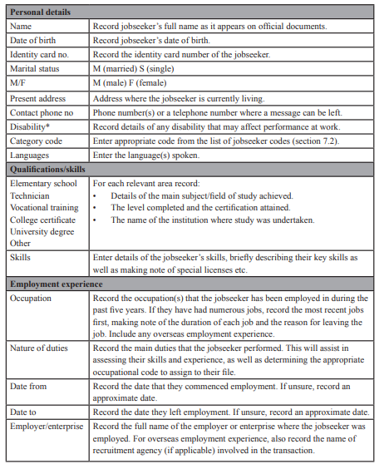
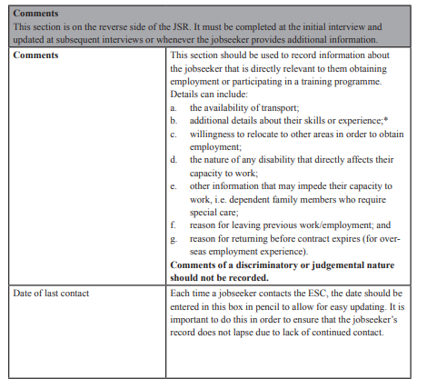
The labour market has two sides. It is not enough to work with the citizens but the knowledge of the demand side is also crucial for any agency wants to act as an intermediate body between the jobs-seekers and companies. Therefore an agency is eager to act as an intermediate body in the labour market also needs to learn how to work with employers. It mainly means that; the intermediate body is able to approach employer at the right way and also capable to understand their needs for new labour force. For this exercise the content of the vacancy needs to be transferred into a structure as job-seekers can be matched with it. Here we highlight two main points;
- collecting vacancies and communication with employers
  - and set the minimal conditions for vacancies
- match the vacancy notes with suitable applicants
First of all any discussions with employers must be based on the real needs of the employers, directly addressing the productivity of the certain employers. So job-seekers cannot be transferred to employers just because a job advertisement was published in a newspaper. First of all the mediating body needs to pay a visit to the employer. This is important in two ways; it is the responsibility of the intermediate body to check the quality of employment and the company on the spot before starts referring job-seekers, secondly an interview with the employers is important to map out the content and skills background of the vacancy.
Information gained from the employers concerning a job will be important to match with the attributes of the job-seekers. The ILO (2016) has been suggesting the following basic vacancy form for the developing countries. The placement office also needs to follow up the route of the sent job-seekers, the reactions of the employers and adjusts the vacancy note and the selection of the job-seekers based on these feedbacks.
Example 2 Job vacancy note (ILO, 2016)
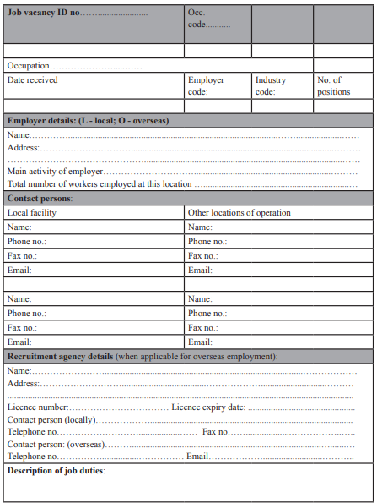
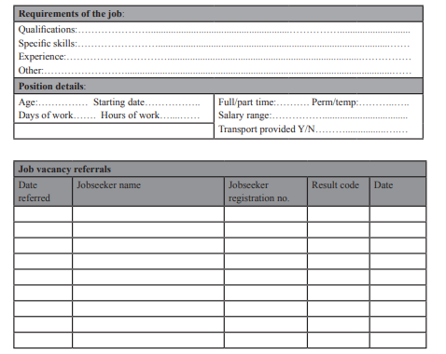

Cross-institutional cooperation
The last item we address in this Concept Paper is role of cross-institutional cooperation. As citizens do not think and act according the mandate of the different state institutions, government bodies must see beyond the borders of the institution. This is easier to say than to practice. In practical sense the NAF in Jordan could see the cooperation with the employment offices of the MoL, the donors such as ILO, UNICEF, GIZ and others.
- mobilizing the local institutional network around the NAF branch office
(e.g. ILO, NGOs, MoL, local municipality etc.)
Once NAF acts alone it provides a very weak outcome so does the other institutions. United steps at a district level could develop a win-win situation for all and would bring in the different expertise.

Way forward
Concerning the current state of play in Jordan the following options need to be seriously discussed within the WG4/Task Force2.
- The NAF tries to cover both, the job-seekers and the employers side and after the current EU project will seek for a Twinning-style institutional capacity development and coaching opportunity where the branch offices need to be fully rearranged; such as workflow, job descriptions, competencies of the staff, etc. It would transform the NAF to a basic public employment service
- The NAF branch offices also could share the mandate with the MoL employment offices and do the first interviewing and profile of the job-seekers but rely on the MoL to collect vacancies and match job-seekers with jobs. In this case a small-scale branch office level could be tested in the country.

Key issues to be tackled in any scenario

- The detailed diagnosis is missing at both sides of the labour market;
The vacancies are only partly explored (see the ILO suggestion included in this report) also the job-seeker’s profile is weakly developed (see the detailed proposals for first interview and profiling in the report)
- The labour market exchange, the profile adjustment between jobs and job-seekers need to be significantly improved as the level of education, age and gender information are not enough
- There is no catalogue of ALMM including labour market trainings, budget isn’t planned at a yearly bases, ALMM acquisition is not part of the MoL practice, donors act at an ad hoc bases. This ALMM Catalogue need to be developed for a daily operation at the governorates’ level and for the branch offices
- The follow up of the placement is ad hoc and not systematic, a mechanism need to be developed to follow up the job-seekers at a regular bases, including the regular cross-checks in the Social Security Corporation system but also in the NAF system.
- The full workflow of the NAF and also MoL Employment Offices need to be reviewed, as part of this project, but also readjusted.
- As NAF will be responsible for employment activation in the future the public profile of the NAF needs to be changed.

References

EC/ EU PES Network/ICF (2018) Integrating services to support the labour market integration of minimum income recipients, Luxembourg https://ec.europa.eu/esf/transnationality/filedepot_download/2594/2043
EU PES Network (2016) European Public Employment Services (PES) Network study on assessment and early intervention to prevent long term unemployment following the Council Recommendation on the integration of the long-term unemployed into the labour market
https://ec.europa.eu/social/BlobServlet?docId=17535&langId=en
EU PES Network (2014) Skills-based profiling and matching in PES - Analytical Paper https://ec.europa.eu/social/BlobServlet?docId=14108&langId=en
OECD (2018) Jordan’s Economic Outlook April 2018 https://www.worldbank.org/en/country/jordan/publication/economic-outlook-april-2018
ILO (2016) Practitioners’ guides on employment service centres: Operating employment service centres vol. 2
https://www.ilo.org/wcmsp5/groups/public/---asia/---ro-bangkok/documents/publication/wcms_549678.pdf
UNDP (2013) The Informal Sector in the Jordanian Economy http://www.undp.org/content/dam/jordan/docs/Publications/Gov/The%20Informal%20Sector%20in%20the%20Jordanian%20Economy-jo.pdf
World Bank (2014) Profiling the Unemployed A Review of OECD Experiences and Implications for Emerging Economies Artan Loxha and Matteo Morgandi, Washington DC.
http://documents.worldbank.org/curated/en/678701468149695960/pdf/910510WP014240Box385327B0PUBLIC0.pdf

Annexes

Job-seekers entry form for NEES
Ministry of labour
NEES
Job seeker form
National number
Social security number
First name
Father name
Family name
Date of birth
Gender
Full address
Land line phone number
Mobile:
Marital status:
Do you hold a driving license…? If yes specify the type
Do you have a care for the use of the work?
The status of the job seeker ___ (seeker or employed)
Email:
If person with disability
Type of the disability …. Mobility, auditory, visual, mental, other
Qualification:
Illiterate
Literate
Primary
Secondary
Vocational training
Tawjehi/ Secondary School-leaving Exam
Apprenticeship
Diploma
Bachelor
High diploma
Master
PHD
the name of the educational institution …………..
year of graduation
specialization
additional information
required jobs
job 1 years of experience…… expected salary……...
job 2 years of experience…… expected salary……...
previous experiences
place of work & from & to & job title & duties and responsibilities
training courses
the name of the course duration the location
technical skills/ languages
the technical skills the level

the language the level
are you still studying yes/ No?
if yes … specify the educational level……. The name of the institution …… specialization…. The date of the expected graduation ………

the natural of the required job: ………………. full time / part time/ temporary / quarterly
do you accept working in shifts? Yes, or no

military service: postponed/ exempted/ finished
additional information:

references:
name……. phone number……. Email………..
name……. phone number……. Email………..
the name of the applicant …….
signature …………………
date of apply……
name of the registration centre…. & the name of the officer……. Date……………….

http://www.dos.gov.jo/owa-user/owa/emp_unemp.show_tables1?lang=E&year1=2018&round=2&t_no=23
Jordan’s Economic Outlook April 2018( OECD) https://www.worldbank.org/en/country/jordan/publication/economic-outlook-april-2018
http://www.dos.gov.jo/owa-user/owa/emp_unemp.show_tables1?lang=E&year1=2018&round=3&t_no=23
UNDP (2013) The Informal Sector in the Jordanian Economy http://www.undp.org/content/dam/jordan/docs/Publications/Gov/The%20Informal%20Sector%20in%20the%20Jordanian%20Economy-jo.pdf
http://www.dos.gov.jo/owa-user/owa/jobs.show_tables1_jobs?lang=E&year1=2017&round=2&t_no=1
EC/ EU PES Network/ICF (2018) Integrating services to support the labour market integration of minimum income recipients, Luxembourg https://ec.europa.eu/esf/transnationality/filedepot_download/2594/2043
https://ec.europa.eu/social/main.jsp?catId=1100&langId=en
https://ec.europa.eu/social/BlobServlet?docId=14108&langId=en

