Report of Tracer Studies Results

Developed by Miroslav Stefanik - IER SAS (NKE Senior),
Razan Hadidi (NKE Junior)

Amman 7th May 2019

introduction
Under activity 1.4.10: Assist in studies measuring employment satisfaction and tracing employability of graduates of E-TVET including the trained skills targeted by the programme. Two existing studies were reviewed, the first one is PSUT trace study of 2017 graduates. And the second one is VTC ….

Princess Sumaya University For Technology (PSUT):

Methodology

The PSUT had develop The part that related to the trace study is a question in the general information about whether the graduates work or not.
The university has developed a questionnaire to collect a feedback information from the students about their experience during their study. The questionnaire consists of four parts: the first is general information, the second is about the quality of the program in which it was studied, and the third part is the assessment of the performance of the faculty members and the final part is of the general assessment. Through the questionnaire, information are collected regarding the occupation status of students.
Usually the questionnaire is filled once and that when the student contact PSUT to get his official papers and certificates, except for occupation information in which they continue contact the student for a year or till he get a job.
PSUT traces all their students and don’t use sampling as the have few numbers of graduates

Results of students Trace study for 2017

The trace study covers the graduates from PSUT in 2017 with a total of 566 from all programmes provided by PSUT it is all three collages, and all the nationalities. According to the data from PSUT all the graduates from PSUT in 2017 were employed by the end of 2018.

Main Characteristics of Beneficiaries

A total of 285 (50%) of these graduates are female and 504 of the graduates are Jordanian (98%). Most of the graduates male and female start their study at the age of 18. The tables below present the main characteristics in more details.

Age Distribution of Graduates by Sex

Age | Female | Male | Grand Total
17 | 8 | 11 | 19
18 | 263 | 224 | 487
19 | 11 | 27 | 38
20 | 3 | 10 | 13
21 |  | 6 | 6
22 |  | 2 | 2
24 |  | 1 | 1
Grand Total | 285 | 281 | 566
Table 1 Age Distribution of Graduates by Sex
The majority of female and male were in the age of 18 when they were enrolled in the study with some differences as female were 92% in compare with 80% of male, few male students 6% were above the age of 19 when they were enrolled in the study.

Nationality Distribution of Graduates by Sex

Nationality | Female | Male | Grand Total
Non-Jordanian | 27 | 35 | 62
Jordanian | 258 | 246 | 504
Grand Total | 285 | 281 | 566
Table 2 Nationality Distribution of Graduates by Sex
The majority of graduates are Jordanian, as 91% of female and 88% of male are Jordanian.

Academic Characteristic

Graduates Distribution by College

Specialization | King Houcien IT science collage | King Talal for Business Technology collage | King Abdallah II for Engineering | Grand Total
Business Management |  | 96 |  | 96
Electronic marketing and social networking |  | 40 |  | 40
Accounting |  | 109 |  | 109
Electronic Engineering |  |  | 18 | 18
Business Information Technology |  | 1 |  | 1
Computer science | 33 |  |  | 33
Computer graphic science | 40 |  |  | 40
Management information systems |  | 43 |  | 43
Communications Engineering |  |  | 55 | 55
Software Engineering | 51 |  |  | 51
Computer Engineering |  |  | 18 | 18
Power and power engineering |  |  | 62 | 62
Grand Total | 124 | 289 | 153 | 566
Table 3 3.2.1 Graduates Distribution by College
Half of the students 51% graduates from Business Technology Collage, while the other half where distributed almost equally between IT Science Collage 22%, and Engineering Collage 27%.

Differences of Years of Graduation by sex
The group of graduates who finalized their study in the specific time for the study were 64% from the total number while about 10% of graduates were able to finish with one to two years earlier, in the other hand 26% of graduates needed more time to finish their study with one to more four years.
The data shows that 35% of female were able to finalize their study in the specific time in compare with 29% of male, While 6% of male were able to finalize earlier in compare with 4% of female. Although 17 % of male need more time to finish their study in compare with 9% of female

Differences of years of graduation | Female | Male | Grand Total
-2 |  | 3 | 3
-1 | 33 | 18 | 51
0 | 201 | 163 | 364
1 | 42 | 66 | 108
2 | 7 | 25 | 32
3 | 1 | 6 | 7
4 | 1 |  | 1
Grand Total | 285 | 281 | 566
Table 4 Differences of years of graduation by sex

Average of GPA By sex
The Female show higher GPA scores in compare with male, both male and female GPA scores decrease with number of years graduates need to finish the study.
The Secondary rate is the score of students before entering PSUT. GPA the score from the leaving exam from PSUT. .
Difference to the modal length of study | Female | Male | The Average
-2 |  | 76.8 | 76.8
-1 | 76.4 | 72.7 | 75.1
0 | 75.4 | 72.1 | 73.9
1 | 67.7 | 66.3 | 66.9
2 | 64.9 | 65.5 | 65.4
3 | 61.9 | 63.9 | 63.6
4 | 65.4 |  | 65.4
Average | 74.0 | 70.0 | 72.1
Table 5 Average of GPA By sex

GPA over Secondary rate by the difference to the modal length of study

There is a clearly observable association between the Secondary rate and the GPA score. Comparison of these scores can be used to calculate the indicator of the value added of the school.

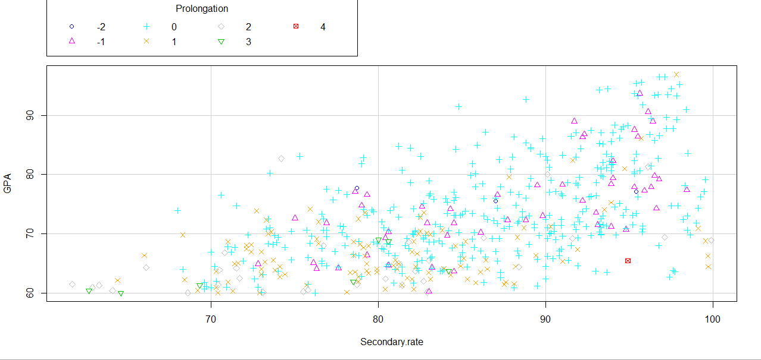
- There is a linear relation between the secondary rate and GPA score, the higher the student's secondary score was, the higher the GPA student get at graduation.
- Most of the students how need more one year to finish their study had secondary rate between 70-90 .

After controlling for other factors using a linear regression model, we can observe that:
- GPA of females is, on average 1.62 points, higher than that of male students;
- There is no statistically significant difference in GPA of Jordanian and Non-Jordanian students;
- Prolongation of the study for one year results in a decline in GPA, of on average approximately 2 points;
- An increase in the average secondary score of enrolled students should result into an increase of GPZ of 0.494.
Results of the Linear regression model with dependent variables of GPA
Estimate | Std. | Error | t | value | Pr(>|t|)
(Intercept) | 22.141 | 9.528 | 2.324 | 0.020 | *
Age at enrolment | 0.359 | 0.462 | 0.778 | 0.437
Female | 1.623 | 0.583 | 2.783 | 0.006 | **
Jordanian | 1.218 | 0.901 | 1.352 | 0.177
Difference to the modal length of study | -1.999 | 0.388 | -5.152 | 0.000 | ***
Secondary rate | 0.494 | 0.036 | 13.579 | 0.000 | ***

Tracing of employers
There are no available data regarding the employer satisfaction questionnaires, PSUT collects data via online questionnaires inquiring on employer's satisfaction. The questionnaire contains 20 paragraphs assessing the life skills knowledge and practices of their graduates, in addition to two paragraphs referring to wither the employer prefer PSUT graduates student for the rest , and if they are willing to welcome students as interne .

