

**LMIS**

360° View of Customer in the

IT Systems of Ministry of Labour

November 2019

This page is intentionally left blank.

Contents

1. List of Terms and Abbreviations 4

2. Document Version History 6

3. Introduction 7

3.1. Purpose of the Document and Background 7

4. Career Guidance Tools 9

4.1. Online Tools 9

4.1.1. Profile Builder 9

4.1.2. School Search 15

4.1.3. Part-time Employment and Internships 15

4.1.4. Self-assessment tool 15

4.1.5. Catalogue of Professions 15

4.1.6. Work Compass 16

4.1.7. Vacancies 16

4.1.8. Courses 16

4.2. Backend Tools for Planning 16

5. Integration with National Aid Fund 18

5.1. Data Model 18

5.2. Electronic Services 18

5.3. Conclusions and Recommendations 19

6. List of Annexes 19

# List of Terms and Abbreviations

|  |  |
| --- | --- |
| Abbreviation | Explanation |
| AQACHEI | Accreditation and Quality Assurance Commission for Higher Education Institutions |
| AG | Advisory Group |
| ALMMs | Active labour market measures |
| ALMPs | Active Labour Market Programs |
| BA | Business Analysis |
| BAU | Al Balqa Applied University; |
| CA | Contracting Authority |
| CASE | Computer Aided Software Engineering |
| CoE | Centres of Excellence |
| CEQA | Centre of Accreditation and Quality Assurance |
| CF | Conceptual Framework |
| CF LMIS | Conceptual Framework LMIS, LMIS for Jordan as foreseen and architectured in the Conceptual Framework document |
| CS | Civil society |
| CSO | Civil society organisation |
| CMS | Content management system |
| DEF | Development employment fund |
| DEVCO | EC Directorate-General for Development and Cooperation (DG DEVCO) |
| DEU | Delegation of the European Union to the Hashemite Kingdom of Jordan |
| DG | Directorate General (of the European Commission) |
| DOS | Department of Statistics |
| EC | European Commission |
| ETF | European Training Foundation |
| ETVET | Employment and technical vocational education and training |
| ETVET-C | ETVET Council |
| EU | European Union |
| GDP | Gross domestic product |
| GIZ | Deutsche Gesellschaft für Internationale Zusammenarbeit (German Agency for International Cooperation) |
| GoJ | Government of Jordan |
| HEAC | Higher Education Accreditation Commission |
| HR | Human resources |
| HRD | Human resources development |
| IS | Information system |
| IT | Information technologies |
| JICA | Japan International Cooperation Agency |
| KE | Key expert |
| KILM | Key Indicators of Labour Market |
| LM | Labour market |
| LMI | Labour market information |
| LMIS | Labour market information system |
| LMIMS | Labour market information management system |
| M&E | Monitoring and evaluation |
| MIS | Management Information System |
| MoE | Ministry of Education |
| MoHE | Ministry of Higher Education |
| MoL | Ministry of Labour |
| MoPIC | Ministry of Planning and International Cooperation |
| MoSD | Ministry of Social Development |
| MSCoE | Model Skill Centres of Excellence |
| NAF | National Aid Fund |
| NCHRD | National Council for Human Resources Development |
| NGO | Non-governmental organisation |
| NES | National Employment Strategy |
| NEES | National employment electronic system |
| NETVETS | National ETVET Strategy |
| NKE | Non-key expert |
| NMPF | National Policy for Microfinance Framework |
| NSHRD | National Strategy for Human Resources Development |
| NQF | National Qualification Framework |
| PC | Project (Steering) Committee |
| PCM | Project Cycle Management |
| PETS | Public Expenditure Tracking Survey |
| PMP | Performance management programme |
| PIU | Project implementation unit |
| PMU | Project management unit |
| PPF | Project Preparation Facility |
| PPP | Public-private partnership |
| PRS | Poverty Reduction Strategy |
| PWDs | People with disabilities |
| QSDS | Qualitative Service Delivery Survey |
| PSC | Project Steering Committee |
| SME | Small and medium-sized enterprise |
| SC | Steering Committee |
| SS-C | Sector Skills Council |
| SSC | Social Security Corporation |
| STE | Short-term Expert |
| TA | Technical assistance |
| TAT | Technical assistance team |
| TVETC | Technical and Vocational Education and Training Council |
| ToR | Terms of reference |
| TOT | Teaching of Teachers or Training of Trainers |
| TVET | Technical Vocational Education and Training |
| UAT | User Acceptance Tests/Testing |
| UNDP | United Nations Development Programme |
| UNHCR | UN Refugee Agency |
| USAID | U.S. Agency for International Development |
| VTC | Vocational Training Corporation |
| WB | World Bank |

# Document Version History

|  |  |  |  |
| --- | --- | --- | --- |
| Version | Revision date | Implemented by | Reason |
| 1.0 | November, 2019 | Ivan Majerčák | Version released for use by The Ministry of Labour, SESIP Project etc. |

# Introduction

## 

## Purpose of the Document and Background

The presented document focuses on the IT tools supporting Ministry of Labour (MoL) and National Aid Fund in order to improve linkages between the employment, social protection and microfinance services, focusing on disadvantaged groups such as people with disabilities (PWDs), long-term economically inactive people depending on cash assistance, and beneficiaries of the government social protection services.

Following is the list of IT tools that were supported by TA missions in Component 4 of the SESIP Project:

* **LMIS** – the whole activity 1.4.6 was dedicated to this future IT tool and a comprehensive Project Dossier was elaborated. This tool is not subject of this document.
* **IT Tools for Career Guidance at Ministry of Labour** – during the last mission of Component 4, a request by MoL was made (based on the exposure and experience from the study visit to Slovakia and Austria) to prepare an overview of the IT support of the Career Guidance in Slovakia. This overview is presented in the **Chapter 4**.

Career guidance services are provided by various actors, from secondary general, vocational and higher institutions to lifelong guidance through employment services and youth centres. However, the National Strategy of Vocational Guidance and Counselling Services (2018) has not yet been operationalised and a CG unified approach not yet adopted. Hence, services have been developed in a random and non-systematic manner, CG is mostly referred to as part of the non-formal education and there is no official recognized and certified role of the Career Advisor in Jordan.

A related problematic concern the IT support for the career guidance. Much of the work of the Career Advisor can be streamlined through a nation-wide IT system, which can give its users a preliminary information about their options, choices, orientation, health-related issues and even point them to the vacancies they would never encounter through a simple job-matching system.

* **IT Tools for the National Aid Fund** – In order to test the New Customer Journey, 5 tools were developed out of which four are electronic forms and the fifth one is the catalogue of the service providers on the ground. In a simplified, the 4 electronic forms simulate how the NAF system should be collecting information, sharing this information with the Employment Office, and the data exchange that should be possible with the MOL Sajeel system that has replaced the previous NEES system.

**In Chapter 5**, this document describes the steps necessary to integrate the 5 tools into the IT systems of NAF and MoL in order to add another building stone to the 360-degree view of the customer.

# Career Guidance Tools

This chapter helps to recognize important IT systems building blocks in the Professional Orientation and Career Guidance.

It starts with the Online Tools, which are accessible by the general public, including pupils and student. In the second part, it discusses the modules on the back office part of the system, which do not focus on the guidance itself, but on the organization of the guidance process (time management, document management etc.).

## Online Tools

The Online Tools are available to general public. Following is the short description of how the Online Tools work in Slovakia. They are focused on the pupils, students and young productive age adults, but not limited to.

## Tool 1 - Profile Builder

The process of Career Guidance starts with the registration of the person. By stating that the person is student, it opens new possibilities of discovering career options, adding extra information to the profile and taking professional guidance tests.

**Module Basic Data**

The building of the profile starts with basic information. A name, surname, city/town of residence, telephone and email as well as the year of birth are required. The profile builder also allows to add the schools for primary, secondary and tertiary education:

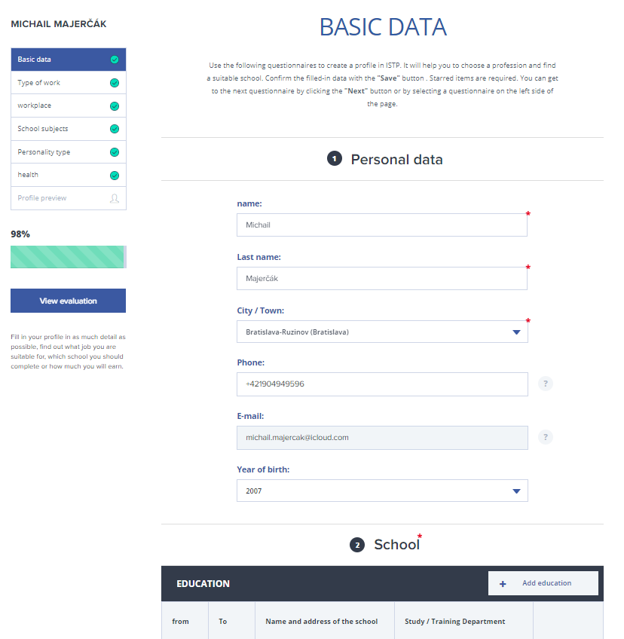

**Module Type of Work**

The next step is choosing the type of work I would like to perform in the future. The type of work is generalized, not talking about concrete jobs/occupations but merely about fields of work like *manual work, machinery handling, crafts, sales, security services, office work, technical work, creative work, jobs with university degree, management.*

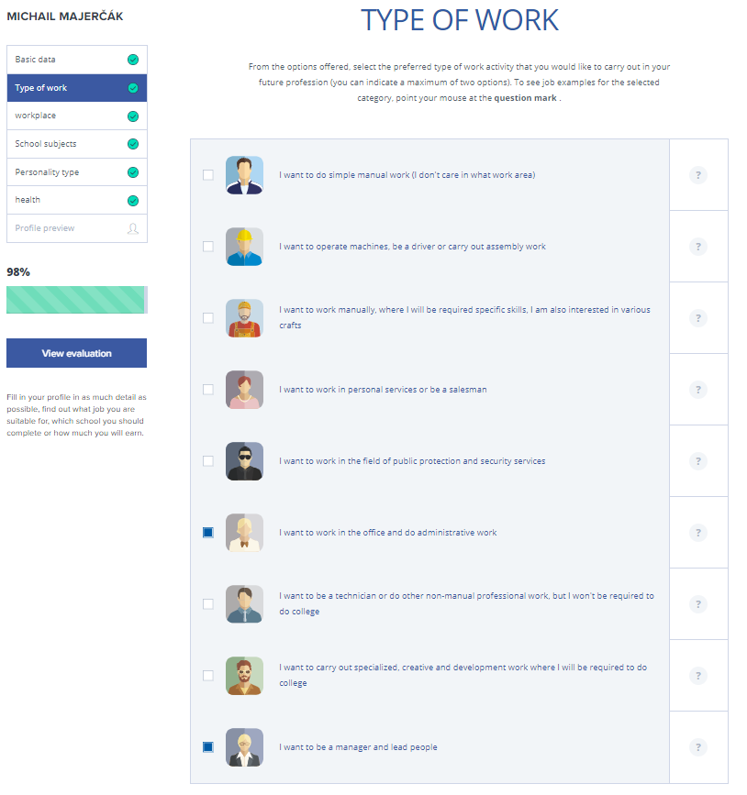

**Module Working Place**

The working place allows the registering person to choose (and to think of) what kind of working environment he/she would like to work in – whether it is a workshop, transportation (workplace in motion), workplaces where he/she meets lots of people, where he/she can help other people, cultural and artistic workplaces, workplaces outside or workplaces which do not require interaction.

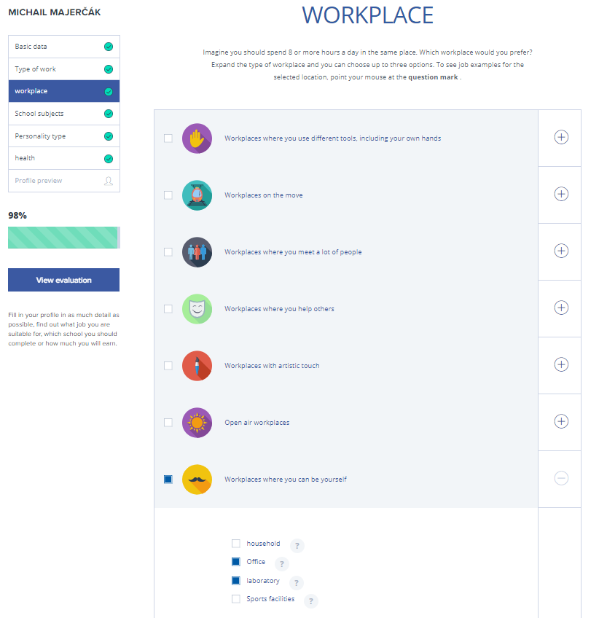

**Module School subjects**

A limited choice of school subjects (mostly areas) is available, each represented by an icon. The areas include numbers and computers (from accounting to software development), economics, languages, trade, physical exercise, nature, services, society, technical subjects, arts and healthcare.

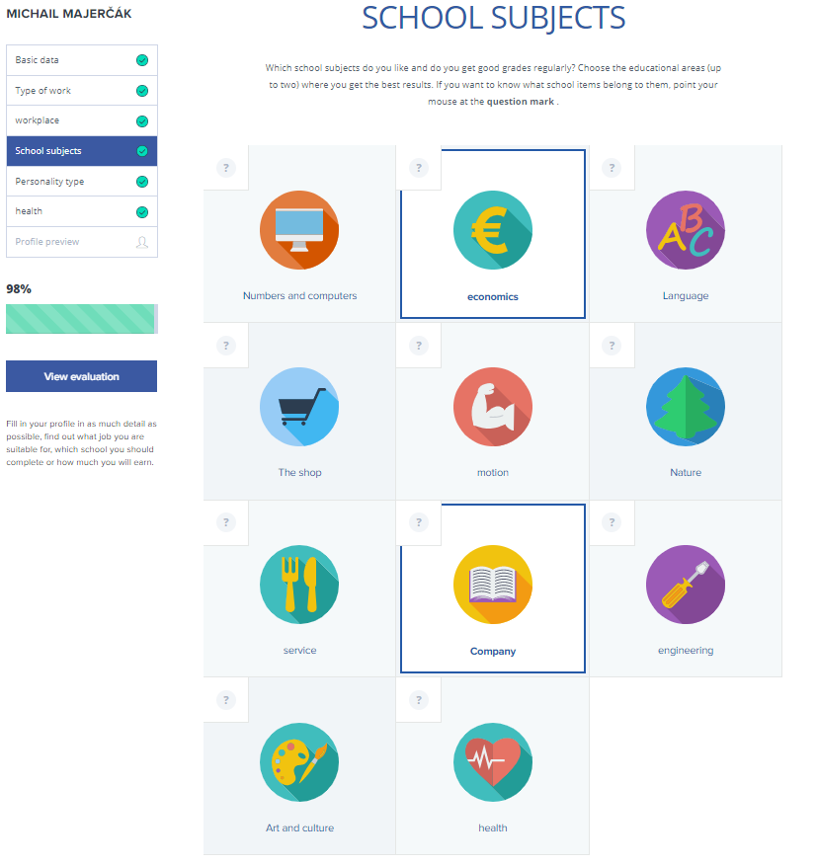

**Module Type of Personality**

Although better not left to “self-diagnostics”, the personality type allows the user to choose between few simply distinguishable type. This step may probably be omitted, as it is duplicate to the choice of Type of Work. A more through analysis of the personality is probably beyond the possibilities of such portal.

The types of personality below include *practical/technical type, intellectual/researcher, arts and languages, social type, entrepreneur and administrative type.*

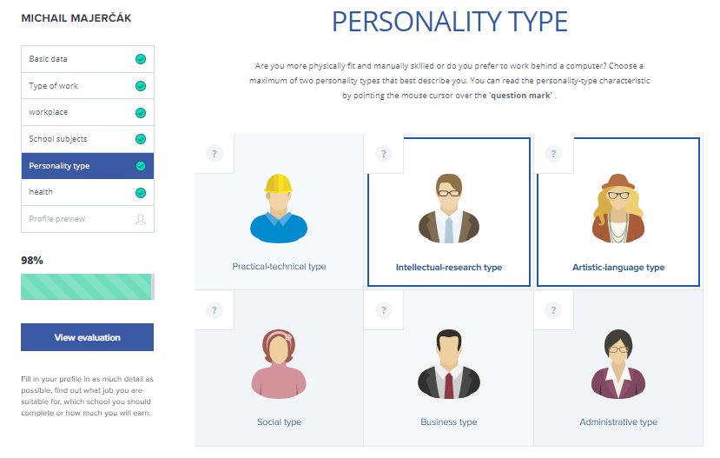

**Module Health/Health Issues**

This section allows to reasonably limit the offer of the courses/jobs/internships based on the known health limitations. The health conditions allow to identify major diagnoses/limitations, including psychological ones. The tool also includes graphical representation of the various body systems for the users with limited knowledge of the human biology.

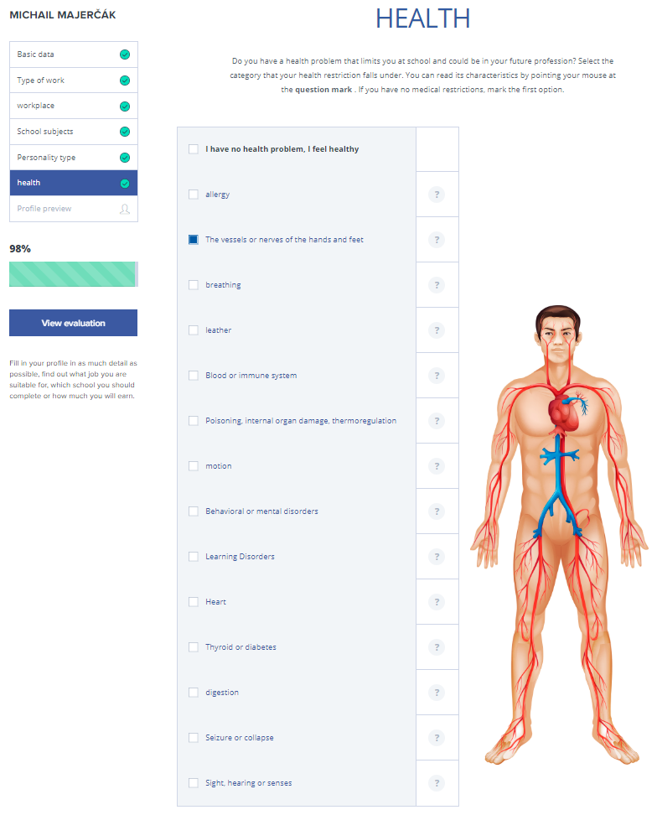

**Module Profile Evaluation**

After filling all the profile areas, the tool allows for a quick assessment of the profile, showing the most probable matches for the chosen types of work, types of workplace, subjects, personality and health issues. It basically selects the matching jobs from the internal database, to encourage the users to start using the job-matching tool as well as other micro-tools.

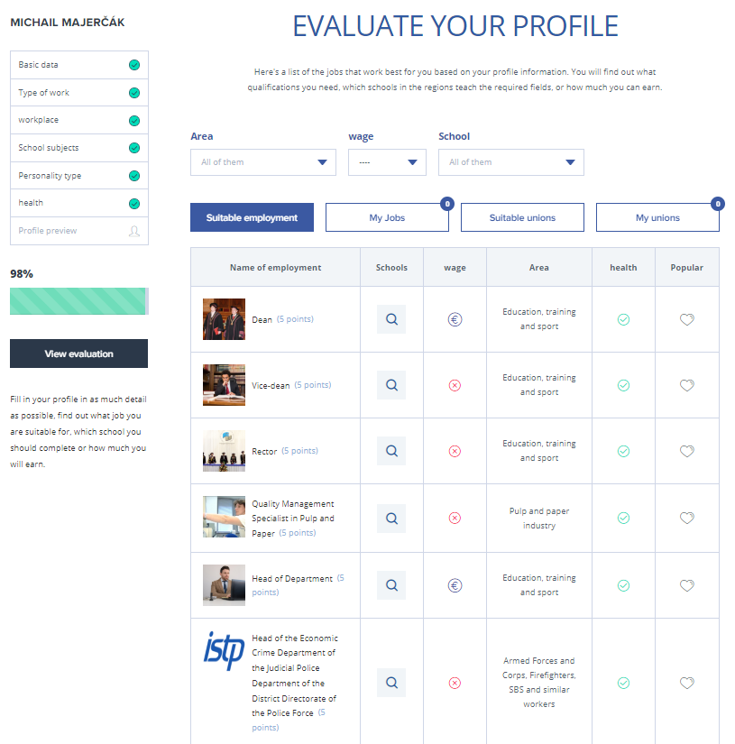

## Tool 2 - School Search

The School Search allows to find institutions with secondary and tertiary education based on their geographic location and keywords.

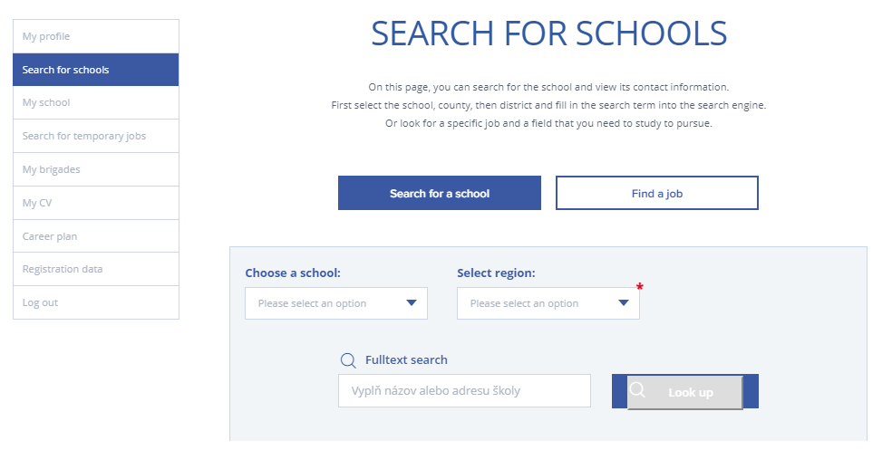

## Tool 3 - Part-time Employment and Internships

Another tool allows for search of a part-time employment and/or internships. Such positions are specially marked within the tool as suitable for students >16 years of age.

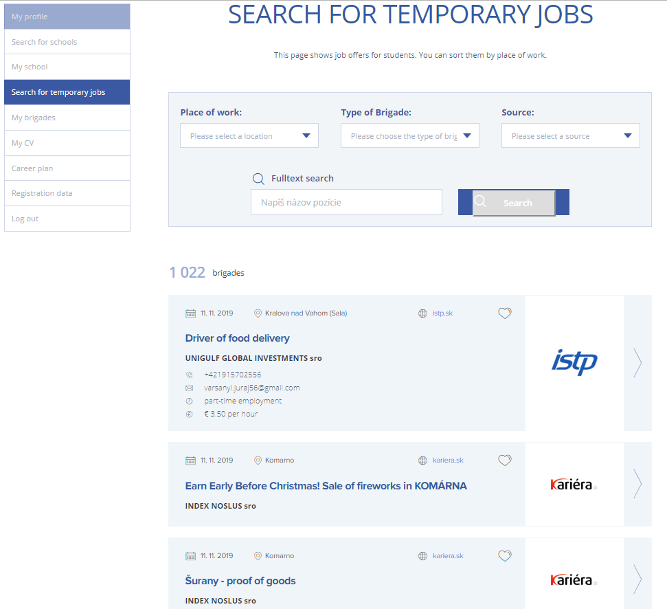

## Tool 4 - My CV

This section allows you to build a CV. The data can be imported from the profile information and exported as a standard DOCX/PDF file. This section also contains additional information to the profile, such as:

* The vacation I am looking for (description)
* Previous employments
* Formal and informal education
* Language skills
* Digital skills
* Personal skills
* Driver’s licence type
* Attachments (course/language certificates, previous employment references etc.)

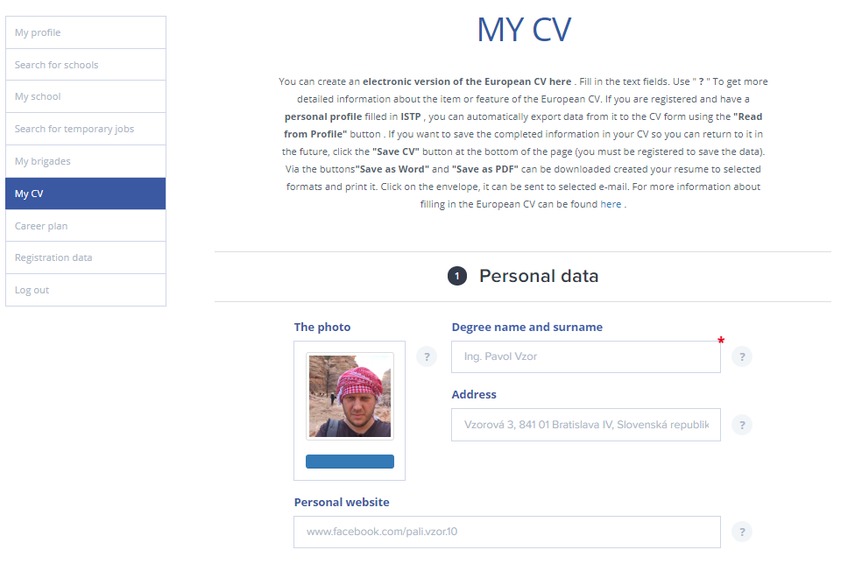

## Tool 5 - Courses

The Online Tool contains not only vacancies, but also courses published by various course-providers. The courses can be filtered by geographical location, name of the profession or by the course name. In the future, a linkage to the profile information is intended.

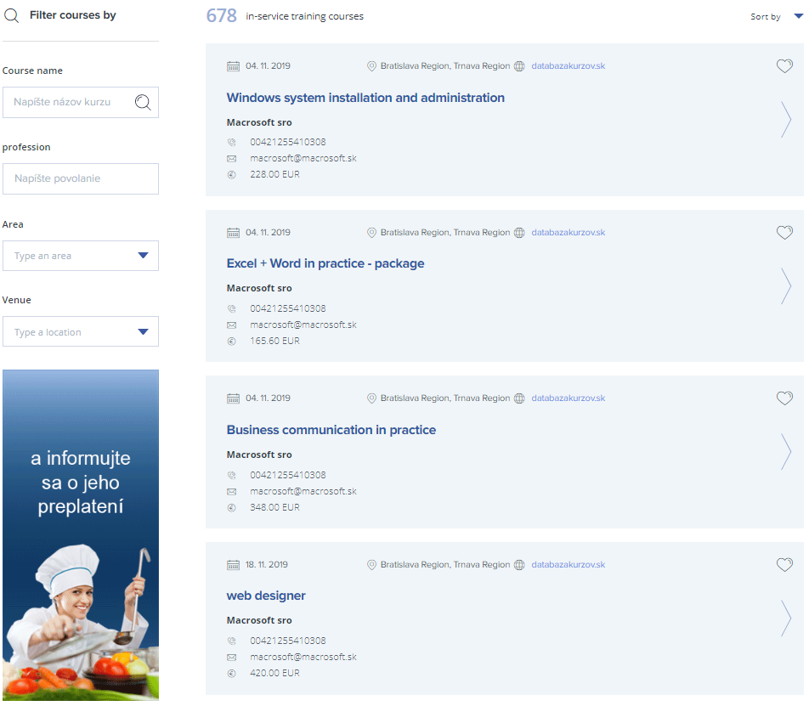

## Tool 6 - Catalogue of Professions

The Catalogue of Professions is a tool available without registration. It is a basic tool for the students and counsellors where they look up up to 1500 jobs either by searching them or going systematically through sectors.

For each job a structured information is provided, containing:

* Necessary qualification
* Personal(ity) requirements
* Health restrictions
* Additional information
* ISCO, ESCO, NACE, ISCED and other classifications

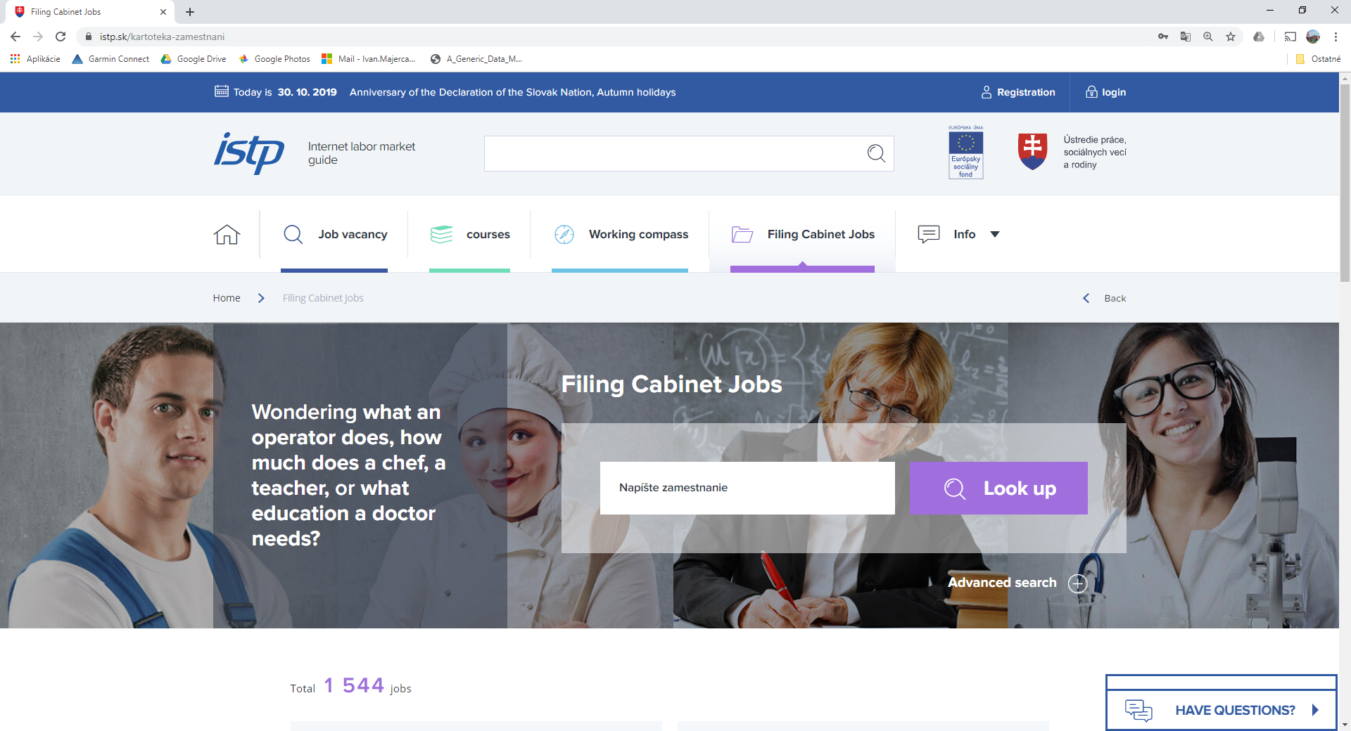

Figure 2 Catalogue of Professions - full-text search

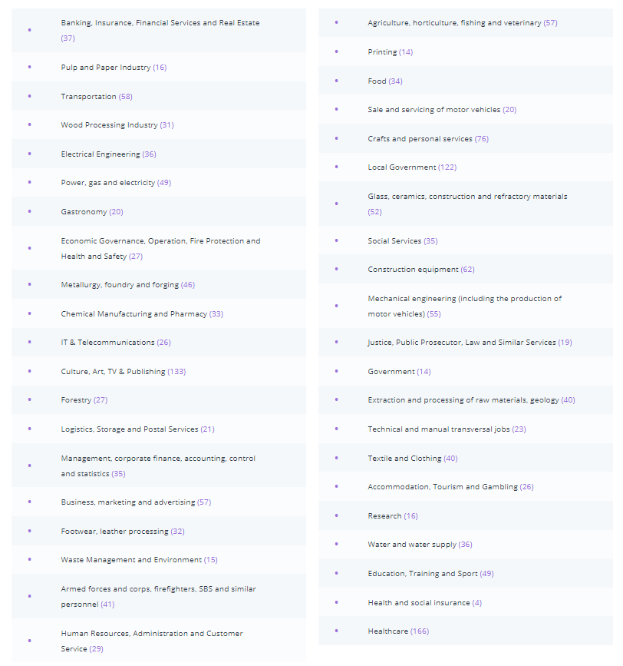

Figure 3 Catalogue of Professions - segregation of jobs by sector

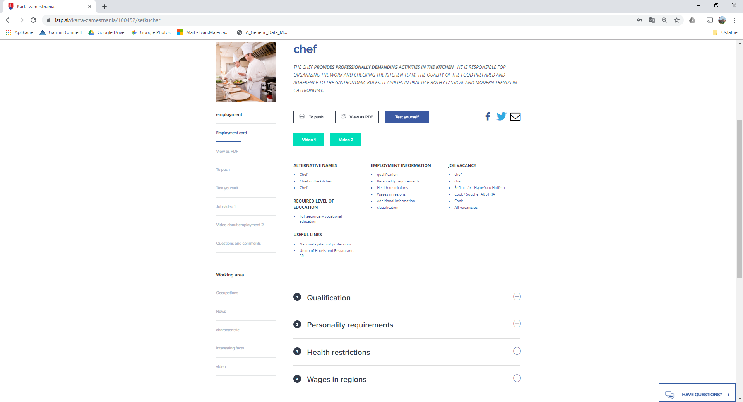

Figure 4 Catalogue of Professions - detailed information page

## Tool 7 - Work Compass

The Work Compass is a tool to help with the job or school search based on the profile of the user. In its current version, it redirects user either to the profile page, where an evaluation of the profile is provided (student) or to the evaluation of employee’s profile.

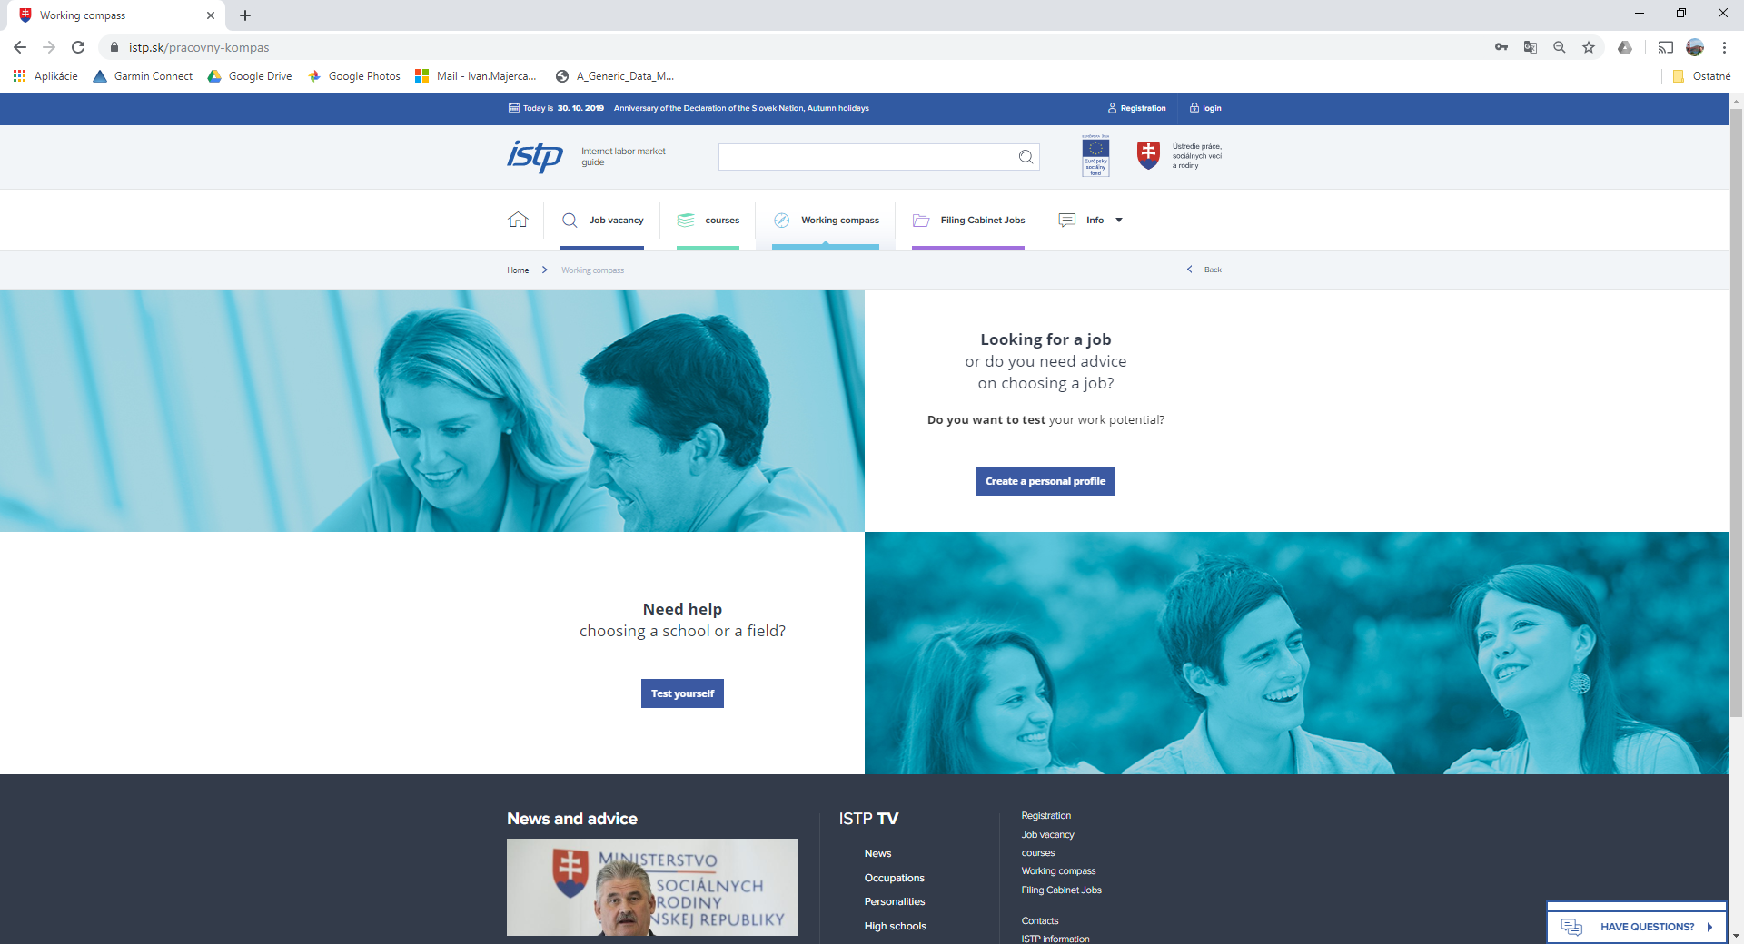

## Programs for Career Guidance

In Slovakia, following programs (not tools) are focusing on the Career Guidance:

* Supporting individualized link for young jobseekers (app. 24 500 young jobseekers)
* Training courses
  + provided by the Office of Labor
  + provided on jobseekers’ own initiative
* Requalification courses
* Competency courses

**Counselling**

* Total 30 hours
  + group activities (15 h)
  + individual activities (3 h)
  + individualized activities (12 h)
* Strengthening personnel capacities
  + 60 new career advisors
  + + 1 or 2 to every Office of Labor
* Selection of young jobseekers into the project
  + leaflets, offer sheets

**Requalification courses**

* Accredited retraining courses
* Non-accredited retraining courses, performed under a license, certificate, or registration under applicable legislation
* Non-accredited retraining courses, conducted based on a consensus issued by the sectoral council, professional organization or professional organization
* For REPAS +, retraining courses for the development of communication, computer, managerial, social, entrepreneurial and linguistic competencies are not considered for retraining
* Driving licenses (group B) are not supported.

**Competence courses**

* Non-accredited courses to develop selected key competencies
  + carried out based on the authorization to perform adult education, the implementation of extra-curricular educational activities,
* Communication skills
  + including social competences
* Personal development
  + including managerial and business competencies
* Computer skills
* Language skills
* KOMPAS+ courses focusing on the development of communication, computer, managerial, social, entrepreneurial and linguistic competencies are considered as competency courses.

## Tool 8 - Backend for Employment Offices

On the backend side of the Online Tool, there is a desktop application, which allows for detailed work with the client.

The employees of the Employment Services can access the client’s public data (in order to prevent double registration) and execute the actions related to on-site work with client - basic anamnesis of the client (history of the employment of the client and his / her family in his / her life situation, information counseling in the life situation of the client and his / her family, guidance of the client in further steps).

The Employment Services officer sees the following areas of data about the client:

* Basic information
* Detailed information
* Public profile (the data entered by the client)
* Client’s calendar – all the actions planned and executed with or for the client
* Vacancies – matching vacancies for the client’s profile
* Client’s roles (includes the roles of the client in the social security system)

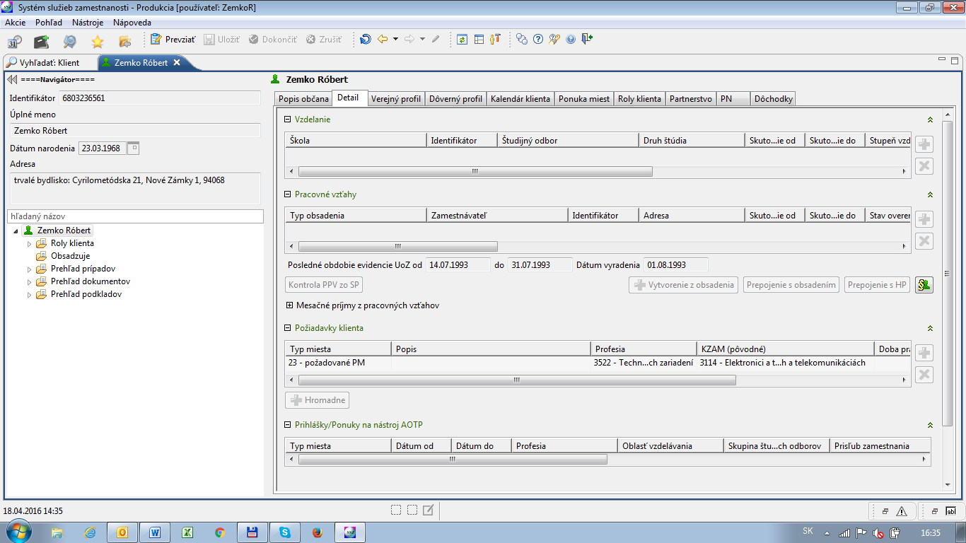

For the POCG it is important, that the Employment Services Officer sees the calendar of client, marking:

* Closed actions (counselling sessions, planning sessions, courses taken, job interviews)
* Planned actions
* Ongoing actions
* System actions (executed by the IT system automatically, usually after a certain legal period)

For each action it is possible to open a case and a case can contain folder of the documents.

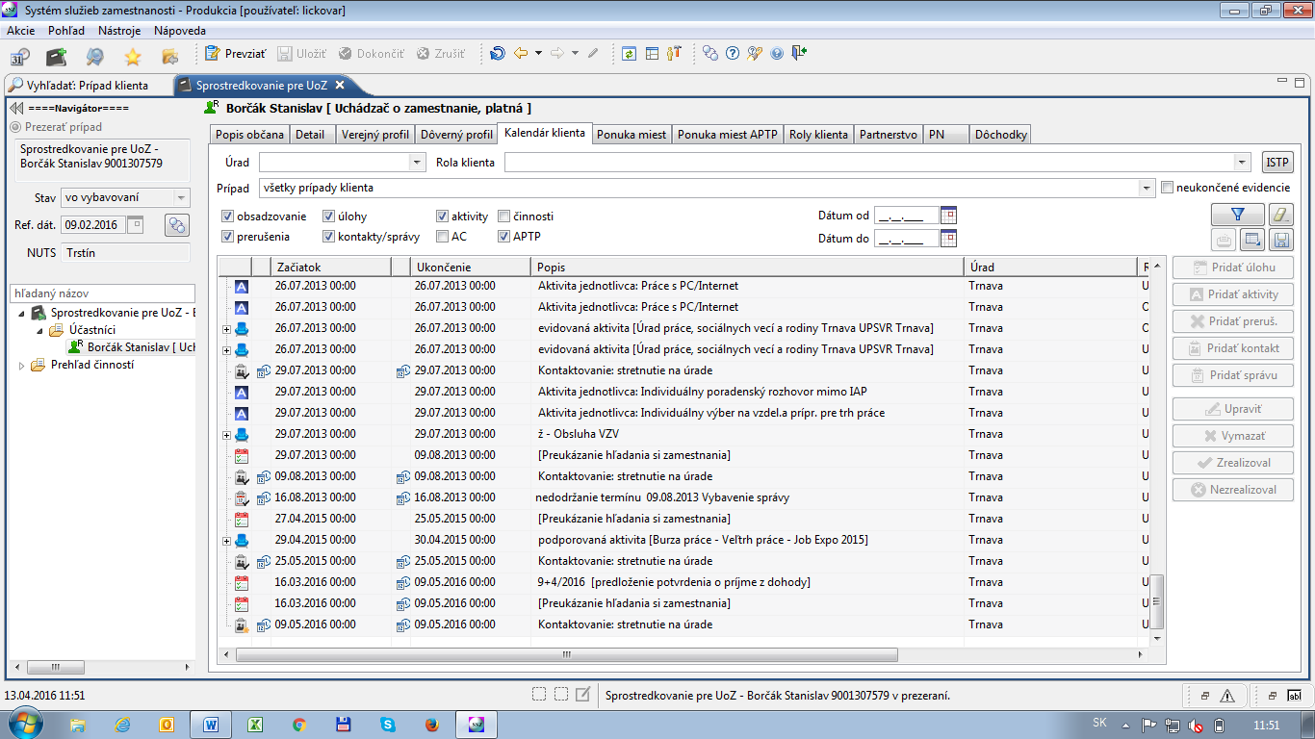

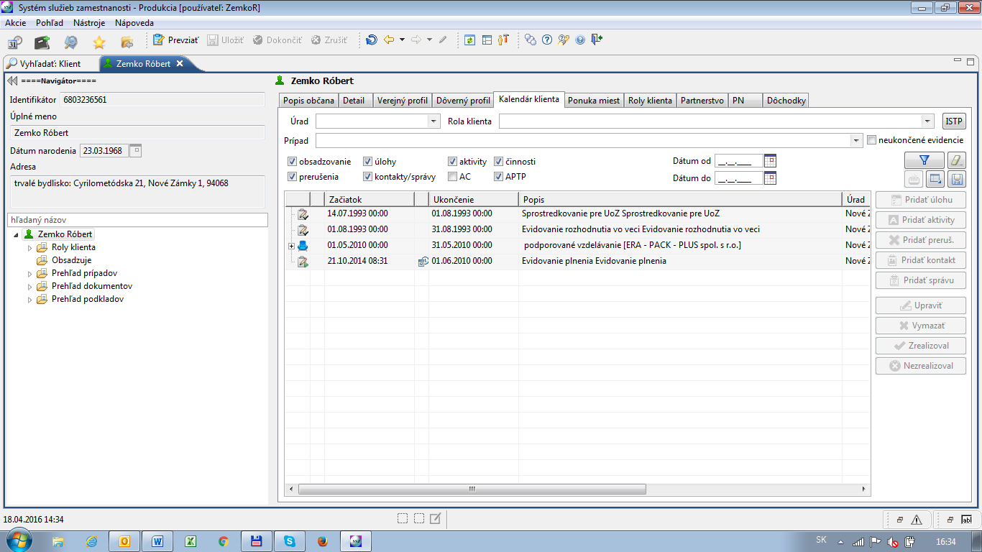

Figure 5 A detailed calendar view on the client's interactions with Employment Services

# Integration of the Ministry of Labour IT system SAJJIL with National Aid Fund (NAF) MIS systems in order to support the New Customer Journey pilot project

The support to the institutions in charge of the activation of job seekers and their insertion in the labour market through formal TVET and non-formal upskilling in Jordan was an objective of the EU financed Technical Assistance project “Skills for Employment and Social Inclusion Programme”.

SESIP TA has supported the Ministry of Labour (MOL) and National Aid Fund (NAF) services as well as other Jordanian institutions, in their effort to make the labour market more effective, efficient and inclusive of vulnerable groups, so that job seekers may face less a difficult and uncertain path to access these services.

To this purpose, the mandate of the NAF was integrated to include the labour market activation of its beneficiaries, in parallel with the general mandate of the MOL- Employment Directorate

Since December 2018, on the occasion of a SESIP learning event dedicated to this subject, and subsequently, in the course of the field visits undertaken by the SESIP Technical Assistance Team to the NAF and the Employment Offices in Russeifa, East Amman, Irbid and Zarqa and EO/MoL in East Amman, Zarqa, Irbid and Al-Karak, the difficulty related to the division of tasks and responsibilities between the MOL Eos and the NAF has emerged.

The EU TA SESIP project (Component 4), has:

* proposed scenarios for customer journey of NAF beneficiaries,
* developed a model for the workflow of NAF beneficiaries and tested it at the NAF local offices in Irbid, Zarqa and East Amman,
* continuously provided technical support and capacity building to NAF and MOL in fine-tuning protocols and internal workflow on how to deal with active age job-seekers.

The proposed and tested model consists of five front-line tools for NAF caseworkers. In particular:

1. Job readiness interview (first interview questions),
2. Screening interview towards ALMMs and LM services (LMS)
3. NAF referral form toward ALMMs and LMS
4. ALMM and Labour Market Services’ catalogues for the three locations
5. Case managers’ feedback form

The model is the result of a continuous consultation within the members of the SESIP Working Group (No. 4) dedicated to Inclusive access to E-TVET and Labour Market Information System (LMIS), and its elaboration stems from the following conclusions reached by the WG 4, of which MOL and NAF are members:

* MOL, Employment Directorate and its 24 Employment Offices, would be the national agency in charge of labour market activation, reflecting the EU and ILO practices.
* NAF would be responsible for the supply side only i.e. the screeningof its active age beneficiaries and their job-readiness. Beneficiaries are currently estimated at 58.000 but bound to increase after the inclusion of 85,000 households in the biennium 2019-2021.
* Protocols, including individual job-seekers’ case management are agreed between MOL, MOSD and NAF.
* MOL Employment Directorate would be the only responsible for profiling the job- seekers**,** engaging employers, and operating the mediation.

As part of SESIP TA tasks. the above protocols and tools, once tested in the three locations, have been handed over, through the ETVET Secretariat, to the concerned institutions, for their upscaling and utilisation at national level and their promotion for resource mobilisation and support by interested donors.

The following picture visualises the new customer journey of a NAF active age beneficiary, based on cross-institutional cooperation and coordination between NAF and MOL/EOs):

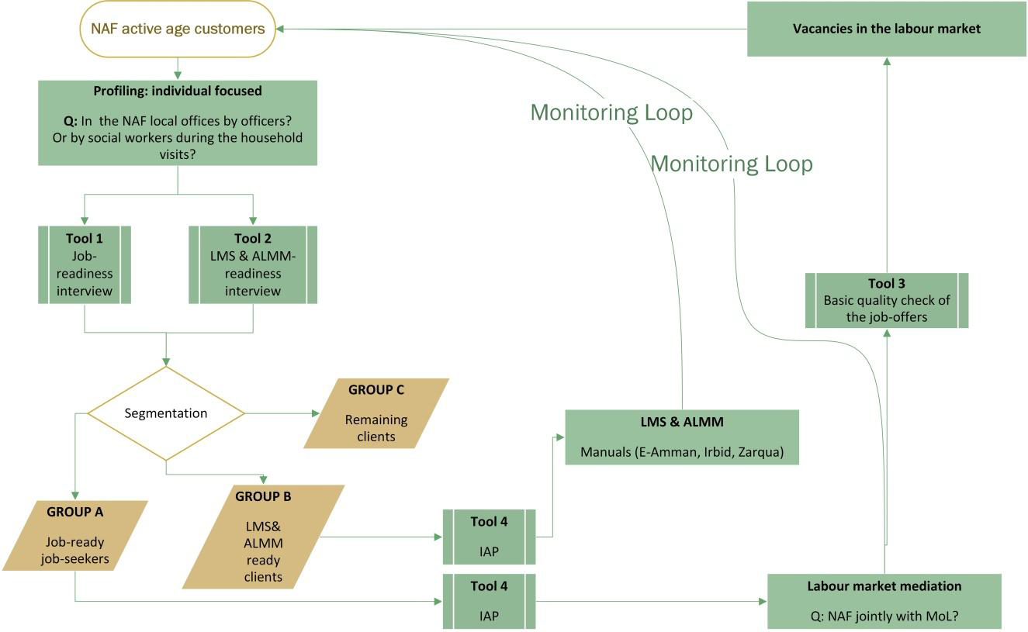

The following table provides a concise view of the activities undertaken in support of NAF/MOL Eos for the entire project duration.

|  |  |  |
| --- | --- | --- |
| Date | Type | Activities and deliverables |
| 26.-27.9.2018 | Job Fair | **NAF participation** in the in the SESIP supported Akhtaboot Job Fair of September 2018 |
| 30.9.-16.10.2018 | TA Mission | **Analysis** of the NAF MIS under construction.  **Advice** on how to structure of the new database in upcoming NAF MIS IT System |
| 10/2018-11/2019 | TA Mission | **LMIS Project Dossier:** NAF connection to LMIS |
| 10/2018-05/2019 | TA Mission | **Analysis** of the Existing Conceptual and Analytical Framework for Annual Reporting (Including NAF) |
| 7.-18.10.2018 | TA Mission | **Document:** Customer’s journey and access to ALMM |
| 18.10.2018 | Capacity building | **Workshop** for the WG 4 onAnalysis Report v. 1.0. - The customers’ journey and access to ALMMs |
| 2.-18.12.2018 | TA Mission | **Concept Paper** on pathway design and capacity development of NAF staff on employment of the working age and fit beneficiaries |
| 16.12.2018 | Capacity building | Workshop on pathway design and capacity development of the NAF for the employment of the working age and fit beneficiaries |
| 17.-28.2.2019 | TA Mission | **Workbook:** Public Private Partnership for cost-effective labour market services and active labour market measures in Jordan  **Catalogue** of LM Services (LMS) and ALM Measures (ALMM) in the governorates of Irbid, Zarqa and East Amman. |
| 26.-27.2.2019 | Capacity building | **Workshop** on **labour** market challenges and active measures (ALMM) |
| 31.3.-11.4.2019 | TA Mission | **Online Tools: and user’s manual** for field testing on labour market activation at the NAF local offices. |
| 14.-21.4.2019 | Exposure to international best practices | **Study Visit** to Slovakia and Austria for the members of WG 4 and the officials of NAF/MOL EO in the three testing locations. |
| 8.4.2019 | Capacity building | **Workshop on** for field testing on labour market activation at the NAF local offices. |
| 12.-23.5.2019 | TA Mission | **Follow-up** of the field testing at the 3 NAF local offices for labour market activation/ active inclusion |
| 27.6.2019 | Capacity building | **3 Workshops**: testing phase – key finding and data on the 1st field visit at Irbid, Zarqa and East Amman) |
| 25.8.-3.9.2019 | TA Mission and Capacity building | Completion of the testing phase of the new tools “The customer journey and training of the concerned NAF and MOL/EOs staff. |
| 20.10.-7.11.2019 | TA Mission | **Technical Specification Document:** “A 360° View of Customer in the IT Systems of MOL related to the Graduation Strategy of NAF |

As the reader can see from the table, between April and September 2019 as part of the SESIP project, Component 4 (C4) had been continuously supporting the development of the improving linkages between employment and social protection (developmental phase (April-May 2019) and the ***testing phase (May-August 2019) of the new customers’ journey of the NAF active age and ready-to-work beneficiaries)***.

The actual testing had been started in May 2019 and come to the end in late August 2019. The NAF refers to the process as the **Graduation Strategy**, highlighting the outcomes of the new workflow but not the yet the detailed action plan which will lead to results. However the phrase customers’ journey refers to the fact that job-seekers (JS) need to go through certain processes before they can be placed to the labour market (LM) and the NAF is responsible for these processes, which need to be developed; such as new internal structures, IT system, trained staff, national professional protocols and many other elements to make the journey of the client a successful one. Last but not least is to satisfy the needs of employers, who are the second customer of these services, with suitable applicants (job-seekers: JS).

The NAF is currently responsible for the registration of certain active age beneficiaries and in its new IT system should have detailed information not only on the household as such but also on each household member including those in the working age. These people may be ready to work, based on their age but also have other burdens which keep them away from the labour market.

The SESIP jointly with the NAF and the support of the MoL set up a testing for the new workflow of the NAF local offices in three selected locations, East Amman, Irbid and Zarqa. The test started in May 2019 and ended in August 2019. The primary aim was to make the role of labour market activation tasks clear for the NAF central management and local staff (front officers) and to support the transformation of the local offices. The NAF originally was established as a social welfare organisation of the government or namely as a social aid fund in the 1980’s for the Jordanian citizens and ***was never transformed to a more complex social and employment protection / labour market activation agency.*** ***However, it has the mandate to act accordingly***. It means that in order to fulfil the new roles of the NAF given by the government of the country ***a full-scale institutional transformation is needed***. SESIP with its limited resources supported part of this process. [1]

This chapter deals with the implications of the Graduation Strategy on IT systems in NAF and Ministry of Labour.

## Data Model

The Forms created for the testing phase were transformed into the following logical data model:



The model is based around the entities Person and BranchOffice, which represent entities in the database model of the new MIS system of the NAF. It is not important, what the real names of the tables are, but we assume their existence (of course in a much more refined and normalized manner).

Other entities were created solely for the purpose of this model. Since the interaction in the original testing phase Graduation Strategy was through 4 forms, we have reflected them in the data model as 4 new tables (JobReadinessInterview, ScreeningInterview, ReferralToMediation, FollowUp). This is mainly because:

1. We consider this process repeatable – the same cycle of interviews can happen after several years (e.g. after maternity leave). Therefore, the data should be stored with versioning history. This will also add some new interesting reporting options, once a significant cohort of users passes the process.
2. We think that distinct parts of the process, represented by the separate forms, can possibly happen in different branch offices of NAF.
3. Since the data model will grow by only few possible added questions, there is no need to model a general question/answer engine, allowing for storage of general types of questions (similar to e.g. testing engine of Moodle).

A similar model is expected on the side of MoL, mapping the supplied data to their entity of Person. The NAFBranchOffice must be obviously created as a new table, since the original data may be mapped to an incompatible structure of branch offices of NAF.

At the side of MoL, a referral to mediation does not have to contain the types of mediation, unless there will be decision to inform MoL about all possible types of intervention request (ranging from Public Work to Microfinance). On the other hand, the deadline for the feedback should trigger an action on the side of MoL backend system, leading to an event in the calendar of the client and of the MoL Employment Services Officer.

## Data Exchange

The Data Exchange between the two systems can be divided into 3 main areas:

* Exchange of the technical data – this is mainly about the exchange of the user entity data – his or her credentials, contact and address data. A mechanism leading to SSO can be established, where full credentials are synchronized between the systems. The synchronization should be near real-time, as there might be business case for client moving from NAF to Employment Office, which is literally next counter and the client might already leverage his/her presence in the system of MoL.
* Exchange of business data – this is data collected through user interface of either system and contains information about the screening of the user on various aspects of his/her participation in the Labour Market (availability, qualification, transport means, health status, etc.).
  + A clear indication of client coming from NAF is necessary in the IT system of MoL in order to secure the client’s promotion in the algorithms for job matching and others.
* Reporting – not a data exchange per se, but the need for an integrated reporting standing above all integrated systems (consider also systems of other destination institutions, like microfinancing, training centers etc.) is clearly a necessity. The reporting might be in the future integrated into LMIS, however at this stage a separate instance should be considered. The main focus of the reporting should be on the full closure of the Monitoring Loop and its effectivity.

## Electronic Services

The interaction(s) between NAF and MoL offices is described on the following schema:



From the schema above it is clear, that there will be a rich data exchange between NAF and MoL. The relevant data is created on both sides, majority on the side of NAF. The MoL creates data which is intrinsic to its systems (mediation results, job matching, ALMMs), while providing feedback to the NAF systems.

An attention must be paid to the authentication data exchange in order to establish a service(s) for common identity in both systems. While the single sign-on is a desired target state, also an exchange of a non-ambiguous identity will be a good start. A timestamp should accompany any changes of the identity (including contact and address info) in both systems in order to update it bi-directionally.

For the exchange of the business data, web services should be established, ideally atomic for their better traceablity/lower exchanged data volumes.

Of course, if the architecture requires it, the services can be handled through any form of Enterprise Service Bus, which allows for their potential reusability.

## Enhanced Data Exchange

From the discussions with MoL representatives, we have learned, that the new SAJJIL system will contain a data exchange service with the Department of Motor Vehicles equivalent institution in Jordan. Such services are very helpful when assessing the client’s situation and can enhance the 360 degree view of the client. Following are other recommended data exchange services, which are usually implemented in systems like LMIMS and Social Benefits system:

This list contains the name of the institution (generalized, so that it can be projected to Jordan environment) and a brief description of the data exchange reasons.

**National Labour Inspectorate**

* Cooperation in control of prohibition of illegal work and illegal employment

**Health Care Surveillance Authority**

* Exchange of data about subsidies for the people providing care or personal assistance
* Exchange of data about people with severe disabilities and/or requiring assistance

**Radio and Television**

* Exchange of data about exemption from monthly fee levied on most individuals registered with electricity retailers

**Health insurance companies**

* Exchange of data about current body covering the health insurance
* Exchange of data about fulfilling the conditions for financial support during unemployment

**National Post**

* Subsidies and compensations payments (structured by the type of fee)

**Statistical Office**

* Data provisioning based on the current national legislation

**Trade Register**

* Data exchange (load) for the agenda of social affairs and employment services

**Ministry of Education and its Institutes**

* Data/statistics provisioning for the analysis of the high school and university graduates placement

**Department of Motor Vehicles (Vehicles Register)**

* Data exchange about car ownership for the subsidies assessment and for the new car procurement contribution

**Financial Administration**

* Data provisioning about personal entities receiving subsidies (taxable)
* Data exchange about debts
* Data exchange about tax declarations

**Social Security Company**

* ALMPs assessment
* Tax and contributions deduction for the unemplyed
* inspection of the employment of the foreign citizens
* assessment of the availability and length of the unemployment benefits
* information about fines imposed
* list of employers for the assessment of their obligation to employ handicapped citizens

**ITMS (Information and Technical Monitoring System – EU Funds)**

* Planning and controlling the resources from EU Funds

**Other data exchanges within LMIMS:**

* Tax declarations
* Back taxes
* Register of businesses (kept by Statistical office)
* Register of taxpayers
* Register of convictions
* Health insurance back payments

## Next Steps

Following is the list of next steps in implementation of the Graduation Strategy between NAF, MoL and possibly other institutions. The list is ordered more or less chronologically, but not necessarily:

1. Finishing of the SAJJIL IT System on the side of Ministry of Labour. The system is developed in rather agile way with new modules appearing fast. The integration with the NAF system can only start once the system is finished, tested and an integration specification is provided.
2. Through analysis of the Graduation Strategy, including:
   1. What part of preliminary screening should be done where (it is still not clear, which part of the screening will be done by NAF and MoL, although there are indications, that the screening will probably roughly adhere to the originally drafted processes by SESIP Project).
   2. Algorithms for promoting NAF clients in the job matching and other actions – this is clearly on the side of Akhtaboot, as a developer of the SAJJIL system. Specific places in the system must be identified, where it makes sense to upvote the NAF users in the search results.
3. Technical equipment for the offices, including:
   1. Internet connectivity
   2. Computers capable of working with the new systems
   3. Improvement of the offices‘ interior (intimacy when working with client)
4. Staffing of the offices – probably the most important thing in this new approach. As it was proven by the testing phase of the Graduation Strategy, the system can work even with a little IT support, but requires qualified and motivated people, both on the side of NAF and MoL. The prerequisites for the officers (either from internal pool or new hires) should be:
   1. Computer literacy
   2. Willingness to learn (embrace the new process, Labour Market Service catalogue)
   3. Ability to communicate with various parties/institutions
   4. Focus on the client
   5. Ability to improvise in an ever-changing environment

# List of Annexes

The following documents were used for reference in the course of creation of this document:

|  |  |  |
| --- | --- | --- |
| N | Document | Author(s) |
|  | TESTING_Final Recommendations only ENG.docx | Tibor Borbély-Pecze |
|  | LINKS TO GOOGLE ONLINE TOOLS_TESTING PHASE_NAF SYSTEM_TOOLS ONLINE.docx | Ivan Majerčák |

1. Taken from *TESTING_Evaluation Report of the field testing Aug_Sept 2019_ACT 144_LP FINAL.docx*