Evaluation Report

of the field testing at the NAF local offices for labour market activation/ active inclusion

April-August 2019

Activity 1. 4.4
By Tibor Bors BORBELY-PECZE, International Senior Non-Key Expert
Reviewed and approved by: Luba Pavlovova, Key Expert4/Component4

Amman, September 2019

Evaluation Report

of the field testing at the NAF local offices for labour market activation/ active inclusion

April-August 2019

Activity 1. 4.4
By Tibor Bors BORBELY-PECZE, International Senior Non-Key Expert
Reviewed and approved by: Luba Pavlovova, Key Expert4/Component4

Amman, September 2019

Abbreviations

ALMM Active Labour Market Measures
EU European Union
MoL Ministry of Labour
MoL/LO Ministry of Labour Employment Directorate Local Office
NAF National Aid Fund
LMS Labour Market Services
IAP Individualized Action Plan
MoU Memorandum of Understanding
JSS Jordan Social Security
JS Job-seekers
ILO International Labour Organisation
PES Public Employment Service
NUR National Unified Registry
PIT Personal Income Tax
SESIP Technical Assistance to the Skills for Employment and Social Inclusion for Jordan
HQ Headquarter/ Central Office
VTC Vocational Training Centre
WB World Bank

Table of Content

Key outcomes of the field testing 4
Irbid 7
Zarqa 8
East-Amman 9
Overall outcomes 9
Final Recommendations 12
System level recommendations 12
Institutional and cross-institutional level recommendations 12
Annex 1 Case studies 14
Irbid 14
Zarqa 14
East-Amman 14
Annex 2 Flowchart of graduation strategy of the NAF 16

Key outcomes of the field testing

Between April and September 2019 as part of the SESIP project, Component 4 (C4) had been continuously supporting the development of the improving linkages between employment and social protection. In this report this period will be referred as the developmental phase (April-May 2019) and the testing phase (May-August 2019) of the new customers’ journey of the NAF active age and ready-to-work beneficiaries. The actual testing had been started in May 2019 and come to the end in late August 2019. The NAF refers to the process as the Graduation Strategy, highlighting the outcomes of the new workflow but not the yet the detailed action plan which will lead to results. However the phrase customers’ journey refers to the fact that job-seekers (JS) need to go through certain processes before they can be placed to the labour market (LM) and the NAF is responsible for these processes, which need to be developed; such as new internal structures, IT system, trained staff, national professional protocols and many other elements to make the journey of the client a successful one. Last but not least is to satisfy the needs of employers, who are the second customer of these services, with suitable applicants (job-seekers: JS).
The NAF is currently responsible for the registration of certain active age beneficiaries and in its new IT system should have detailed information not only on the household as such but also on each household member including those in the working age. These people may be ready to work, based on their age but also have other burdens which keep them away from the labour market.
The SESIP jointly with the NAF and the support of the MoL sets up a testing for the new workflow of the NAF local offices in three selected locations, East Amman, Irbid and Zarqa. The test started in May 2019 and ended in August 2019. The primary aim was to make the role of labour market activation tasks clear for the NAF central management and local staff (front officers) and to support the transformation of the local offices. The NAF originally was established as a social welfare organisation of the government or namely as a social aid fund in the 1980’s for the Jordanian citizens and was never transformed to a more complex social and employment protection / labour market activation agency. However it has the mandate to act accordingly. It means that in order to fulfil the new roles of the NAF given by the government of the country a full scale institutional transformation is needed. SESIP with its limited resources supported part of this process.
This Evaluation Report describes the main step taken during the testing and the key outcomes of the test. Finally it highlights the most important further steps as recommendations which can be used as a basis for further actions (follow up).

Five new front-line tools for caseworkers were introduced, namely;
- job readiness first interview questions,
- screening interview towards ALMMs and LM services
- NAF referral form toward ALMMs and LM services
- ALMM and LMS catalogues for the three locations
- case managers’ feedback form
The SESIP project together with the local and national NAF and MoL staff redesigned the workflow of the NAF local offices. This new workflow indicates the new customers’ journey of the active age beneficiaries whose are ready for jobs and also meet with the basic criteria of the labour market. The field testing of the tools were supported by the Key Expert 4 and a Non-Key Senior Expert of the SESIP. Three field visits were organized (May, July, August 2019) to support the learning process of the three selected offices. The HQ of NAF also the MoL through the two designated coordinators supported the process; several co-ordination meetings were organized and the NAF HQ and MoL HQ staff was all the time invited for the field visits so these meetings could serve as trouble shooting occasions, so-called Gemba meetings for the transformation.
Gemba Meetings
'Going to Gemba' is the act of visiting the shop floor in Lean and Kaizen. Literally translated as 'The Real Place', it pushes the importance of leadership understanding what is happening at every level. In business, however, gemba refers to the place where value is created. The most common use of the term is in manufacturing, where the gemba is the factory floor. Beyond this, gemba can really be any "site", such as a building site in construction, the sales floor in retail, or somewhere the service provider interacts directly with the customer e.g. a car dealership showroom.
(sources: http://insights.btoes.com/resources/what-is-going-to-gemba-lean-kaizen-definition-introduction)

Flowchart No. 1.
Active age beneficiaries of the NAF – labour market activation, the customer’s new journey

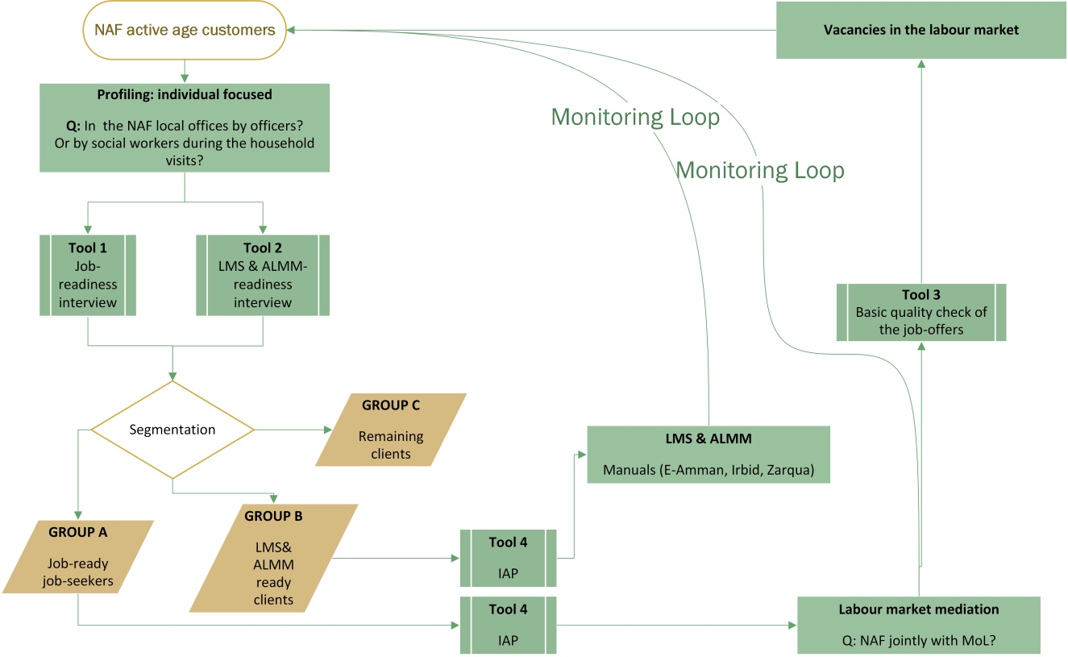

The testing process had four phases. During the first phase SESIP, NAF and MoL agreed on the new suggested workflow of the NAF client, new tools were developed and also agreed. The primary change of the tested model comparing to the previous NAF model is that it used a preliminary job readiness interview and based on the result of the interview it grouped (segmented) the customers to different segments. Group A are 100% ready for jobs, Group B needs active measures and probably social services as well and Group C are the NAF customers but too far from the labour market so the current NAF services cannot support them properly.
The most important parts of the tested new model is that it runs a short job-readiness interview with all active age clients of the NAF and as an outcome the first basic segmentation of the client must be done by the NAF officers.
Secondly only Group A, ready for work, has been transferred with a referral letter to the MoL/LO where the labour officers are responsible for a deeper employment related interview, for labour market mediation and referral to employers.
Thirdly, the NAF caseworkers now are seeking for evidence that the referred clients arrived to the MoL/LO and also they need to know the outcomes of the labour market interventions for each of the referred clients. This means the end of the group-based care and a move forward to individual-case management.

Chart 2. Testing phases of the new customers’ journey
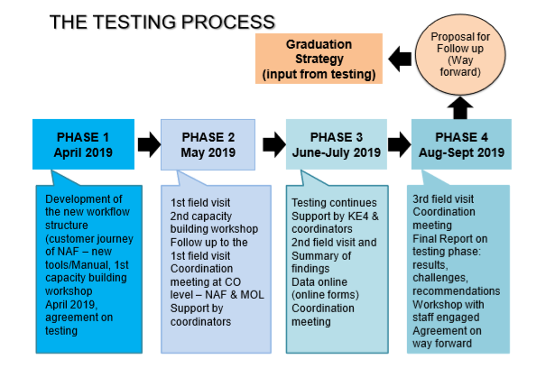
Between 27-29th of August 2019 we conducted final visits to the three local offices of the NAF where the new customers’ journey and the new tools were tested. Here we discuss the main reflections of the three offices after the testing phase.

Irbid
The most important element of the testing was in the Irbid NAF local office, that the workflow needs to be planned in advance and the case work with the active age beneficiaries (job-seekers) must be based on planning and individual needs. This was a completely new experience for the staff of the office. The time for certain activities (e.g. first interview, making contact with MoL/LO, etc.) are counted now. The tools had been developed by the SESIP/C4 are well used and the daily cross-institutional coordination with the MoL/LO is also a new and useful experiences according the view of the local director and staff engaged in the testing.
Still the employment component is not separated and the local staff deals with it alongside with other activities. Since the beginning of the testing the human resources were doubled, currently two staff members have been working for the employment component but only as part of their working time. The infrastructure for the employment component is still underdeveloped; lack of IT tools and data on active age JS, internet access, office car are missing, etc.
The level of engagement with the employment component remains low, for example between late July and late August the NAF local office conducted job-readiness interview with 31 JS and categorized 16 beneficiaries to Category A, 14 to Group B and 1 to Group C and referred those belonging to the Group A to the MoL/LO in Irbid. NAF hasn’t received any answer from the MoL/LO about status of the referred clients. NAF LO still has been contacting the beneficiaries by phones. NAF local office does not contact the MoL/LO for a follow-up of the referred JS, waiting for response of the MoL/EO.
Concerning Group B clients the NAF local staff is still lacking professional self-confidence. Explaining for the clients the expected outcomes of ALMM or LMS (labour market services) is hard for them and it creates uncertain situations. 14 clients were segmented to Group B during the last weeks. All of them are in a training of the VTC and the local officer has been following then via a What’s App group. The ALMM/ LMS Catalogue hasn’t been used by the local office as they have no financial mechanism neither professional protocols how to handle individualized needs.
The job-readiness interview which is a corner-stone of the new workflow has been misused. Instead of being used as a first screening interview for job-readiness it is often used for data gathering of the NAF IT system.

Zarqa
In Zarqa the local director and the staff of the office had reported a significant improvement in the cross-institutional level co-operation. The local NAF officer has been working as one team with the MoL/LO officers. Importantly for the third field visit the MoL/LO officers also showed up for the discussion. The employment office does the follow-up of the placed client by calling the employer and also makes a call to the individuals. The NAF office, according the current legislation, keeps the payment of the social benefits of the placed clients for another two years.
Based on the cooperation the offices NAF and MoL/LO already started the rearrangement of the customers’ segments. It means that individually select cases and transfer them to the MoL/LO and do the follow up of the clients. The office started to use the employment component as a preventive tool, so the staff offers the service of the employment office before the client can make their case for cash social benefits, this option is also offered for those clients are not eligible for NAF benefits/ social assistances.
As a bottleneck issue the NAF local office still has only one contracted employee for the task doing this work alongside with other daily duties. Since May, the start of the testing, the office made 70 cases. Out of them 5 found employment individually and 5 were placed by the employment office. 5 were transferred to VTC directly and 5 more were referred to trainings by the local employment office. The local employment office had received 61 NAF beneficiaries and placed 30 also sent 5 to professional training. For the second group the MoL/LO offered career guidance as the service is available on the spot as an outcome of a previous JICA project. A number of NAF clients have no clean criminal record which makes the placement hard or impossible.
The case management of Group B is still very weak, not all of the SESIP tools are mobilized in the daily practice also the case management feedback form hasn’t been used by the local offices.

East-Amman
This office has the biggest number of registered customers and also more staff members than the other two local offices were involved in the testing. They have 2 or 3 staff members dedicated for employment and the local director provides a close support for the activities. Since the 2nd field visit the NAF local office stopped the placement of the client and now works closely with the MoL/LO.
59 NAF customers were referred to the local MoL office. The MoL office organized a job fair where they invited all Group A clients. The references are still based on groups. The NAF office issues referral letters with 15-30 names. There is still no individual case management. The group of NAF beneficiaries are transfered as a group based on the available new job openings at the MoL/LO. Based on the request of the employment office the individual NAF beneficiaries are not transferred to the MoL/LO but just when job offers are available. Out of the 189 Group A clients only 10% showed up in the employment office. Out of the 189 people 10 are in work. The sanctioning part of the violation of the cooperation between the client and the NAF office doesn’t work in reality although rules are in place.
Although NAF beneficiaries know that they can keep the cash benefits for additional two years after the placement the low wages, commuting time and working conditions keep them away from the jobs.
For Group B life training courses and job-seeking trainings were available via a youth association but the training hasn’t started yet. 37 Group B clients were sent to this training. The NAF local office has been using the SESIP prepared Catalogue and ALMM&LMS selection tool.

Overall outcomes

This section of the report describes the key outcomes of the testing phase based on the Google forms data were recorded by the staff of the three NAF testing offices. These offices have limited access to the internet (usually only the local director has a line) and the officers recorded the data during the evenings/ nights after the working hours the figures in this section of the report may differ from the figures in the three follow-up (Gemba) visits. Nevertheless, the main aim of the testing was to observe the operational new workflow and start the transformation of the mind-set of the NAF local officers as well as the MoL officers. Therefore not the number of the newly engaged cases are the most important but the evidence that the new workflow is durable in the country.
According the recorded Google forms, were used for the testing, 354 job-readiness interviews were conducted in the three locations during the testing period. Out of this figure 130 interviews were recorded in Irbid, 37 in Zarqa and the remaining figures arrived from the East-Amman office, which has the biggest registered beneficiary group out of the three locations.
Interestingly most of the NAF clients are very young, are between the ages of 16-25. The prime age job-seekers were hardly involved in the testing. Based on this fact the question later on needs to be addressed; is the NAF/MoL a major channel for job-search in the country? And if the answer is no, in which way the reform (Graduation Strategy) needs to be drafted and implemented. The majority (605) of the interviewed would be ready to work for the official gross minimal wage of JOD 220. In a correspondence with this fact most of them are unexperienced and not able to describe his/her career planes, would accept any jobs.
146 interviewee were sent to active measure and labour market services as Group B. Labour market training was suggested 17 times, apprenticeship 25 cases, micro-financing 4 times and only in the Irbid office. Out of the Group B client the majority were sent to labour market information provision which without an existing national Labour Market Information System (LMIS) makes the service weak.
Table 1. Group B client based on the suggested ALMM & LMS
Training | 17
Micro-credit | 4
Apprenticeship | 25
LM information | 100
TOTAL | 146

The follow-up tools were rarely used, only the East-Amman office had recorded 19 cases.

Chart 2 Age groups of the testing groups by office

Table 2.
Outcomes of the new workflow & tools testing in the three test branches of the NAF
May– August 2019 *

local offices | no. of job-readiness interviews made | Categorized to Group A | Group A referred to local employment office | Group B (for ALMMs and LMS) | Group B clients referred to service providers | Group C | feedback form MoL/LO & other providers | at work
Irbid | 101 | 48 | 55 | 17 | 17 | 1 | 24 | 13
Al-Zarqa | 70 | 65 | 61 | 5 | 5 | 0 | 35 | 10
East-Amman | 266 | 189 | 59 | 37 | 37 | 40 | 19 | 10
TOTAL | 437 | 302 | 175 | 59 | 59 | 41 | 78 | 33
*the testing started in May 2019 and finished in August 2019.
*The chart was last updated on 29th of August 2019 based on the data from the Google forms, these figures may differs from the data had been received from the local NAF offices during the three field visits.

Final Recommendations

The testing of the new workflow of the NAF and partly the MoL to pave the way for employment was successful. In a very hard environment, where not only the decent work opportunities are limited but the local offices of the NAF are dealing with the issue of lack of resources; a few caseworkers were able to show results. Closely 300 NAF beneficiaries were involved in the testing and more than 10% are already employed, another group now participates in labour market retraining programmes.

Implementing new policies is never an easy task for any government. The rearrangement of a social policy system as part of a country’s social defence system is even more challenging task. The aims of the Jordan Government to put active age citizens back to work could bring a simple change in the organizational model of the National Aid Fund (NAF) but also in the operational structure of the MoL Employment Directorate. The testing of the new workflow of the labour market activation of the NAF active age clients led to a better understanding of the forthcoming challenges.
These challenges can be grouped as; i) policy or system level issues ii) institutional issues, iii) cross-institutional issues.

System level recommendations
- The success of the implementation of a new employment activation policy in the country relays on the institutional rearrangement of the employment and social security institutions. It means the organisational restructuring of the NAF but also the MoL Employment Directorate.
- The poverty gap and neglecting basic decent work criteria are a reality in the country. Case workers themselves cannot go beyond this barrier. New forms of activation benefits, such as in-work benefit, subsidized commuting etc. are needed in a much bigger scale. As a start the NAF has a right to keep the payment of social benefit for those already employed up to two years. This in-work benefit eligibility needs to be regularly cross-checked with the Social Security Corporation. Also the right for the NAF and MoL to make sanctions against employers have been neglecting the labour market regulation and minimal occupational and safety regulations is a must for the successful policy transformation.
- The labour market training as an ALMP is still supply-driven, it needs to be transformed to a demand-driven system based on the inputs of the job-seekers not only the employers and mainly not by the input of the different state bodies.

Institutional and cross-institutional level recommendations
- The testing of the new workflow in the shop-floor showed evidence that the NAF and MOL/ LO are able to work together and capable to move forward to the individual case-management approach. This new workflow now needs to be further strengthened and reinforced at all levels;
  - within the local offices where HR are often underdeveloped
  - infrastructure such as internet access, direct regular access to NAF IT system, phone, cars are missing
  - proper, extra and detailed training of the NAF front-line staff (caseworkers) is a precondition as well
  - the cross-institutional case-management between NAF and MoL is part of the new workflow and this needs to be referred within the MoU between these institutions.
  - finally the NAF HQ needs to be rearranged and a methodological support unit for employment/labour market engagement needs to be established. Most preferably with two or three labour market experts with a deed knowledge about labour market services, active measures and the basic functionality of PES (public employment services) and welfare systems.
- Preventing the early burnout syndrome of the NAF and MoL/LO staff regular case management discussion, supervision opportunities would be useful. Also the appreciation of the well elaborated casework within the NAF and MoL should be somehow reflected in the wages and status of the local staff.
The above-mentioned recommendations need to be further discussed and reflected by the two institutions NAF and MoL/Employment Directorate which are mainly responsible for active inclusion/labour marker activation. The management of the two institutions have been receiving detailed information about the testing phase and the added value of the SESIP, will also receive the Final Evaluation Report. Based on this evidence it is up to the management of the NAF and the MoL/Employment Directorate to find a common ground for further policy implementation.

Amman, 3rd of September 2019

Annex 1 Case studies

Irbid

Name: Rahaf
She is a 24-year old, single, her father receives a patient aid (cash assistant), and he is unemployed. The family consists of a father and a mother (housewife), three children and a brother working irregularly.
She was interviewed in Irbid local office, classified in group (B) she enrolled in a training course on making pastries and sweets at the vocational training institute (VTI) for girls.
Through follow-up visits to the institute and communication with her, we informed that she successfully finished the training and was referred to the employment office and now she is waiting for the right job opportunities.

Zarqa
Miss Nour, she finished her high school education. She received extraordinary aid for her and her brothers. She was exposed to bad social conditions. She preferred to work to complete her study. Her mother was separated from her father, and she married another person to support her and her children. this had a bad impact on Noor, so she decided to work in order to support her brothers, and not to rely on her stepfather, she was referred to the EO, she was supported with good services, and appropriate actions.
.....................................................................................................................
Mr. Samer he is a son of a beneficiary, his father receives aid (physical disability aid) he was referred to the National Company for Training and Employment (NET), he enrolled in a training course on (furniture painting), then he was referred to the EO but he did not find a suitable opportunity in this field, so he was referred to Ayman Hariz company and he start working in the company.

.........................................................................................................................

Mr. Fadi, He is a son of a beneficiary, his mother receives aid from the fund (orphans aid). He was referred to the EO, then the EO referred him to A’lwalaa company, He did not succeed in the interview, so he was referred once again to Al Shorouk Company and now he is working in the company.

East-Amman

Age: 23 years
Gender: Female
Family background:
The beneficiary lives with her family in Amman Jabal Al-Joufeh area, her family benefited from the National Aid Fund (orphans families), her mother is a widow, she is not working, the family is consist of widow mother, daughter her name is Shams 23 years old, and a 14 years old son still in the school seats, the father of the family previously worked daily He left his family with no source of income to rely on, leaving the family obliged to turn to the National Aid Fund for monthly financial assistance to help them live in dignity. The daughter tried to find work but she did not find the right opportunity until she was interviewed by the National Aid Fund in 6/2019 where she was interviewed and referred to group (A)
Her information was filled electronically on the agreed forms, and then referred to work in the Jerash Textile Factory located in Sahab region through direct communication and coordination between the National Aid Fund Office / East Amman and the factory. Transportation to the factory was provided by the factory on 22/6/2019.
The first interview was conducted in 6/2019 by one of our employees in the office of the National Aid Fund / East Amman in details mentioned above.
Listed in Group A.
The first action was taken, it was referring her to work in the Jerash Textile Factory, and by giving her an official letter (referral letter), she was referred on 22/6/2019. then she was followed directly by our office, where the factory conducted a personal interview on the first day of the referral and informed her on the nature of the work that will be done, asked her to be bring a non-criminal certificate, then her fingerprint was defined on the system of the factory, and the factory asked her to bring a personal photo for the design of the employee identification card.
Feedback process and follow-up Conducted by two offices:
A) NAF LO in East Amman
We assured that our beneficiary still placed in the work, working in good work environment, and subscribed in the social security by contacting her during several periods after her appointment, also we contacted the factory to follow the status of the beneficiary.

B) EO/MOL in East Amman
All personal information and the date of joining the job were sent to be followed-up by the EO. The Directorate has followed up with her in details step by step, and it was clear that she has obtained all her rights as an employee.
Her Statues:
She has been working for almost two months and, she is registered the in social security with a salary of 220 dinars.

Annex 2 Flowchart of graduation strategy of the NAF
labour market mediation
Q: NAF jointly with MoL?
LMS & ALMM : Manuals (E-Amman, Irbid, Zarqua)
transferring Group A & B to providers with IAP

feedback & follow up
Tool 4:
IAP
Tool 3:
basic quality check of the job-offers
Vacancies in the labour market
Remaining clients
GROUP C
Outcome 2:
LMS& ALMM ready clients
GROUP B
Tool 2
LMS & ALMM-readiness interview
Segmentation
Tool 1:
job-readiness interview
Outcome 1:
job-ready job-seekers
GROUP A
profiling: (individual focused)
Q: In the NAF local offices by officers? or by social workers during the household visits?
NAF active age customers

.Concept paper & manual Tools for field testing at the NAF local offices for labour market activation, April 2019, activity 1.4.2 & 1.4.3. See also the Follow-up Paper of the field testing at the NAF local offices for labour market activation/ active inclusion, May 2019, activity 1.4.4.
ALMM and LMS were described in These tools were described in Public Private Partnership for cost-effective labour market services and active labour market measures in Jordan, 26-27 February 2019, activity 1.4. and SESIP hosted a training even.
At present, NAF is developing new IT system that is not still in place and availave for the staff of the local offices
This figure is different from what the local offices had reported during the field visits. The reliability of data within the administration need to be carefully examined.

