Technical Report

Analysis of ICT system of E-TVET Council

Component 1
Governance and Performance Management
Activity 1.1.6,1.1.7, 1.1.13
Developed by
Ahmad Mohammad Sawalhah

Version 1.0
Amman, 28/10/2018

Contents
Technical Report 1
Analysis of ICT system of E-TVET Council 1
Introduction: ……………………..……………………………………………………...4
Mission Scope and specific objectives:…...………………………………………….4
Review of the current ICT system………………………………………………….…5
Conclusions and recommendations:………………………………………….……...6
Next steps:…………………………………………………………………………..…..7
Annexes:……. 8
ANNEX 1: DATA WAREHOUSING TERMINOLOGY:……………………………..9
ANNEX 2: PROPOSED SYSTEM SPECIFICATIONS:…………………………...10
Annex 3 PowerBI specifications and screenshots:………………………………11

Abbreviations
EU European Union
DoS Department of Statistics, Jordan
GIZ Die Deutsche Gesellschaft für Internationale Zusammenarbeit (GIZ) GmbH
NET National Employment and Training Company
MoL Ministry of Labour
LMIS Labour Market Information System
VET Vocational Education and Training
TVET Technical and Vocational Education and Training
ETVET Employment, Technical and Vocational Education and Training
M&E Monitoring and Evaluation
PMS Performance Management System
VTC Vocational Training Corporation
KPI Key performance indicator
PIC Performance indicator card
BAU Al- Balqa' Applied University
CAQA Centre for Accreditation and Quality Assurance
SSC Social Security Company
DW Data Warehouse
MSBI Microsoft business intelligence
ETL Extract, Transform, Load procedure
BI Business intelligence
OLAP Online Analytical processing

Introduction:

According to the ToR document, Monitoring and evaluating TVET performance in Jordan and identifying the possibilities for improving its quality and coverage require an understanding of the nature of its functions, goals and key characteristics. The M&E system of the TVET sector links its key interlocking components to the policy areas of governance, relevance for employability, increasing inclusiveness of TVET (access and participation), quality, financing.
The ETVET M&E system is based on indicators, covering, to different extents, means, process, or the goals in achieving set objectives. Indicators also comprise input, access, output and outcome. It has become evident that achieving a balance between these different types of indicators in use is the crucial point for developing an efficient and effective M&E systems for the ETVET sector and its stakeholders in Jordan.
The M&E system of the ETVET Secretariat utilizes different sets of indicator in line with its reporting requirements and obligations. Indicators in use, whether developed with the support of international development partners over the years or resulting from the ETVET and the HRD Strategies, should be harmonized to really help benchmarking the TVET sector. In turn, benchmarking helps in linking the internal processes to external expectations, to develop appropriate internal mechanisms for the enhancement of TVET quality and effectiveness, as well as to compare the results with national goals and international good practices [ToR pg2].

Mission Scope and specific objectives:

The first mission aimed to support assessment and development of the current performance measurement system for E-TVET in line with the E-TVET Strategy 2014-2020 and in consultation with all relevant stakeholders and support the process of its adoption and implementation. It is recommended to use the best EU/international practices and standards in use in E-TVET or Education Sector. (Activity 1.1.6)
In particular, the specific objectives of the mission 1 were to:
- Assist public and private TVET providers (including VTC and NET) in the development, updating & implementation of an internal monitoring and evaluation. (Activity 1.1.7)
- Develop capacities for data collection and statistics to facilitate reporting on indicators of the EU budget support program. (Activity 1.1.13)
- Establish a M&E system for the EVET secretariat that is link with and coordinates the M&E internal systems of the key ETVET stakeholders including public and private providers by:
  - Updating the conceptual framework for a unified M&E system managed by the ETVET Council Secretariat and accessible by the training providers and the stakeholders of the ETVET sector as a whole,
  - Assisting the training providers such as the VTC and NET and BAU
  - Defining software specifications. (ToR, pg4).

Review of the current ICT system

The ICT system currently available at ETVET Council is based on a Decision Support System, (DSS) –and a Microsoft business intelligence (MSBI) stack.
The structure of the system is based on the following technologies:
- MS SQL Server.
- Integration Services (SSIS).
- Analysis Services (SSAS).
- Reporting Services (SSRS).
- ASP.NET application for data entry.
- SharePoint Server 2010 used as reporting portal.

The existing system is relatively straightforward and consists of approximately 10 structured database tables in the MS SQL Server database.
The analysis of the current system revealed several issues related to its functioning and utilization, such as:
- a data entry application that although recovered by the NKE did not allow for data entry, a gap that can be reasonably attributed to masking an error during a connection to database);
- the reports the system should generate were designed by using SSRS, and supposed to run on a SharePoint server. The team was unable to run the reporting function because SharePoint server was not working for reasons that could not be immediately identified..
- the existing system utilises as a reporting service SharePoint, a technology that proved over the years of being powerful but not exempted from many flaws such as :
- high hardware requirements(8 GB Ram, 64-bit 4 Core CPU…etc.)
- it requires specific MS windows server versions
- it is complex to adapt and use.
- It brings about a costly software licence.
- It requires continuous update and upgrade;.
- the reports were expected to run individually from the development environment (Visual Studio 2008), but it was not possible to verify this function because SharePoint was not working.
- no data had been uploaded in the database due to problems related to the Data Entry Forms and database connectivity;.
- the source code for Data Entry Forms did not function;
- the whole application is also limited by the now obsolete IT solution that would require high cost of licencing to modify (mainly SharePoint sever).
For the above reasons, although those problems in the code could have minor character, the option for limited adjustments and updates does not seem to viable.
As a general remark, the current system did not take into account any data other than indicators names only, and some simple dimensions such as (region, gender…etc.), and it does not contain all data relevant to ETVET Council needs to publish a complete report e.g.. Stakeholders data, Indicators cards full description, and so on..

Conclusions and recommendations:

The conclusions the KNEs could draw from the analysis of the existing IT application and technology, are the following:
- The original functionality of the system in use cannot be restored because the source code is not available, and the SharePoint server is not working.
- The updating of some components of the system only, is not advisable because it is exposed to bugs and malfunctioning.
- The technology now available would allow generating reports flexibly, and it is up to date, worth noting that it is also simple to use by none IT professionals.
- maintenance and upgrading of the application in use and its adaptation to the needs of the stakeholders reporting to the ETVET Council Secretariat will require more time and effort, and it is not guaranteed to be adequate and running in a proper way.

Based on the conclusion of the functional analysis of the existing IT application and technology, the Non Key experts (international M&E expert and IT experts) formulated the following the recommendation:
- with respect to minimising costs, it is possible to :
  - Recreate the data entry application from scratch and modify the original database structure to suit new data required for the system, by using ASP.Net MVC with C# language.
  - Extend the web application to collect all data needed to generate the ETVET-Council report.
  - Build a data warehouse for ETVET Council, so they can create their own reports dynamically and not as a compilation of individual reports.
  - Use MS PowerBI for analysing the data and issuing the report.
  - Train the institutions mandated to use the M&E system managed by the ETVET Council Secretariat on the use of the Power BI for data entry as well as reporting.

- With respect to feasible software options it is proposed to consider:
  - Windows server 2012 (update of the licence to 2016 is recommended)
  - MS SQL server 2012 (update of the licence to 2017 is recommended)
  - Visual Studio 2017 community Edition. (free)
  - PowerBI desktop edition (free edition).

- The development of the M&E system application should be done in close cooperation with the ETVET Council and the M&E services of the institutions mandated to report.

Next steps:

The next steps that will be undertaken in the course of Mission 2, are to analyse the indicators' cards and start collecting necessary data needed to build the proposed system, This action will require on-the-spot visits to ETVET-Council and the M&E focal points.

Annexes:
- Data warehouse definition:
- Proposed system specifications:
- PowerBI specifications and screenshots.

ANNEX 1: DATA WAREHOUSING TERMINOLOGY:

A data warehouse (DW or DWH), is a system used for reporting and data analysis, and is considered a core component of business intelligence.

Business intelligence (BI) is a technology-driven process for analysing data and presenting actionable information to help executives, managers and other corporate end users make informed business decisions.

OLAP: Online Analytical processing ( Data warehouse)

ETL: ( Extract , Transform, Load ): processes to prepare data for analysis.

The data warehouse system can be visualised as follows:
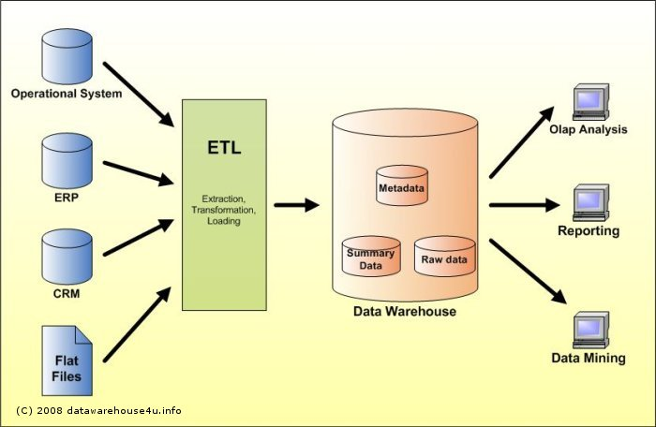
Figure 1 Data Warehouse structure and components

ANNEX 2: PROPOSED SYSTEM SPECIFICATIONS:

The system specification proposed presented at the Mission 1 final workshop on 17 October 2018 and discussed in the work group session, entails the following features

User Friendly: the new system's web pages and data entry forms, should be very simple and informative to be used by the focal points. With minimal training, they should use it correctly.

Multilingual: web pages should conform Arabic and English languages.

Dynamic: the new system should be dynamic in dealing with data and users ( i.e. add/delete/update user, add/delete/update indicator , assign/unassign indicators to stakeholders, grant/revoke user privileges ..etc.)

Authorized Access only: each user has his own authorization to his own data, no intervention between users may occur.

Secure: access to the system's content and data must be by authenticated users only; no anonymous access should be permitted for sensitive data.

Responsive: Compatible with Smart Devices, and can be used from any smart device.

High Performance: high speed in response time, to guarantee data entry to be efficient and takes less time.

Annex 3 PowerBI specifications and screenshots:

What is Power BI?
Power BI is a business analytics solution that allows visualizing data and share insights across every organizations, or embed them in their apps or websites. It permits to connect to unlimited data sources and bring data to life with live dashboards and reports. (Microsoft website)

Power BI can perform all tasks for data warehousing, starting from extracting data from several data sources, transforming data to specific format, and loading them to data warehouse.
The first screen shot shows the extracting data phase of Power BI, worth noting the several data source types that can be dealt with.
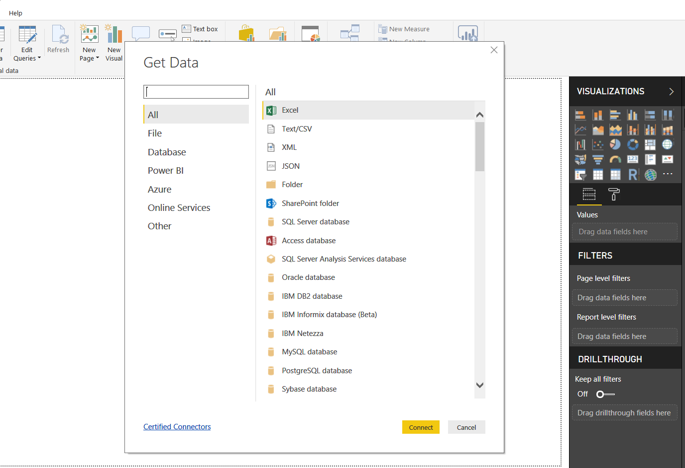
Figure 2 PowerBI extracting data from many data sources

The next screen shot provides examples of the Power BI’s capacity of typing and uploading, editing transforming, deleting, updating data and information, in specific fields.

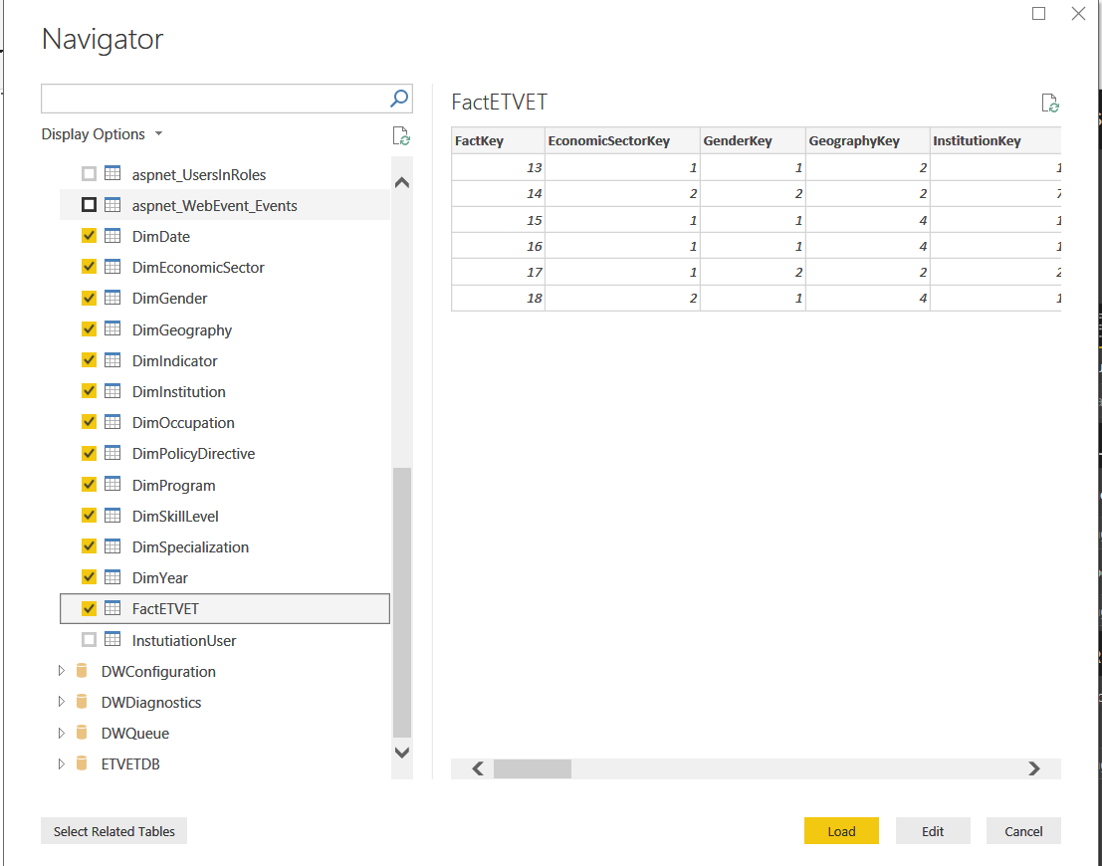
Figure 3 : PowerBI Edit/Transofrm Data.

The following screenshot shows the relation between facts and dimensions in data warehouse, which are required to generate a report.

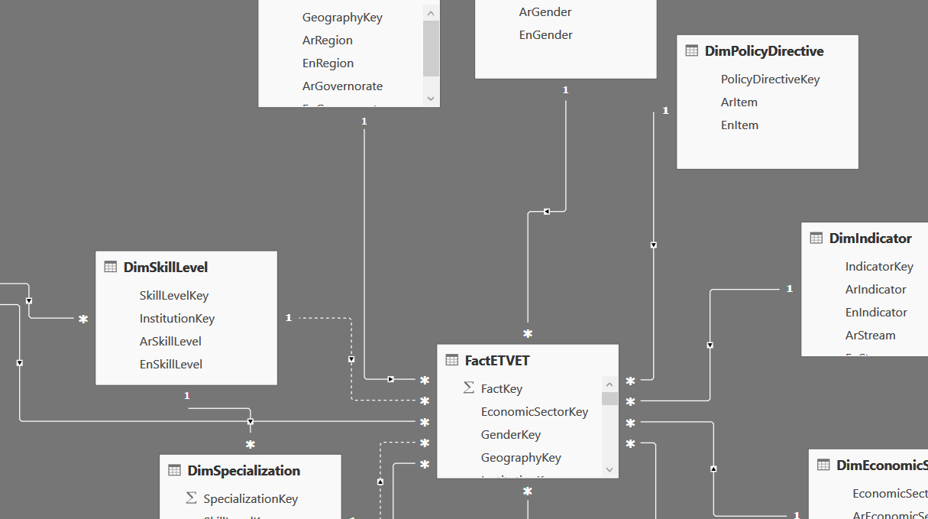
Figure 4 PowerBI relationships

The last screenshot shows how simple are the operations to generate dashboards and publish reports by using this application.

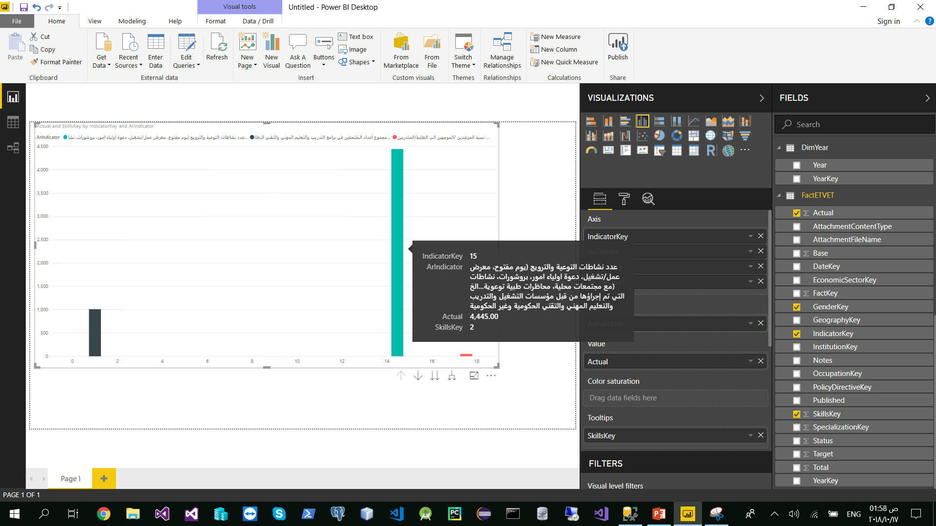
Figure 5 PowerBI Dashboard

