Campaign concept & plan

Table of Contents
Predicament 2
Factors associated to TVET image in Jordan 4
Country communication context 4
Current communication opportunities 5
Overall campaign goal 5
Specific campaign objectives 5
Strategic focus of the campaign 6
Campaign target groups 6
Segmentation of the target groups 6
Messages frame outline 10
Suggested activities and tools 13
Activity 1: TV spot production and broadcast 13
Activity 2: Use and adapt TV spots for Web 2.0 information campaigns 15
Activity 3: 6-week digital media campaign 15
Activity 4: Six-week outdoor campaign 16
Activity 5: Placement of TV interviews 17
Activity 6: Radio Spots & interviews 18
Activity 7: Design, and production of personalised Cardboard Cut-outs for schools. 18
Slogans 19
Operational work plan 20
Compliance with EU Visibility Guidelines 22
Annex I: References 23

Predicament
While Technical and vocational education and training (TVET) has a key role to play in the education and employment agenda, in Jordan and many other developing countries, yet enrolment rates in TVET are declining and many students continue to prefer to go to follow the academic higher education track as their first choice.
According to a 2015 Policy Brief, published by the Higher Population Council in Jordan:
- The percentage of students enrolled in TVET (vocational training, secondary education, technical education and under graduate education) in 2013 reached 10.3% of the total number of same level students enrolled in the education system: 13.6% males and 7.2% females.
- The ratio of unemployed TVET graduates to total unemployed labour force in Jordan reached 11.7% in 2013, with 8% representing males and 20.2% females
On the other hand, overall unemployment rates in Jordan during the fourth quarter of 2018 registered at 18.7% that’s a 0.2% increase from the same period last year: 16.9% males and 25.7% females.
This lack of attractiveness of the TVET as an educational pathway compared to academic education tracks, is thought to be linked to multiple factors. Many studies, reports, and surveys that were commissioned by international donors as well as those produced by national CSOs, public institutions and line ministries, concluded that the following factors seem to be the culprit of such predicament:
- Social stigma: Lack of encouragement from parents and family, society looking down at VET, and VET being associated with students who failed at school or dropped out, cultural barriers restricting women employment to specific trades and crafts, etc.
- Peer pressure: Low self-esteem of TVET students versus those in the academic stream
- Absence of counselling at an early stage at school: lack of clarity about the worth of TVET by students and parents
- TVET provisions not meeting labour market requirements
- Low wages offered by the private sector and workers’ rights (social security)
- The influx of migrant workers who have replaced Jordanian labour or skilled talent in many fields and sectors.
- Lack of mobility for continued education

Other factors:
- Belief that academic pathways lead to better jobs and thus higher income.
- Belief that academic pathways increase the chances in landing a job in the public sector, which is viewed as “stable” and “secure” career.
- Limited chances for women participation in TVET labour market: “Professions that are perceived as acceptable for women is extremely narrow. For example, occupations that require frequent interactions with unknown males, such as the tourism industry and the hospitality sector, are considered less appropriate, whereas employment in the government sector with well-defined rules is perceived as being more appropriate.”
- “Skills mismatches are aggravated by enrolment choices which are motivated more by prestige than by labour market demands.”
It is important to note that there are many structural challenges known to all the ETVET sector’s stakeholders that cannot be addressed through the present campaign, such as governance and policy-related issues. Thus, the present concept will aim only at addressing challenges that are related to instilling a positive image of the TVET among the target groups, as an alternative educational and professional path.
TVET image
The TVET image can be the sum of attitudes, associations and feelings about non-academic vocational education and training that people in a specific culture or community, communicate, directly or indirectly, among each other and that influence the choices of individuals who may invest in TVET. The implementation of the NQF and possibility for mobility across the systems TVET might be seen as a more attractive option.

Factors associated to TVET image in Jordan
Socio-historical
In the particular case of the Jordan, the image of TVET has some socio-historical roots, among other. According to a UNDP survey conducted in 2014 “The promise of upward mobility in the Gulf [in the1970s] encouraged both parents and school graduates to seek exclusively academic career paths, rather than vocational tracks. It is then, as envisaged by many, that a cultural shift began with regard to vocational occupations…This shift marked a decline in society’s opinion of vocational occupations, to the detriment of the labour system as a whole.”
Societal
Today, the most prevailing perception/ belief is that “every student should join the university which should be discussed at all the societal levels because some of the simple vocational tracks have a promising future far better than the future of some students who join university specializations that don’t provide job opportunities”.
Information gap-related
Also, the absence of reliable statistics and data about the income rates of those working in vocational sectors and their contribution to the overall Jordanian economy/ growth, as well as career prospects, diversity of job opportunities, advantages of self-employment, success stories, etc, reinforce beliefs that academic higher education tracks might be a better option.

Country communication context
A careful observation of the communication and interaction of Jordanians across different media channels including social ones, indicates a high degree of cynicism, trust deficit and general frustration among Jordanians, caused mainly by the deteriorating socio-economic conditions, new tax income law, rising poverty, unemployment and inflation rates, etc. Recent flash floods that caused major damage to commerce shops in downtown Amman, demonstrated to which degree Jordanians are being cynical about any move or communication coming from the government or else, including positive initiatives and measures. Jordanians seem to be in a constant state of disbelief, with an overwhelming sense of gloom that nothing is going to ever change or improve. As a reaction or survival mode, Jordanians’ use of satire to expose public institutions shortcomings and express despair, has almost become a “trademark”.
This situation makes the implementers of the present campaign more inclined towards building and diffusing the following forms of communication:
- Compassionate: emotive tone/ stories that speaks to the target audiences, creates an emotional connection in light of the current emotional disconnection
- Realistic where the used wording and tone do not imply any form of inducing high expectations or any form of idealisation of the sector
- Evidence-based: using verified data
- Visionary: showing long-term impact and improvement over time
- Light: using humour to get messages through

Current communication opportunities
- A draft law for the development of vocational and technical skills has been submitted to the parliament for endorsement. The law is expected to result in major changes that will improve the governance of the sector, accessibility to the TVET and quality of skills.
- Launch of Khedmat Watan program by the Jordanian Prime Ministry and relevant communication campaigns, constitute an important momentum to seize.
- Jordanian gov’t announced 30,000 jobs to be provided during 2019 through the Empowerment and Employment Programme.

Overall campaign goal
To improve the perception of the TVET sector in Jordan and challenge the prevailing mindset: social stigma, stereotyping, undervaluing of vocational pathways, cultural barriers, etc., and improve students’ self-esteem.

Specific campaign objectives
- Make school pupils aware of their capacities and make skill development look attractive, clean and modern, and up-grade the image of TVET from last resort path to viable occupations.
- Make TVET students aware of the spectrum of career prospects, income generating vocations, and benefits of formal VET,including data on employment in the VT trades as resulting from official tracer studies and placement results by VT institutions.
- Awaken the collective memory of Jordanians, specifically parents, to remind them of the value of vocations practiced by their parents and grandfathers, i.e. apprenticeship, etc.
- Show the bright side of TVET in terms of: “learn and gain”, good income, freelancing, widening the possibilities of employment, breaking the stereotype, etc.
- Challenge pre-defined ideas hindering women access to labour market: peer & societal pressure and relevant constructed beliefs, and encourage them and their families to work in non-traditional occupations

Strategic focus of the campaign
This campaign will focus on cognitively and affectively influencing the specific target groups and their wider social context, by supplying collective memory cues and materializing those into TV & Radio spots and Web 2.0 videos with different story themes and styles, as well as outdoor billboard and social media campaigns.
The produced spots and videos shall be powerful enough to stir, awaken and create emotional attachments to values, memories, practices that existed in the past, and that can be projected onto the present and the future. This will require the use of strong framing elements, be it in the narrative, or visualising memory ingredients, or use of catchy slogans that resonate with the various target groups, etc. This strategy will apply to all the proposed activities and shall be implemented by the different service providers.

Campaign target groups

- Students (both genders)
- Parents
- Unemployed youth
- Disadvantaged women
- Society at large

Segmentation of the target groups

Target groups | Sub-target group/s | Age | Location | Specific communication objective/s
Students  (both genders) | - School pupils starting 9th grade  - Students subjected to peer pressure  - TVET students | - yr | ‘- 12 governorates identified by the Department of Statistic’s 2010 survey as poverty pockets  ‘- Centers of Excellence in specific locations that can be identified in collaboration with the Secretariat or/and VTC | - Make school pupils aware of their capacities and make skills development look fun and modern! and uupgrade the image of TVET from last resort path to viable occupations.  - Make TVET students aware of the wide career prospects and income generating vocations , including some facts on placement
Parents | ‘- Employed couple or one in the public sector  ‘- Self-employed couple or one  ‘- Employed couple in the private sector or one  ‘- Unemployed couple  ‘- literate parents or one  ‘- illiterate parents or one  ‘- low-income parents or one  ‘- Middle-income parents or one  ‘- Educated parents or one  ‘- None-educated parents or one | 30-65 yr  30-70 yr | ‘- 12 governorates identified by the Department of Statistic’s 2010 survey as poverty pockets  ‘- Centers of Excellence in specific locations that can be identified in collaboration with the Secretariat or/and VTC | - Awaken the collective memory of Jordanians, specifically parents, to remind them of the value of vocations practiced by their parents and grandfathers, i.e.  - Show the bright side of TVET in terms of: “learn and gain”, capability of shaping raw material into useful products, good income, freelancing, widening the possibilities of employment, breaking the stereotype, etc.  - Challenge pre-defined ideas hindering women access to labour market: peer & societal pressure and relevant constructed beliefs, and encourage them and their families to work in non-traditional occupations.
Unemployed youth | ‘- Compulsory unemployed: need high-paying jobs  ‘- Compulsory unemployed: need a job but can’t find an opportunity or employer  ‘- Voluntarily unemployed: need incentives to work  ‘- Voluntarily unemployed: influenced by stigma and peer pressure  ‘-Voluntarily unemployed: waiting for a job in the public sector (social security, etc.)  ‘- TVET graduates  ‘-Drop-outs  ‘- Apprentice  TVET funding options through NAF and MIOL (Active Labour Market Measures) | 16-40 | ‘- 12 governorates identified by the Department of Statistic’s 2010 survey as poverty pockets  ‘- Centers of Excellence in specific locations that can be identified in collaboration with the Secretariat or/and VTC | - Show the bright side of TVET in terms of: “learn and gain”, good income, freelancing, capability of shaping raw material into useful products, widening the possibilities of employment, breaking the stereotype, etc.  - Challenge pre-defined ideas hindering women access to labour market: peer & societal pressure and relevant constructed beliefs, and courage them and their families to work in non-traditional occupations.
Disadvantaged women | ‘- Young women, teenagers and young adults, of disadvantaged families who have been disengaged from general education due to economic, geographic, socio-economic or other causes that prevented them from entry to formal vocational education;  TVET funding options through NAF and MIOL (Active Labour Market Measures)  ‘- Households headed by widows, divorced /separated/ deserted women are in significant numbers; and  ‘- The home workers; self-employed workers-unregistered micro enterprises; self-employed workers – market vendors, street workers; home based workers in agriculture, industry, services;  ‘- wage earners in unregulated jobs. | 16-50 | ‘- 12 governorates identified by the Department of Statistic’s 2010 survey as poverty pockets  ‘- Centers of Excellence in specific locations that can be identified in collaboration with the Secretariat or/and VTC | 2. Awaken the collective memory of Jordanians, specifically parents, to remind them of the value of vocations practiced by their parents and grandfathers, i.e. apprenticeship, etc.  3. Show the bright side of TVET in terms of: “learn and gain”, good income, capability of shaping raw material into useful products, freelancing, widening the possibilities of employment, breaking the stereotype, etc.  4. Challenge pre-defined ideas hindering women access to labour market: peer & societal pressure and relevant constructed beliefs, and courage them and their families to work in non-traditional occupations.  And up-grade the image of TVET from last resort to a path to viable occupations.
Society at large | ‘- Youth  ‘- Parents  ‘- Students  ‘- women  ‘- Employers  ‘- Decision- & policy makers  ‘- private sector  ‘- CSOs  ‘- Etc. | N/A | Across the country | All objectives

1: Department of Statistics Poverty Survey 2010, showing poverty pockets in Jordan
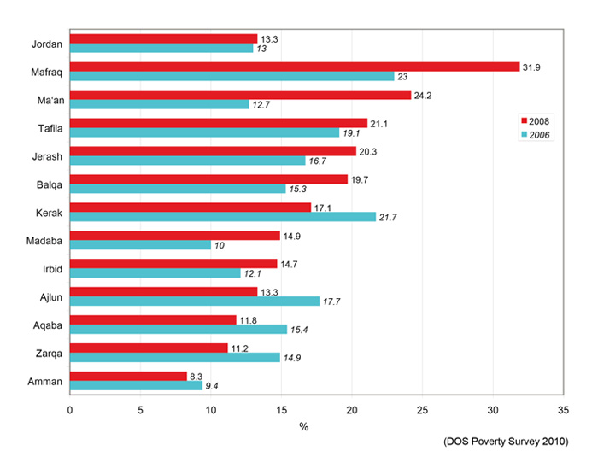

Messages frame outline
The messages are what we want all target audiences to know of, understand and embrace.

Target group | Communication objective/s | Messages frame outline
Students (both genders) | - Make school pupils aware of their capacities and make skills development look fun and modern!  - Make TVET students aware of the wide career prospects and income generating vocations | - Shying away from TVET deprives your community and country from your talents  - TVET can be about traditional crafts and modern vocations: hospitality, filmmaking, culinary arts, ICT, etc.  - TVET as an alternative pathway and not a less privileged one.  - At the end of the day you’d have a vocation that will never leave you jobless and will have a good income maybe even better than those with higher education  - certificates. TVET qualifications can give mobility in regional labour market
Parents | - Awaken the collective memory of Jordanians, specifically parents, to remind them of the value of vocations practiced by their parents and grandfathers, etc.  - Show the bright side of TVET in terms of: “learn and gain”, good income, freelancing, widening the possibilities of employment, breaking the stereotype, etc.  - Challenge pre-defined ideas hindering women access to labour market: peer & societal pressure and relevant constructed beliefs, and courage them and their families to work in non-traditional occupations. | - Apprenticeships and VET are part of our cultural heritage and identity (remember the past and envision the future)  - At the end of the day your daughter or son will have a vocation that will never leave them jobless and will have a good income maybe even better than those with higher education certificates.  - Make your children appreciate their talents and transform them into skills and jobs!  - Some women made it to untraditional jobs and vocations and are successfully supporting their families and generating income.  - Prepare your children for the world of work.
Unemployed youth | - Show the bright side of TVET in terms of: “learn and gain”, good income, freelancing, widening the possibilities of employment, breaking the stereotype, etc.  - Challenge pre-defined ideas hindering women access to labour market: peer & societal pressure and relevant constructed beliefs, and courage them and their families to work in non-traditional occupations. | - TVET can be about modern well-paid vocations: hospitality, filmmaking, culinary arts, ICT, etc.  - TVET can be an alternative pathway and not necessarily a less privileged one than this chosen by your peers!  - Make the first step to enter the job market!  - Vocations and apprenticeship can bring you a good income sometimes even better than those with higher education certificates.  - There are Engineers for instance who switched to vocational training to be able to land jobs that are needed in the market  - At the end of the day you’d have a vocation that will never leave you jobless  - Using your hands is a gift not a curse  - Vocations are freelancing, which is about freedom and better income  - Those working in vocational sector can also become entrepreneurs, e.g Aoun app, A Laundry app, etc.  - TVET qualifications can give you mobility in regional labour market
Disadvantaged women | - Challenge pre-defined ideas hindering women access to labour market: peer & societal pressure and relevant constructed beliefs, and courage them and their families to work in non-traditional occupations.  - . Awaken the collective memory of Jordanians, specifically parents, to remind them of the value of vocations practiced by their parents and grandfathers, i.e. apprenticeship, etc.  - Show the bright side of TVET in terms of: “learn and gain”, good income, freelancing, widening the possibilities of employment, breaking the stereotype, etc. | - Some women made it to untraditional jobs and vocations and are successfully supporting their families and generating income.  - Those working in vocational sector can also become entrepreneurs, e.g Aoun app, A Laundry app, etc.  - At the end of the day you’d have a vocation that will never leave you jobless  - Financial independence sets you free!  - You are equally talented and can do a lot with little means, if you harness your talents and use your creativity  - TVET qualifications can give mobility in regional labour market
Society at large | All objectives | All messages

Note: The above are messages outline that shall develop later into creative inspirational messages, slogans, hashtags, etc.

Suggested activities and tools
- Production and broadcast of TV spots
- Use and adaptation of TV spots for Web 2.0 information campaigns
- Digital media campaign
- Outdoor billboard campaign
- Placement of TV interviews
- Radio Spots
- Design, and production of personalised Cardboard Cut-outs

Activity 1: TV spot production and broadcast

Despite the growing numbers of Jordanian internauts, and those using social media and news websites as one of their main sources of information, yet TV remains the most popular medium, and “domestic Jordanian channels compete for audiences with pan-Arab stations, especially UAE-based MBC”. To ensure that nationwide communication campaigns will reach out to the diverse target groups and influence their wider social medium, TV campaigns remain an indispensable information tool.
Thus, the need to produce and air at least two TV spots during peak times on the three main local TV channels in Jordan that enjoy the highest viewership rates, or at least two of them, preferably Roya and JTV:
- Roya TV – Established in 2011 in Amman as an independent satellite channel focusing on entertainment programming, with occasional news coverage and talk shows. Roya TV has offices established in various governorates and uses a lot of cross-media channels by being actively present through social media channels as well such as You Tube, Facebook, etc.
- Al Mamlaka TV was established on July 10 2015 and launched on 16 July 2018. The TV channel is government-funded and offers public broadcasting services – it is neither state-owned nor commercial, proposing a new concept of public service information system that’s modernised and advocate for diversity and freedom of expression, with focus on local news, and live debate programmes on political, social, cultural and economic issues.
- JRTV – The state-owned broadcast network was established in 1985. In 2001, it underwent a significant restructuring process resulting in a primary channel, a dedicated sports channel and a third devoted to movies and children’s programming. JRTV has a network of local correspondents, and focuses mainly on gov’t news and local affairs.
The TV spots will be produced by a service provider according to specific terms of reference and shall address mainly the Jordanian society at large, parents, TVET students and unemployed youth. Each TV spot will be aired twice a day for a period of 6 weeks.
TV spots creative concepts
45-second influential and inspirational video spots, AJ+ video style, will be produced to make the TVET look more attractive to young students and their parents, as well as unemployed men and women, and revive the Jordanian collective memory around vocations that were practiced by their grandparents and those of their compatriots and passed on throughout many generations.
The following topics can serve as basis for more elaborate art work to be implemented by the respective service providers:
- Convince through role-models with testimonials from successful women, both who graduated from the formal and informal TVET system, or self-employed, and those working in untraditional vocations, etc. Examples of women stories working in untraditional vocations:
  - Female AC technician-Egypt
  - Female_mecanic_Jordan
  - Female petrol station-workers
- Inspire through testimonials of successful young and old men working in the vocational sector demonstrating the positive side of such pathways: better income, not having to wait for years to land a job in the public sector, pride of the socio-cultural heritage. Examples of videos identified through the Internet: Ruwanda , Jordan, Australia,
- Convince through role-models such as testimonials from Jordanian engineers for instance who have joined VET programmes to learn a vocation and increase their chances in obtaining employment or those who work with Uber and Careem Taxi services. Example of similar video story form Egypt: Doctor working as butcher
- Endorse through influential people: Script-based TV spot (staged video) to be performed with the participation of Jordanian influencers/TV icons/Royalties, etc. to address the collective memory of Jordanians and remind them of their socio-cultural heritage in terms of vocations that were performed by their grandparents an inherited by their siblings, relatives, etc.
Note: the video examples given above are examples of content and not necessarily of video styles.

Activity 2: Use and adapt TV spots for Web 2.0 information campaigns

This activity consists in adapting videos used for TV spots to be used in digital marketing campaigns across the various social media channels of SESIP, MOL and all stakeholders who are represented in the four inter-ministerial working groups: Facebook, Twitter and You Tube. Videos have proven to be #1 choice of digital marketers across the globe and are already changing how brands communicate with users, vice-versa.
The latest Cisco Visual Networking Index (VNI) Complete Forecast, estimates there will be nearly 1.9 billion Internet video users by 2021. A Go-Gulf news report published in 2017 stated that the Middle East and North Africa (MENA) region ranked second in the world by number of daily YouTube video viewed with more than 310 million views. The AJ+ documentary video style will be applied as it has proven to generate a viral impact on social media channels.

Activity 3: 6-week digital media campaign

According to the 2017 Arab Social Media Report the total number of Facebook users in Jordan per month has reached 5.80 million, and 200 000 users on Twitter. The report states that 91% access the social media via mobile devices, out of which 42% are females, while 58% were male users. Also, a recent report issued by the National Jordanian Council for Family Affairs stated that Facebook was the most popular social media channel used by families, out of which 41% of users were fathers and 36% mothers. Another survey conducted in 2017 by the Ministry of Information and Communications Technology, indicated a rise of the number of households with Internet access that reached 88.8% comparing to 80.8 % in the former year.
The statistics, are very encouraging and as such a digital marketing campaign will be launched in parallel with the TV and outdoor campaigns. The service providers will receive clear terms of reference defining the needs and techniques to be employed to ensure best results. The videos under activity 2 will be included in this campaign.
Sub-activities (activity 3)
- Infographics with high visual impact, using creative, powerful and straightforward iconography, will be produced by the SESIP EU-funded project for the digital media campaign, to illustrate key data about the contribution of TVET in the national economy, and visualize the future of the VET and its positive impact on the socio-economic evolution in the country, etc. See Figure 2.

- Six critical cartoons will be produced to break the social stigma around TVET and relevant constructed beliefs. The cartoons will be produced by local visual artists based on specific terms of reference and will be promoted across social media channels. 1 cartoon will be promoted per week. See Figure 3.

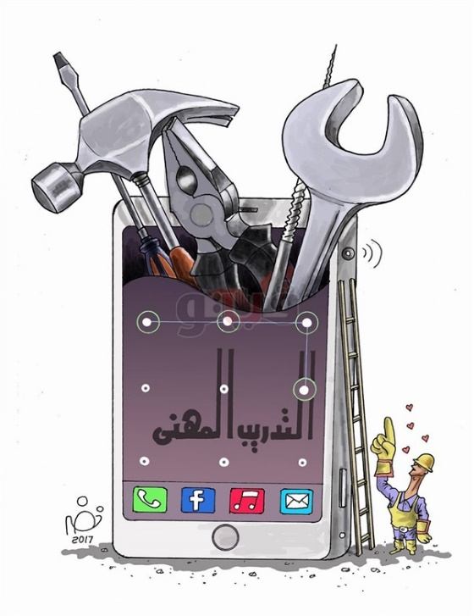
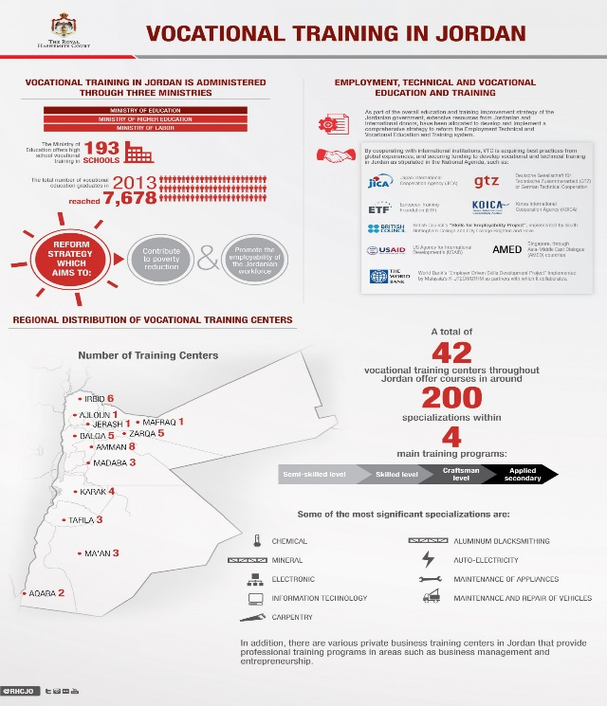
Figure 2: Infographic about TVET in Jordan Figure3: Cartoons tackling TVET

Activity 4: Six-week outdoor campaign

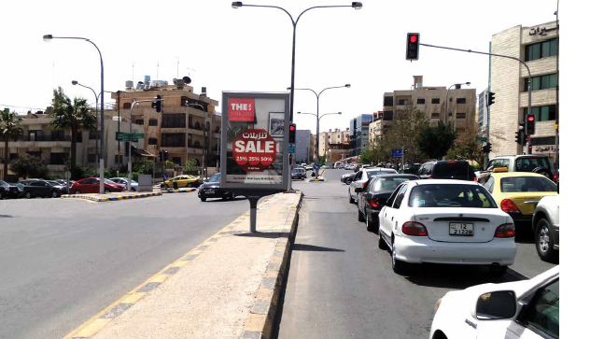
In 2017, the number of registered vehicles in Jordan was reported at 1,583,318.000, according to a CECIC report . Jordanians who don’t own cars use both public and private transportation for their mobility across the country, and tend to spend a lot of time driving, especially during traffic peak hours. Outdoor billboards cannot be ignored or missed because they are in the face of passengers and drivers in their vehicles, particularly those that are displayed at strategic and highly visible spots such as traffic lights (figure 4), busy streets and highways, etc. Billboards are strong brand-builders and in this particular case, the design of the posters should use concise clever slogans/messages, and attractive well-balanced visuals to avoid blurring the creative and strategic focus of the campaign. Billboards and wall units will be designed and installed across the 12 governorates identified by the Department of Statistic’s 2010 survey as poverty pockets, or/ as well as locations close to the Centers of Excellence that can be identified in collaboration with the Secretariat or/and VTC.
Figure 4: outdoor billboard at a traffic light

Activity 5: Placement of TV interviews
The importance of airing TV spots on Jordanian local TV stations was explained under activity one. This campaign will be further substantiated through strategic placement of interviews with the participation of the ETVET Secretariat Director, the EU Project Manager, and other ETVET Secretariat staff members as advised by the Director, and probably other sector stakeholders such as MOE and VTC, etc. The following TV shows were identified with the highest viewership:
- Roya: Donya ya Donya, Caravan, Helwa ya Donya, Nabd el Balad, 19:30 News,
- Al Mamlaka: Sabah Al Mamlaka, 19:00 News, Sawt el Mamlaka
- JTV: 20:00 News, 60 Minutes, Yesed Sabahak,

The interviews will be prepared beforehand: speaking points, key messages, topics, speakers, expected Q&A, etc. in collaboration with the ETVET Secretariat Director, MOL Spokesperson, and in close coordination with the SESIP Team Leader and the EU Project Manager.

Activity 6: Radio Spots & interviews
Despite high internet penetration rates in the country, radio continues to be an important communication tool that allows a wider outreach to people especially those residing in remote areas, without the need for internet connection. It is mainly advised to reach vulnerable groups such as the illiterate, the disabled, and the poor. Radio offers all citizens the possibility to debate and express themselves freely regardless of their education or background. It is an open platform and a practical one that you can tune in to on-the-go: while in your vehicle, public transportation, at home or at work. According to a report produced by UNESCO in 2018 “out of 40 radio stations, 14 are government owned”, and the rest are privately-owned. The same source identified the following list as being the top radios in circulation:
- Al Quran/ Jordanian, government owned, with listening percentage of (13.6%)
- Hala (12.7%)
- Rotana (11.4%0
- Amen (security) (governmental) (6.7%)
- Amman FM (5.0%)
- Hayat (3.8%)
- JBC (3.3%)
- Fann FM (3.0%)
- Yaqin (2.4%)
- Amman FM main (2.1%)
For this specific campaign, radio spots will be developed based on the produced TV spots, where the latter will be adapted into radio spots that will be broadcast at least on the top 4 radio stations. Interviews for ETVET Secretariat Director and EU Task Manager will be placed also in different radio shows.

Activity 7: Design, and production of personalised Cardboard Cut-outs for schools.

The idea is to design, and print out life-size cutouts representing various technical vocations, and have them installed at different schools and public venues. Cardboard cut-outs are fun and many people especially young ones would hurry up to take photos with their faces popping-up through the cut-outs. The images that will be used to produce the product must have the highest resolution possible, at least 300 dpi for any wide format print job. Well defined terms of reference will be prepared to outsource the services of a graphic designer and printing company. The distribution of the products will be done in collaboration with the MOL and MOE, in coordination with the ETVET Secretariat, SESIP Team Leader and the EU Project manager.
Figure 5: Examples of life-size cardboard cut-outs
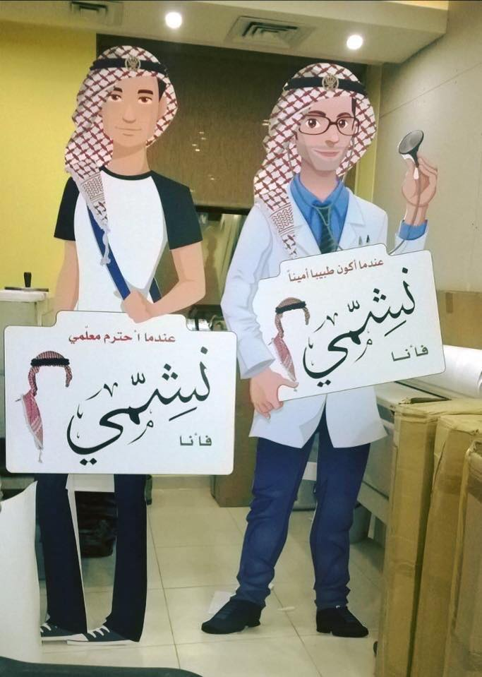 Figures 6: Example of life-size cardboard cut-outs

Slogans
Framing of the messages has to comply with the strategic focus of the campaign and make sure to borrow from popular proverbs in colloquial and/or classical Arabic, any other sources or elements from the Jordanian diverse cultural heritage or the Arabic literature, etc.
Other slogans could simply be created specifically for this campaign or borrow from inspirational leaders in the world but in that case, they have to be adapted or localized according to the local context, target groups, and communication objectives. Calls for action can be used to ignite enthusiasm, and prompt the target audience. The development of slogans must take into consideration, the country communication context, defined earlier in the present document.
The following might serve as basis for such research and proposal by the service providers:

Learn today, work tomorrow!
Find your vocation, build your future!
Learn and gain!
Stand out of the crowd!
Failure doesn’t equal TVET

Operational work plan
Activity | Technical action/s | Admin action/s | Indicative timeline
- Production and broadcast of TV spots | ‘- draft ToRs  ‘- Evaluate the submitted technical and financial offers  ‘- Review contract  ‘- Liaise with TVs for placement of spots  ‘- Coordinate with ETVET Secretariat & MoL re script, identifying testimonials and success stories  ‘- Briefing and kick off meeting with the service provider  ‘- Coordinate and follow up on the implementation and service delivery with all stakeholders  ‘- Finalise spot production  ‘- Coordinate with TVs for airing time, payments etc.  ‘- report on results and impact | ‘- Review ToRs and contact the shortlist of companies  ‘-Collect financial and technical offers  ‘- prepare contract and follow up on contractual issues  ‘- Admin overseeing and advising regarding payments schedule  ‘- suggest solutions for outsourcing and contracting services
- Use and adaptation of TV spots for Web 2.0 information campaigns | ‘- This service must be included in the original contract for the production of the TV spots.  ‘- Review contract  ‘- Coordinate with ETVET Secretariat & MoL re script, identifying testimonials and success stories  ‘- Briefing and kick off meeting with the service provider as well as with the Digital marketer  ‘- Coordinate and follow up on the implementation and service delivery with all stakeholders  ‘- Finalise spot production  ‘- Coordinate with TVs for airing time, payments etc.  ‘- report on results and impact
- Digital media campaign | ‘- Draft ToR for the digital marketer and review draft contract  ‘- kick off meeting and briefing to the service provider  ‘- revise and input to digital marketing strategy to be submitted by the service provider  ‘- review and feedback to Digital marketing content calendar for the 6-week campaign  ‘- Set and agree on KPIs  ‘- Prepare content for the infographics and coordinate the work of the graphic designer  ‘- Draft ToR to hire cartoonist, supervise and coordinate his outputs  ‘- Provide content and designs for the social media campaign: cartoons, infographics, videos, FB profile picture frames, etc.  ‘- Validation of plan, calendar and launch campaign in parallel with the other activities.  ‘- final report
- Outdoor billboard campaign | ‘- Draft ToR  ‘-review draft contract  ‘- kick off meeting and briefing to the service provider  ‘- define the needed poster sizes and networks/locations, etc.  ‘- follow ups and coordination  ‘- Final report
- Placement of TV interviews | ‘- Coordinate with MoL, TVET Secretariat, and EU PM to set up interviews calendar  ‘- Draft ToR  ‘- Review draft contract  ‘-Contribute to preparing speaking points/messages and speakers  ‘- Coordination and follow ups  ‘- Final report
- Design, and production of personalised Cardboard Cut-outs | ‘- Identify service providers  ‘- Draft ToR  ‘- Build a list of schools and venues where products will be installed  ‘- check site  ‘- Coordinate work: design, quality, finalisation  ‘- report
Timeline Campaign | Draft timeline for the implementation of the entire campaign + budget

Compliance with EU Visibility Guidelines
Any communication on EU-funded external actions must be consistent with the Union’s values and political priorities and with other EU-related communication activities and events. While raising awareness of the external policies and actions of the Union in its role as a global player, these guidelines also provide accountability and transparency on the use of EU funds to taxpayers and the citizens of partner countries. Thus, promotional materials, publications produced including website, animated movie, roll-ups, leaflets, etc., financed within the framework of this campaign, should be compliant with the European Union visibility guidelines, recently updated in 2018 and titled “Communication and Visibility in EU-financed external actions”. This manual can be downloaded at the following address: https://ec.europa.eu/europeaid/sites/devco/files/communication-visibility-requirements-2018_en.pdf

Annex I: References

- Online Desk work: identifying good practices, news reports, video samples, pictures, illustrations, statistics, etc.
- ETF: Employment Policies in Jordan, 2014
- Mapping Vocational Education and Training Governance in Jordan, GEMM, European Training Foundation, 2014
- The Jordan National E-TVET Strategy 2014
- Reasons for avoidance of vocational education in Jordan 2016, Mon’im A. Al-Saaideh
- Promoting efforts aiming at increasing the economic participation of Jordanian women, by Phenix Center for Economics and Informatics Studies, January 2014.
- Labour Market: The Case of Vocational Training in Jordan
- Youth in Jordan: Transitions from Education to Employment, © Copyright 2014 RAND Corporation
- Virtual conference report on Improving the image of TVET UNESCO-UNEVOC TVET Forum, 16 to 24 July 2018
- Promoting youth employment and empowerment of young women in Jordan: An assessment of active labour market policies, Copyright © International Labour Organization 2017
- Youth Well-being: Policy Review of Jordan, © OECD Development Centre (2018)

-End-

2015 Policy Brief, Higher Population Council- Jordan https://www.hpc.org.jo/sites/default/files/Technical%20education%20training-Policy%20brief.pdf
News quoting recent statistics announced by DOS http://www.ammonnews.net/article/440585?fbclid =IwAR1qIOFIGn9ZXruFt95-uUEKsUrVwmV_TeJRmjN0GejcdMU7xhsxiynoSng
A bibliography is included in annex 1
Promoting youth employment and empowerment of young women in Jordan, Copyright © International Labour Organization 2017
Promoting youth employment and empowerment of young women in Jordan, Copyright © International Labour Organization 2017
Labour Market: The Case of Vocational Training in Jordan
Reasons for avoidance of vocational education in Jordan (2016), by Mon’im A. Al-Saaideh
Khedmat Watan” is a non-compulsory program for youth aged between 18-27 and aims at training and qualifying about 20,000 of those who have not been lucky enough to obtain a career in order for them to get jobs in the targeted sectors, including industry, construction and tourism, and in cooperation with the Jordanian Armed Forces.
“The program shall reduce unemployment rates in saturated specialisations, attract national workers, increase women’s participation in the labour market, expand recruitment programmes in cooperation with the private sector, encourage entrepreneurial work and support the business environment” http://jordantimes.com/news/local/ministry-provide-employment-programme-jobs-coordination-govt-private-sector
Excerpt taken from reasons for avoidance of vocational education in Jordan (2016), by Mon’im A. Al-Saaideh: “The most influential item in the social reasons was “My colleagues‟ attitudes discourage from joining VE‟. This shows the great deal of students being influenced by their peers‟ attitudes which are originally influenced by the society and family attitudes to which these peers belong. A student may feel inferior if s/he saw his colleagues‟ orientation towards academic education while s/he joins the VE.”
Mafraq,Ma’an, Tafila, Jerash, Balqa, Kerak, Irbid, Madaba, Ajlun, Aqaba, Zarqa
Mafraq,Ma’an, Tafila, Jerash, Balqa, Kerak, Irbid, Madaba, Ajlun, Aqaba, Zarqa
Mafraq,Ma’an, Tafila, Jerash, Balqa, Kerak, Irbid, Madaba, Ajlun, Aqaba, Zarqa
The Jordan National ETVET Strategy
Mafraq,Ma’an, Tafila, Jerash, Balqa, Kerak, Irbid, Madaba, Ajlun, Aqaba, Zarqa
https://www.bbc.com/news/world-middle-east-14636310
http://www.unesco.org/new/fileadmin/MULTIMEDIA/FIELD/Amman/pdf/Gender_in_Media_EN_25062018.pdf

