TECHNICAL ASSISTANCE PROJECT

“Skills for Employment and Social Inclusion Programme”
Conceptual paper

The conceptual framework of the M&E and ICT system of E-TVET Council
Under activity 1.1.6, 1.1.7
developed by
Marek Radvansky, IER SAS,

version 1.0
Amman, 4/12/2018

Content

List of Abbreviations 3
Introduction 4
Monitoring and evaluation system at ETVET council 4
Rationale and objective 4
Structure of TVET M&E system 5
Strategic framework of M&E system 6
Institutional typology of ETVET sector 7
Structure of proposed M&E system 9
Main elements of proposed M&E system 10
Funding of the ETVET sector 11
Proposed structure of ETVET M&E system 12
The role of focal points at ETVET monitoring 13
Performance Indicator Cards 13
Tools and the methods of M&E system 15
Evaluation 16
Setting / adjusting targets for indicators Error! Bookmark not defined.
Disseminating information 16
TVET council meetings Error! Bookmark not defined.
Time frame 19
Recommendations: 20
Annexes 21
Code lists related to KPIs 21

List of Abbreviations

EU European Union
DoS Department of Statistics, Jordan
GIZ Die Deutsche Gesellschaft für Internationale Zusammenarbeit (GIZ) GmbH
NET National Employment and Training Company
MoL Ministry of Labour
LMIS Labour Market Information System
VET Vocational Education and Training
TVET Technical and Vocational Education and Training
ETVET Employment, Technical and Vocational Education and Training
M&E Monitoring and Evaluation
PMS Performance Management System
VTC Vocational Training Corporation
KPI Key performance indicator
PIC Performance indicator card
BAU Al- Balqa' Applied University
CAQA Centre for Accreditation and Quality Assurance
SSC Social Security Company

Introduction

Effective Monitoring and Evaluation system (M&E) is an essential part of improving the ETVET sector in Jordan. The updated M&E system should support the role of the ETVET Council as coordinating body responsible for providing managerial and technical support related to the ETVET strategies in order to accomplish its main tasks. The national task should deal with issues related to employment policies at the national scale, improving the ETVET standards, and providing job opportunities that help in developing human resources to cope with the requirements of the socio-economic development in the Hashemite Kingdom of Jordan.
The scope of this conceptual paper is to present the Conceptual framework of the M&E and ICT system of the ETVET Council. This framework discusses main components and phases of an M&E system, its objectives and expected results, the indicators of results and the tools and the methods for collecting, processing, analysing and disseminating this information. The main findings related to the ETVET sector development and based on information provided by relevant stakeholders (ETVET focal points) are gradually concluded in M&E reports regularly provided by the ETVET Council.
The purpose of this report is to provide an overview of the proposed updates of the ETVET Council M&E system to all partners and relevant stakeholders, as well as the ETVET focal points as main reporting units and data providers.

Monitoring and evaluation system at ETVET council
The presented framework of the M&E system provides the approach and structure for monitoring and evaluating of the sectoral development in line with key ETVET policies and strategies. The current monitoring system is output based and mainly observes the past development. The main adjustments should aim towards the main objective of ETVET M&E system, thus providing a comprehensive picture of the sector development, primarily related to the information about the size of the sector (enrolment, graduates and the structure of providers) and its importance in the Jordan education sector with implications to the development of the labour market. Despite the best effort of the ETVET Council, information about the overall number of TVET participants related to the short-term programs is still limited. Additionally, mapping and evaluating relevant policies, system performance, ETVET infrastructure, related costs and the role of all stakeholders (not only council members) should be an essential part of this system.

Rationale and objective

Application of the proper M&E system should result in providing better information and understanding of the effects related to the applied measures. The obtained information can be used not only by the TVET Council itself but can be useful also to the training providers and other TVET stakeholders as well as for the government and policymakers to make well-informed decisions. The current state of the monitoring system could not provide a deeper understanding as it is strongly output based. Therefore, the further development of the system with a focus on the quality criteria and more targeted outcomes of the TVET system in Jordan should be done.
According to the UN definition (United Nations Evaluation Group), Monitoring is the systematic process of collecting, analysing and using the information to track a programme’s (strategy) progress towards reaching its objectives and guiding the management decisions. Monitoring usually focuses on processes, such as when and where activities occur, who delivers them and how many people or entities they reach. Monitoring is conducted since the beginning of program implementation and continues throughout the programme implementation period. As a process, monitoring system systematically collects data against specified indicators at each stage of the programme or project cycle; providing evidence-based reporting on programme progress at every stage, relative to respective targets and outcomes.
Evaluation is the systematic assessment of activity within programme, strategy, policy, topic, theme, sector, operational area or institution’s performance. Evaluation focuses on expected and achieved accomplishments, examining the results chain (inputs, activities, outputs, outcomes and impacts), processes, contextual factors and causality, in order to understand achievements or the lack of achievements. The evaluation aims at determining the relevance, impact, effectiveness, efficiency and sustainability of interventions and the contributions of the intervention to the results achieved. An evaluation should provide evidence-based information that is credible, reliable and useful. Findings, recommendations and lessons of the evaluation should be used to inform the future decision-making processes regarding the programmes and sector.
From the definitions above, it is clear that understanding and applying both roles of the M&E system are crucial for useful application and utilisation of the system to support the Jordan ETVET system. Continuous transition from an output based monitoring system towards outcome-based monitoring system could also significantly increase the quality of the monitored measures covered by the sector relevant strategies. A systematic approach will require the continuous increase of the data quality and high level of the engagement of all involved institutions. Applications of well-established quality PDCA loop (plan; do; check; act) will lead to constant improvement of the system in all its aspects. Evaluation part of the system is currently somewhat limited, and its mostly aimed towards descriptive and qualitative assessments of the current achievements, past and expected development related to strategic goals.

Structure of TVET M&E system

Further development of TVET council M&E system should be aimed towards two main directions. Within the monitoring system, stronger involvement of council members should be done via utilising redesigned ICT tool containing main information related to the key indicators of the TVET sector. More effective transfer of knowledge related to the current development and sector achievements can shorten the period of (policy) reaction. Additionally, an efficient ICT system could significantly decline the effort needed for reporting and data gathering both for reporting institution as well as TVET council. Saved time can be diverted more effectively to the evaluation part and recommendation for target and policy adjustment. Increasing the efficiency of the M&E system should be one of the priorities of all involved institutions and TVET council, mainly due to limited (lack of) capacities in these institutions (based on information from all previously available assessments).
Secondly, TVET council is responsible for providing an integrated picture of the whole TVET sector. Therefore its role is to gather, analyse and provide information about the development of the sector, despite its fragmentation on the level of providers, funding and governance. It is necessary to stress out, that evaluation of provided information enables the Secretariat of the ETVET Council to fulfil its main function: strategic planning and evidence-based and results-oriented steering of the sector. In addition, control and reporting function will serve as a tool to support higher levels of accessibility, transparency and efficiency by all the ETVET sector training providers and stakeholders.
From dissemination perspective, the results and recommendations from ETVET council should be efficiently disseminated mainly in the form of reports and briefs across all stakeholders (members, institutions and professionals). The role of the M&E units within participating organisations should also not to be taken just as reporting units, but also their findings and recommendations based on internal results should be taken into consideration in the M&E process. The proper way of processing this information should also be discussed and incorporated into the system.

Strategic framework of M&E system
Monitoring and evaluation of the ETVET sector should be done in relevance to the key strategies. There are four strategies at with close relevance to the sector:
- National strategy for Human Resource development 2016-2025
- The Jordan National E-TVET Strategy 2014-2020
- Jordan’s National Employment Strategy 2011-2020
- Jordan vision 2025
We follow the current ETVET strategy in redefining the structure of the M&E report as well as clustering of the Performance Indicators, as the core strategic document of ETVET sector since its adoption in 2014. In line with the structure of strategy, the performance indicators (input, output and outcome) were suggested for main pillars (and the clear link to the targets).
The current version of the strategy has five core pillars (Figure 1):
- Governance
- Relevance of Education and Training for Employability
- Increased Inclusiveness of the TVET System
- Performance Measurement
- Sustainable and Effective Funding

The detail description of the legislative framework can be found in project technical reports.
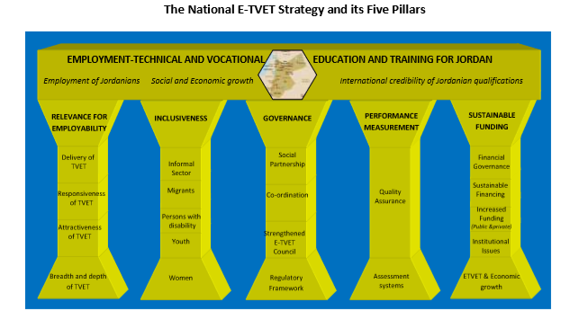
Figure 1 - The National E-TVET Strategy Pillars (2014)

Institutional typology of the ETVET sector

The ETVET sector consists of four main types of stakeholders responsible for different parts of ETVET sector and their role in the M&E system. Providers (public and private) are responsible for training and education in regular and short-term TVET programs. The funding authorities consist from public one (TVET fund, Budgetary department, NAF), national private donors (such as employers association, industries and individuals) as well as external (UN, EU, GIZ…). The third important group of ETVET council members consist of social partners (Trade unions, Chambers, Industries), which can utilise the results of the training and education system in the form of qualified employees. The specific role is taken by governmental authorities responsible for the basic function of the system, such as accreditation or legislative framework (MoL, MoE, CAQA, AQESHI). All stakeholders have an essential role in the system and could take a role of a reporting unit in relation to the national (or program) framework.
Some institutions can play a significant role in several parts of the sector. For example, the main role of chambers and employers’ associations (commerce, industry, tourism) is usually related to labour demand, thus as employers. Additionally, they can provide funds for providers to obtain employers with certain skill through TVET education. In this case, they will play the role of funding organisations. Some employers and associations could establish their own training facilities, and within the system, they will be considered as providers as well. Due to this reason, there should be a clear distinction between the roles of stakeholders and their relation to the M&E system to avoid double counting on the one side and underreporting on the other side. From the main point of view related to the sector outcome (employment with VET education and graduates from regular and short-term programs), the role of providers should be crucial. As a total outcome of the system, only the graduates from officially accredited programs (by CAQA and AQESHI) should be considered. Other VET education aimed to gain additional VET related skills would be considered as informal education. The significance and the structure of informal education could be part of the monitoring system in following years (aimed surveys usually take the measuring), but it does not take an essential role in proposed M&E system.
Figure 2 - Institutional typology of the ETVET sector

The group of institutions representing all type of stakeholders was selected as focal points (cooperating and reporting units) to comprise monitoring and evaluation system of TVET sector. The reporting role must be obligatory to ensure the necessary degree of cooperation in the compilation of VET data. The number of involved stakeholders as focal points is also gradually increasing to a possible coverage of the sector.
Figure 3 - ETVET council focal points
The most important indicators for the TVET sector are those related to the number of students and graduates in the sector. The main indicators of long-term programs are largely covered by the main public service providers (the Ministry of Education, VTC) and provide a relatively comprehensive picture of those. In addition to public providers, several dozen private providers operate in the vocational education sector, particularly in short-term programs. TVET council currently involves the largest institutions in the provision of vocational education at secondary and tertiary levels (NET, Luminous, Al Balqa, etc.). As far as possible, additional relevant information is being addressed by continuous involving of other major stakeholders such as Khawarismi College. Obviously, involving all private institutions to cover the sector is very demanding and costly.
For this reason, additional data from other sources (such as funding organisations, accreditation institutions, etc.) will also be needed to get a comprehensive picture of the sector. These data sources about students are overlapping with each other. In order to avoid this problem, data from other sources than from the providers should be deeply analysed to provide the best estimate without the possibility of multiple counting of students (and other outputs and outcomes). From the point of view related to graduates, certification authorities are one of the main important data sources, which can also provide information on certificates and diplomas awarded. At least a formal check has to be provided with another relevant institution – the Social insurance company to cover the outcomes of the system related to a number of employed persons (employability) from certain programs. Therefore also this institution can be addressed as one of the focal points.
All reporting units play a role in the ETVET sector and should follow an individual as well as sectoral priorities. If possible, the individual stakeholders should also provide additional information related to the reported KPIs, mainly to describe the individual development, causes and conditions related to the past development. This qualitative information can provide a valuable information for the evaluator and should be considered in the assessment phase. This supplementary information is often essential to provide a good judgement according to the causes leading to the current development of the system. It is clear that the development is related to the objective and subjective causes. These causes can last an only a short time (with minimal affection to long-term targets) or can be symptomatic for more serious structural change, which can require more serious policy action.

Structure of proposed M&E system

The ETVET sector in Jordan can be perceived in several levels. As it was mentioned in the strategic framework, one of the main targets of TVET council M&E system is to provide an overview of the sector as a whole, thus on the national level. From the perspective of the VET education, the second level of evaluation would be the level of providers, thus institutions responsible for outcomes. Taking into consideration the current monitoring system and capacities of TVET council M&E unit, the level of providers could remain covered by internal M&E units of individual providers. On a secondary level, MoE is responsible for covering and supervising the regular TVET programs. From the perspective of short-term programs, there is a limited comparability across providers (public, private) about the structure, length and regional coverage of programs. Therefore, TVET M&E unit should additionally concentrate (in cooperation with accrediting organisations) its tasks on the activity level of the TVET system, thus level of programs. The lowest level (level of individuals) completes the overview of the system. On this level, individual decisions are being made, such as decisions related to the choice of provider and the program. This level is being addressed by providers to gain their sector market share.
Figure 4 - Levels of Monitoring and Evaluation system

Main elements of the proposed M&E system

A systematic approach to monitoring and evaluation should follow the sequence of individual logical steps. The monitoring and evaluation (as we understand from the definition) are a key part of the broader defined Performance management system (Figure X). For the purpose of the system clarity, we can define several following steps within the PMS:
- The primary task of the ETVET council M&E unit is the collection of data defined by KPI cards. Each card defines several types of indicators in a different depth structure to be obtained from the stakeholders defined in the previous section. To simplify the data collection, a new ICT tool providing the simplest possible solution for all reporting units has been developed. This tool has a web interface and the ability to upload data using a predefined MS Excel file.
- After obtaining all the necessary data, it is possible to continue with monitoring of the ETVET sector. Within the monitoring, aggregated information from all focal points so that key information on the size, structure and development of the sector can be provided. Monitoring can be based on observations about the current state or use advanced data tools to identify the key changes. For this purpose, the IT system for collecting data, the so-called business intelligence. Monitoring also includes a basic comparison of the status and development of individual data with the objectives of the key strategies and objectives.
- After creating a comprehensive overview of the ETVET sector, the evaluation task comes at a glance. Within the evaluation, individual outputs and outcomes are identified. It is important to analyse contextual factors and causality, in order to understand achievements or lack of achievements. That means that it is necessary to identify the individual types of inputs into the system and their effect on the total output. Here, it is possible to evaluate their effectiveness and relevance regarding individual strategic objectives. At the same time, when assessing the achievement of the goal, consideration should be given to the sustainability of inputs (e.g. financing) and outputs of individual elements of the monitored system in relation to the identified objectives.
- The final step after formulating the recommendations and adjusting the goals is the transformation of these findings into a final evaluation – policy assessment. This phase involves reviewing the goals (redefining or creating new ones) and describing the key achievements. In this context, it is necessary to provide the findings in the way, that they can be individually addressed including the proposition of the precisely targeted measures at the policy level.
Figure 5 - Main elements (steps) of the Performance measurement system

Funding the ETVET sector

Financing the ETVET sector is one of the key inputs that underpin its performance. From the system sustainability point of view, it is necessary to provide a basic overview of resources and their use. It is clear that, in order to achieve comparable results and sustainable development of TVET provision, the most appropriate is a continuous funding relevant to the objectives set at the sectoral and individual level. In the case of the ETVET sector in Jordan, the situation is, besides the long-term programs provided within the network of schools under the MoE, rather complicated. The main source of funding is the sources allocated through ETVET Fund, whose are predominantly generated as a share of Working Permits cost. The sources obtained through this channel are relatively volatile and do not allow long-term planning of the development of any supported program. Also, such a resource is pro-cyclical regarding economic development, with education (including supplementary and short-term programs) often playing the role of counter-cyclical action. Another important source of funding, especially for private providers of TVET, are donors. A separate strategy (Donor Coordination Strategy for the E-TVET Sector in Jordan) is devoted to this specific area. At present, very poorly used funding for short-term education programs are active labour market measures (ALMM), thus programs mostly funded through the National Aid Fund (NAF). VTC provides most of the currently contracted programs. However, in the terms of ALMM, the role and responsibility of individual sectors in the unemployment support system remain relatively unclear. Another part of the Technical Assistance is dedicated to this area.
Figure 6 – Basic scheme of ETVET funding sources

The proposed structure of ETVET M&E system

Based on the previous discussion and current legislative framework, the proposed structure of the M&E system of ETVET sector can be provided (Figure 7). The responsible institution for providing M&E of TVET sector is the Monitoring and Evaluation Unit of ETVET Council secretariat. Secretariat is addressing all relevant stakeholders (focal points) with a query to obtain the crucial information related to the sector. Most of the focal points have institutional M&E units responsible for analysis on an institutional level and which are able to provide requested data described at KPI cards. These data should be reported and processed through the TVET council ICT monitoring system (and can be accessed by related institution also for own analytical purposes). After processing the data provided by focal points, M&E unit of ETVET council secretariat can compile and analyse the data about strategic targets in system and activity level. This analysis is provided in the form of the TVET sector yearly report. The next step is related to reviewing the sector achievements and proposing the recommendations. If necessary, the proposal for updating targets, strategies or policies should be made to ensure proper reaction to current development.
Additionally, M&E can propose adjusting of priorities, if a meeting of the goals can be achieved by relatively simple adjustment of any stakeholder behaviour. The conclusion of these findings should be provided together with other qualitative assessment (at all levels including comments of stakeholders, if they are relevant) at the yearly M&E report. The findings, recommendations and updates should be further utilized in a regular update of ETVET council action plan (every 1-2 years). Both reports (and other supplements) should be further discussed at ETVET council (and through policy level) to discuss further actions in order to ensure sustainable development of ETVET sector in the desired direction.
Figure 7 – Proposed structure of the M&E system of ETVET sector
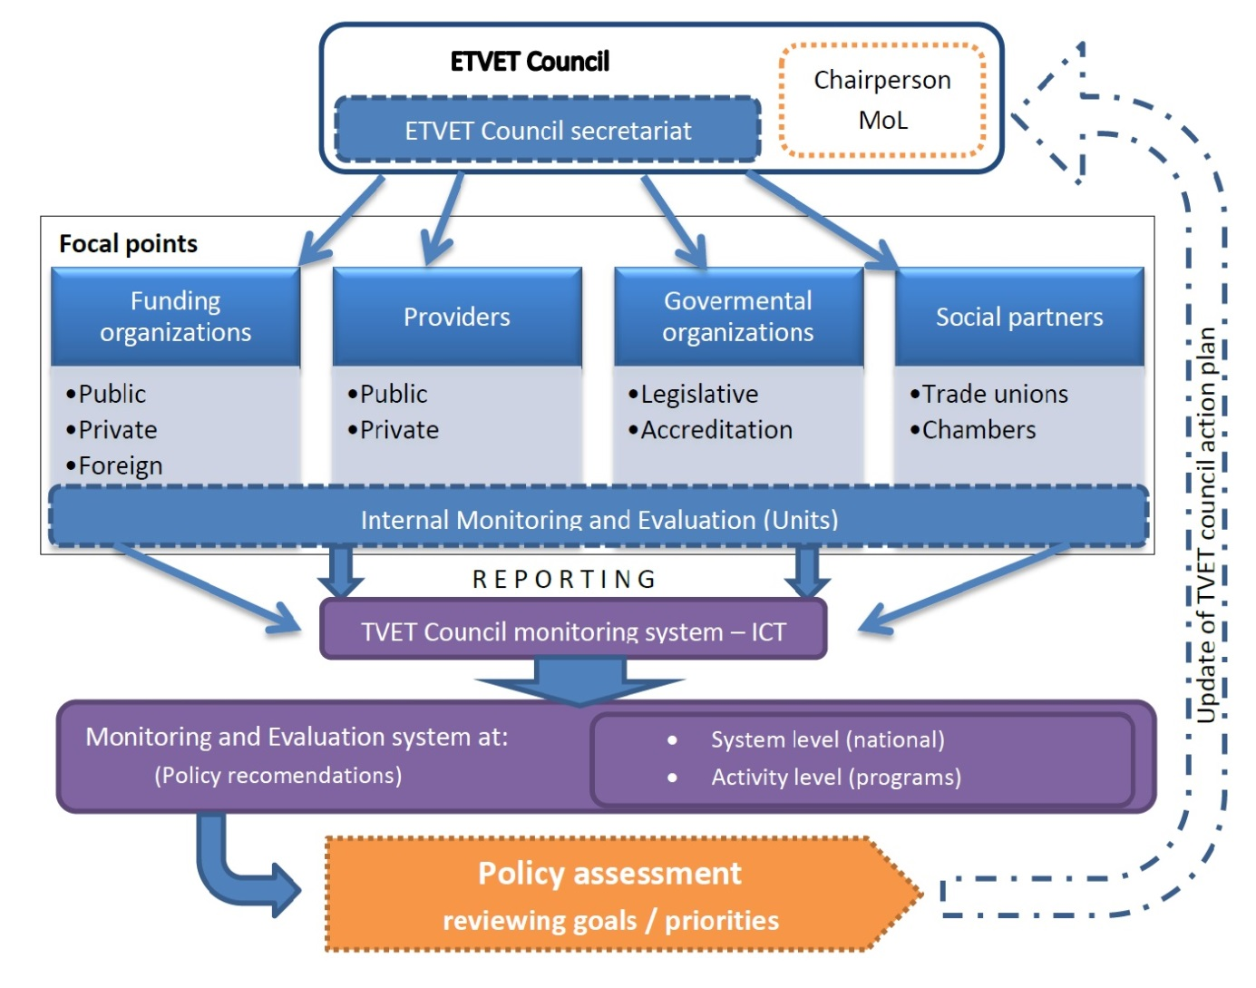

ETVET monitoring and evaluation

Performance Indicator Cards
The previous technical report was aimed at the analysis of an existing PMS system. The major part was devoted to the development and updating of the set of the Key Performance Indicator within the logic of the current strategies. The group of twenty-two KPI cards was provided in line to provide a comprehensive picture of the TVET sector (Figure 8). It was stressed out, that despite the relatively clear structure of the indicators and the scope of the cards, problem with measurability or comparability can arise. Therefore, set of proposed indicators have to be taken as open, and should allow flexible amendment from the side of TVET council in relation to obtain required information to cover/obtain all relevant data in line with their M&E role in PMS system. Moreover, one indicator card can cover a set of tables/information in relevance to its content, thus not only one information (data) is provided within a card.
Figure 8 – The role of the indicators in the strategy pillars structure after clustering
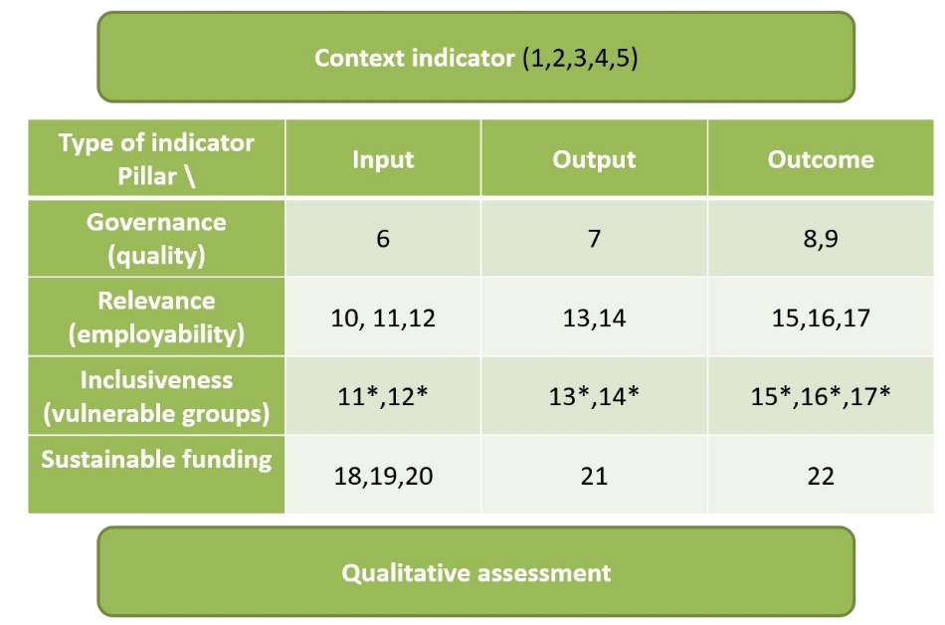

The necessity of providing relatively “rich” information by each indicator to serve both monitoring and evaluation tasks is crucial. Therefore, several queries are usually related to each card (please consult the chapter Reporting to the M&E system). From the reporting point of view, several types of indicators are on place. Each particular set of indicators should be provided by a different type (or group) of institutions. The simple logic behind the set of indicators can be observed in Figure 9.
There are four main groups of indicators at the proposed system. First set of indicators (1-5) provides contextual information about the background of the system – the current situation and development of the labour market including information about structural changes related to the employability of graduates. Department of Statistics and the Ministry of Labour are responsible for reporting of these indicators. The second group of indicators (6-10) is related to governance, thus how is the system managed in relation to the main concern. The crucial information related to the ETVET sector are listed in the third group – VET provision. This information is mainly reported by providers, but to gain more comprehensive picture also additional information from accreditation authorities, and funding organizations can be requested. The fourth group is related to the funding of the system. All these information together represent a basic network of indicators and is crucial for a proper evaluation of the system development.
Figure 9 - List of Indicator Cards and their main context
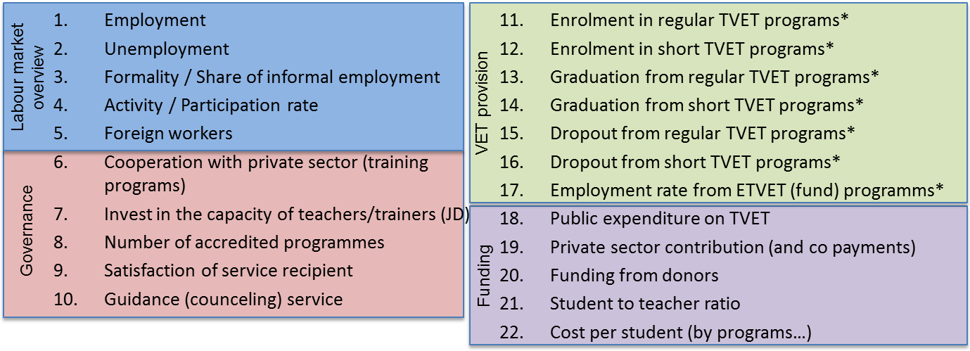

ICT tool and the methods

Due to the major obstacles related to the utilisation of previously developed ICT system at TVET council secretariat (see technical report), a new tool has been proposed and developed from scratch. The new tool provides a flexible solution for data gathering and processing while utilising the most up to date open source software. ICT tool including documentation can ensure long-term sustainability in maintaining and updating. Data warehouse using SQL database is fully transferable if needed.
Proposed ICT tool is visually provided as a website with individualised access and localisation for each individual focal point to ensure data security. With some adjustments, the core of the system can be provided as a project output to the stakeholders, if they are willing to use it as their internal M&E tool. In this case, the reporting to the ETVET Council secretariat could be nearly automatized. Otherwise, there are two possibilities for focal points to upload the data. First is uploading through the website interface, which is convenient for relative short queries. If more complicated data structure are requested, the predefined excel sheet can be download and update back later after the data preparation. In this case, two-stage controlling (approval) of data validity is on the place, including options for attaching qualitative justification in text form related to each requested indicator.
To conclude, the new ICT tool is able to provide comprehensive options for:
- data gathering (collecting) base on indicator setting (core functions)
- data processing (e.g. aggregation, structuring, formatting)
- data analysis (providing options for various analysis)
- Reporting (providing structure graphs, tables)
It is obvious, that newly developed system and structure of KPI cards will have limited backwards-looking information. The previous M&E reports provide mainly aggregated data in the much simpler structure. If the information in this report is fully in line with the requested data, it is suitable to update them into the system also for the past at least on the aggregate levels. That allows at least some comparison of the past ETVET sector development.
The business intelligence extension provides many descriptive and analytical options to observe various data dependencies and provide proper support for creating recommendations and decision making process by the evaluator (as „smart Excel“). The observation of the current state and development of the sector is further compared to the baseline and target values. As the baseline we understand first known observation related to the strategy or KPI, thus for current strategy, the data should be compared to the base year 2013, or any available data since this period, if 2013 is not available. BI tool can combine analytical part together with descriptive information provided by focal points and M&E unit (evaluator). The final output will be the drafted M&E / yearly report.

Evaluation

The evaluation represents the part of the system, where most precious information can be obtained. Monitoring itself provides just general observations about the current state and development of the system. Evaluation is “digging” much deeper and tries to explain the caused and obstacles related to observed development. This assessment needs to be done on all monitored levels, thus at the level of the system and programs. Obtained information must be particularly credible and useful so that individual findings can be transformed into appropriate recommendations. In the case of long-term goals, it is possible to determine whether the current trajectory can achieve these goals or to focus on activating some of the elements in the system (e.g. regarding effectiveness). Recommendations can also be targeted at individual stakeholders. If it is clear that the situation in the sector has changed or the long-term goals are not realistic regarding the current relevant factors, it is needed to adjust the objectives, for example. At a lower level, individual problematic programs can be identified (need to change focus, financing, etc.).
From the context point of view, we can evaluate progress towards the strategic goals, system outcomes and policy impact. Moreover, the evaluation should incorporate all relevant assessment questions at the ETVET sector and council. Therefore, besides regular evaluation and reporting, an additional ad-hoc evaluation should be prepared in special cases, such as evaluation of Indicators of ongoing financial agreement with European Union, evaluation of the performance of individual providers (if requested) or other relevant reporting requirements (e.g. government, donors).
Results of evaluation can also be directly incorporated as an adjustment (fine-tuning) of current system setting, by review of the goals and priorities, regular update of action plan or general recommendations and conclusions. If an underperformance caused by an external factor is observed, the extent and expected impact of these factors should be discussed. High-quality, evidence-based reporting is also essential for promoting sectoral interest at the national policy level if needed (e.g. in adjustments of sector funding).

Disseminating information

There are two main regular yearly reports provided under the coordination of the E-TVET Council Secretariat monitoring and evaluate the progress towards the E-TVET Strategy:
Regular M&E reports provided by ETVET council
- Performance Evaluation Report of the Jordanian E-TVET Sector
- E-TVET Council Annual Report
These reports should incorporate assessment on both system and national level. As is was discussed before, reporting system also considers any ad-hoc evaluation (e.g. Report on financial agreement). Some of the reports are not aimed at a wider audience nor published. From the point of dissemination to public and to protect sector best interest (e.g. improving public opinion and perception of TVET sector to ensure higher enrolment..), the information from M&E system can also be reported differently. A good example is providing policy briefs (for professionals) and communications about sectoral achievements (for public). The role of these narrow oriented reports is to stress one or more details to ensure support in any decision-making process.
The main channel of disseminating findings from M&E system is through reporting to the ETVET council (and focal points), where more detail information can also be shared in the way of formal and informal meetings or negotiations.

Reporting to the M&E system

All focal points should be obliged to provide relevant information related to ETVET sector in their sphere of activity. The description and the structure of requested data including relevant institution and the data gathering are described at the set of KPI cards. One of the main goals of the updated M&E system was to make the way of data reporting as simple as possible. On the other hand, the provided information should be “rich” to ensure its analytical value for the evaluator and should cover almost all main strategic targets. Each indicator is defined by the list of attributes and dimensions to cope with its purpose. The example of code lists related to attribute is provided at Figure 10.
For each KPI, several dimensions have to be provided. Otherwise, the information could not serve for analytical purposes and would provide very limited information for performance assessment. That also means, that one KPI can also consist of several sub-tables and these can also be provided by different type of institutions (please also consult the Annex). It is necessary to stress out, that no individual (or sensitive) information are gathered or disseminated via this system. As it was pointed out, the reporting process should be beneficiary both for reporting institution as well as TVET council M&E purpose. Therefore, the reported data could also serve for focal point internal M&E system purposes (even with the possible utilisation of introduced ICT tool).
Figure 10 – Example of code lists for KPI Number of programs and Level of satisfaction
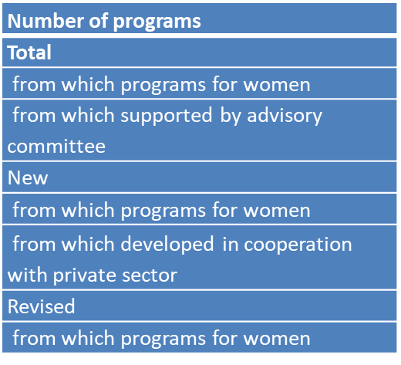 | 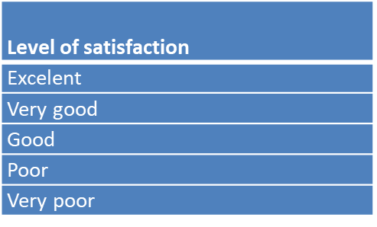

Each KPI is based on a combination of attributes and dimensions (called statistical sentence - query). The ICT system is able to provide a structured table in the form of a predefined excel sheet (Figure 11). For example, when considering to obtain information related to the KPI 14: Graduation from short TVET programs, we find out that three structured tables are required from each provider:
14.a) Provider/Governorate/Gender/Age group/Type of program/Length of program/Count(number)
That means, that each provider will provide table distributed by governorates, within governorates, there will be present combinations of gender and age groups, and these will be further desegregated by type and length of the program. The structure of the requested table will be given, and the provider will fill just the highlighted box with a number of students.
14.b) Provider/Disability/Type of program/Length of program/Count(Number)
14.c) Provider/NAF Status/Gender/Type of program/Length of program/Count
These data can be requested just in one but even more structured table. On the other hand, increasing the structure of a table by one dimension will multiplicities the number of entry points. Therefore, if the combination of several factors is usually not needed, the query will be rather simplified as a separate one.
Figure 11 – Example of the KPI entry form
Provider | NAF Status | Gender | Type of program | Length | Count
VTC | Not registered | Male | Semi-skilled | 60 | 25
VTC | Not registered | Male | Semi-skilled | 100 | 15
VTC | Not registered | Female | Semi-skilled | 60 | 4
VTC | Not registered | Female | Semi-skilled | 100 | 10
VTC | ... | ... | ... | ... | ...

The proposed ICT Tool does not allow to skip any column to ensure full requested reporting, but if there is nobody with some of the attributes (e.g. age group 50+), there will be a possibility by unselecting these fields simplify the reporting structure (number of rows), if necessary. Most of the existing ICT tools at the focal points allows relatively easy transformation of available information to the requested structure.

Timeframe

The implementation of the proposed M&E framework at the TVET Council secretariat has several steps. Initial analysis of the existing system including ICT system was described at October 2018 in Technical report Analysis of the current PMS including M&E and ICT system of E-TVET council. Since October, the new ICT reporting system is under development. After proposing a conceptual framework of new M&E system and its approval from the side of ETVET council, the ICT system can be finalized during January 2019, which should be concluded by short training related to data upload. Until the end of February, the data for 2017 and 2018 should be uploaded to the system by all focal points. This is the precondition to more structured training in analysing the requested data, final adjustments to the system and the sustainability. In the meantime, the update of the 2017 report based on the previous reporting based on the already provided data should be done. The first draft of the 2018 report should be compiled as a result of the data collection through the new system.

Figure 12 – Expected timeline for introducing updated ETVET council M&E system

Recommendations:

Based on the current assessment, the proposed M&E system can be used for the preparation of the following ETVET report 2018. Until now, mainly limited picture about the TVET sector was provided via current (output oriented) monitoring system. Proposed results-based M&E system should be adapted in following months and should provide a comprehensive picture about the sector including relevant analysis resulting in better analysis of sector development and its relation to main strategic goals of TVET sector, including well-aimed policy recommendations. Formal approval of TVET council members to adopt this system is still required.
In the meantime, ETVET sector M&E report for 2017 should be provided by the TVET Council secretariat (January-February). Some assistance can be requested in this respect, but from the side of the project, the focus should be aimed mainly to suggestions for the structure and style of the report (based on previous technical reports and situation analysis). There is no possibility of data updates regarding new KPIs for 2017 report, the new structure related to proposed KPIs monitoring and evaluation will be adapted in the next phase.
In the scope of the proposed M&E system, at least two focal points for each participating institution should be selected and at least one, which is directly responsible for handling internal ICT tool or the data provided. To be able to provide a more comprehensive picture about TVET sector, the data for the past reports could be also added to the system in the structure they have been collected since 2013 to ensure at least basic comparison of system development.
It is also essential, that focal points will upload/update the data in the structure of newly proposed KPIs (at least for years 2018, 2019) until end of February to ensure that the training exercises can be provided properly. The results of proposed training could be used immediately for structuring the TVET sector report 2018.
From the perspective of providers, some issues have been taken according to the requested depth of information. Based on the current assessment, all stakeholders should be able to comply without major obstacles, thus just with minor adjustments with their current ICT system. Moreover, the new ICT tool allows relatively easy upload of the data by pre-defined excel sheet. Only possible obstacle can be observed in those focal points, where suitable IT tool (register) is absent, which could require further attention from the project side.

Annexes
- Annex 1. Structure of indicators and relevant institutions
- Annex 2 Code lists related to KPIs

Annex 1. Structure of indicators and relevant institutions

Indicator | Institution | Statistical Sentence
- Employment | DoS, MoL | Population/Age/Gender/Governorate/Activity/Employment/NACE/ISCO/ISCED/Formality/  Employment/NACE/ISCO/Governorate/COUNT  Employment/NACE/ISCO/ISCED/COUNT  Employment/Gender/Age/Governorate/NACE/COUNT  Employment/Age/Gender/Governorate/ISCED/COUNT
- Unemployment | DoS, MoL | Unemploment/Gender/Age/Governorate/Duration/COUNT
- Formality / Share of informal employment | DoS, MoL | Activity/Governorate/NACE/Formality/COUNT  Employment/Age/ISCED/Formality/COUNT  Employment/Age/ISCO/Formality/COUNT  Employment/Nationality/Formality/COUNT
- Activity / Participation rate | DoS, MoL | Population/Activity/Age/Gender/Education/COUNT
- Foreign workers | MoL | Employment/Nationality/NACE/ISCO/Gender/Governorate/COUNT
- Cooperation with the private sector (training programs) | Providers | Provider/Type of program/Number of programs/COUNT (also the length of progam??)
- Invest in the capacity of teachers/trainers (JD) | Providers | Teachers(Trainers)/Gender/Governorate/Sector of program/COUNT(what count means?)
- Number of accredited programmes | CAQA, AQESHI | Provider/Sector of program/Type of program/Governorate/COUNT  Provider/Sector of program/Number of programs leading to technical and vocational education/COUNT
- Satisfaction of service recipient | Providers, Social Partners (and employers) | Provider/Area of satisfaction (student)/Level of satisfaction/COUNT(SHARE) no meaning(either share or select)  Provider/Area of satisfaction(employer)/Level of satisfaction/COUNT(SHARE)
- Guidance (counselling) service | Providers | Provider/FTE/COUNT (number of counsellors)  Provider/COUNT (number of ETVET students)
- Enrolment in regular TVET programs* | Providers | Provider/Governorate/Gender/Age group/Type of program /COUNT  Disabililty/Type of program/Length of program/Count  آNAF Status/Gender/Type of program/Length of program/Count
- Enrolment in short TVET programs* | Providers | Provider/ Governorate/Gender/Age group/Type of program/Length of program/Disability/COUNT  Disabililty/Type of program/Length of program/Count  NAF Status/Gender/Type of program/Length of program/Count
- Graduation from regular TVET programs* | Providers,  Funding org.  Accreditation authorities | Provider/ Governorate/Gender/Age group/Type of program/Count  Disabililty/Type of program/Length of program/Count  NAF Status/Gender/Type of program/Length of program/Count
- Graduation from short TVET programs* | Providers  Funding org.  Accreditation authorities | Provider/Governorate/Gender/Age group/Type of program/Length of program/Disability/COUNT  Disabililty/Type of program/Length of program/Count  NAF Status/Gender/Type of program/Length of program/Count
- Dropout from regular TVET programs* | Providers | Provider/ Governorate/Gender/Age group/Type of program /COUNT  Disabililty/Type of program/Length of program/Count  NAF Status/Gender/Type of program/Length of program/Count
- Dropout from short TVET programs* | Providers | Provider/ Governorate/Gender/Age group/Type of program/Length of program /COUNT  Disabililty/Type of program/Length of program/Count  NAF Status/Gender/Type of program/Length of program/Count
- Employment rate from ETVET (fund) programms* | Providers | Provider/ Governorate/EMP VET LENGTH/EMPLOYMENT TVET/Type of program/LENTGTH OF PROGRAM/Gender/SECTOR/COUNT(SHARE)  Disabililty/Type of program/Length of program/Count  NAF Status/Gender/Type of program/Length of program/Count
- Public expenditure on TVET | Providers, Funding org. | Provider/TYPE OF FUNDING/Type of program/SUM(JD)  For ETVET Fund  Project Name/Provider/Value (JD)/Gender/Number of actual trainees/Number of Employed
- Private sector contribution (and co-payments) | Providers, Social Partners (and employers) | Based on 18
- Funding from donors | Providers, Funding org. | Based on 18
- Student to teacher ratio | Providers | Provider/Type of program/FTE/COUNT(number of students)  Provider/Type of program/FTE/COUNT(number of teachers)
- Cost per student (by programs…) | Providers, TVET Fund | Provider/Type of program/COUNT(number of students)/COUNT(costs in JD) – based on the definition of Provider

Annex 2 Code lists related to KPIs

Age groups
0-4
5-9
10-14
15-19
20-24
25-29
30-34
35-39
40-44
45-49
50-54
55-59
60-64
65-69
70+

Nationality
Jordanian
Non-Jordanian | From which
 | Egyptian
 | Palestinian
 | Syrian
 | Other

Region / Governorate
Amman | العاصمة
Balqa | البلقاء
Zarqa | الزرقاء
Madaba | مأدبا
Irbid | اربد
Mafraq | المفرق
Jerash | جرش
Ajloun | عجلون
Karak | الكرك
Tafielah | الطفيلة
Ma'an | معان
Aqaba | العقبة

Education / ISCED
Illiterate | أمي
Read&Write | ملم
Elementary | ابتدائي
Preparatory | اعدادي
Basic Education | أساسي
Vocational Apprenticeship | تلمذة مهنية
Secondary | ثانوي
Diploma Intermediate | دبلوم متوسط
Bachelor&Above | بكالوريوس فأعلى

Sector of Economic Activity / NACE
A - Agriculture, forestry and fishing | الزراعة والحراجة وصيد الاسماك
B - Mining and quarrying | التعدين واستغلال المحاجر
C - Manufacturing | الصناعات التحويلية
D - Electricity, gas, steam and air conditioning supply | إمدادات الكهرباء والغاز والبخار وتكييف الهواء
E - Water supply, sewerage, waste management and remediation activities | امدادات المياه والمجاري وإدارة النفايات، ومعالجتها
F - Construction | التشييد
G - Wholesale and retail trade; repair of motor vehicles and motorcycles | تجارة الجملة والتجزئة وإصلاح المركبات ذات المحركات والدراجات النارية
H - Transportation and storage | النقل والتخزين
I - Accommodation and food service activities | أنشطة الاقامة والخدمات الغذائية
J - Information and communication | المعلومات والإتصالات
K - Financial and insurance activities | أنشطة المالية والتأمين
L -Real estate activities | الأنشطة العقارية
M - Professional, scientific and technical activities | الأنشطة المهنية والعلمية والتقنية
N - Administrative and support service activities | أنشطة الخدمة الإدارية والدعم
O - Public administration and defence; compulsory social security | الإدارة العامة والدفاع والضمان الإجتماعي الإجباري
P - Education | التعليم
Q - Human health and social work activities | أنشطة الصحة البشرية والخدمة الإجتماعية
R - Arts, entertainment and recreation | أنشطة الفنون والترويح والترفيه
S - Other service activities | الأنشطة الخدمية الأخرى
T - Activities of households as employers; undifferentiated goods and services-producing activities of households for own use | أنشطة الأسر المعيشية كصاحب عمل، أنشطة الأسر المعيشية لإنتاج سلع وخدمات غير مميزة لإستعمالها الخاص
U - Activities of extraterritorial organisations and bodies | انشطة المنظمات والهيئات الخارجة عن نطاق الولاية الإقليمية

Occupation / ISCO
1 Managers | المشرعون وكبار الموظفين والمديرون
2 Professionals | الإختصاصيون
3 Technicians and associate professionals | الفنيون ومساعدو الإختصاصيين
4 Clerical support workers | الموظفون المكتبيون المساندون
5 Service and sales workers | عاملو البيع والخدمات
6 Skilled agricultural, forestry and fishery workers | العمال المهرة في الزراعة والغابات وصيد الأسماك
7 Craft and related trades workers | الحرفيون والمهن المرتبطة بهم
8 Plant and machine operators, and assemblers | مشغلو المصانع والاّلات وعمال التجميع
9 Elementary occupations | العاملون في المهن الأولية

Formality
Formal
Informal

Employment
Unemployed
Employed | From which
 | Public sector employee
 | Private sector employee
 | Self-employed

Duration of unemployment
< 1 month
1-2
3-5
6-11
12-23
24+

Health disability
Not Disabled
Disabled

NAF status
Registered in NAF
Not registered in NAF

Activity
Active
Non-Active

Providers
Ministry of Education
Vocational Training Corporation
NET
Luminous
UNRWA
Balqa Applied University
Other

Length of program
Hours

Type of program
Semi-skilled
Skilled
Vocational
Technician
Specialist

Number of programs
Total
from which programs for women
from which supported by an advisory committee
New
from which programs for women
from which developed in cooperation with the private sector
Revised
from which programs for women

Teachers / Trainers
Total
from which attend development courses and workshops
from which have 1 month professional secondment during last year
Newly hired Teachers / Trainers
from which with proper experience (education and 2 years industry involvement)

Sector of qualification
Electricity
Electronics
IT
Vehicles and Machines Maintenance
Sales and Service
Hospitality and Tourism
Handcraft Industry
Salts and acid production
Carpentry, upholstery and decoration
Manufacture of detergents
Oil and Petrochemicals
Mining and Metallurgy
Personal services
Construction
AC and Water supplies
Printing and binding
Enviromental Treatment
Textile and leather industries
Food industries
Metal Forming and Maintenance
Public Health and Safety
Management and Financial Sector
Pharmacy
Other

Level of satisfaction
Excelent
Very good
Good
Poor
Very poor

Area of satisfaction / student
Training facilities
Equipment
Study materials
Teachers / Trainers

Area of satisfaction - Employer
Job-related skills
Employability
General skills
Motivation

FTE
Full time
Part-time

ETVET employment
Employment rate after six months
from which
formally employed as an employee
formally self-employed
informally employed
Employment rate after two years
formally employed as employee
formally self-employed
informally employed

Funding
Public
from which ETVET fund
from which General Budget department
Private contributions and co-payments
from which private sector contribution
from which co-payments
Donors
national donors
external donors

EMP TVET LENGTH
after 6 months
after 2 years

