Concept paper & manual

Tools for field testing at the NAF local offices for labour market activation

Activity 1. 4.2 & 1.4.3

by Tibor Bors BORBELY-PECZE, International Senior Non-Key Expert
Amman, April 2019

Abbreviations

ALMM Active Labour Market Measures
EU European Union
MoL Ministry of Labour
NAF National Aid Funds
LMS Labour Market Services
IAP Individualized Action Plan
JSS Jordan Social Security
ILO International Labour Organisation
PES Public Employment Service
NUR National Unified Registry
PIT Personal Income Tax

Table of Content

Abbreviations 2
Rationale 4
Introducing internal protocols and tools 4
Job-readiness interview 8
LMS and ALMM screening interview 9
Individual action plan (IAP) 10
Key features of individual action plans 11
Referral forms to jobs or ALMM&LMS 12
Basic criteria for collecting decent job offers 13
Individual level data request for the testing 13
Annex Flowchart of graduation strategy of the NAF 15

Rationale

The National Aid Fund (NAF) of Jordan was nominated to support the activation process of active age social beneficiaries of the country. The original mission statement of the NAF was clearly extended with this duty. Labour market activation and empowerment requests the development and utilizations of professional protocols and tools are associated with Public Employment Services (PES) according the global and European standards. In Jordan the responsibilities of an EU/ILO-style PES has been shared between different institutions, mainly the MoL Employment Directorate and the NAF. A Memorandum of understanding was signed between these two agencies of the government.
The memorandum of understanding (MoU) between the NAF and the Ministry of Labour (MoL) will be soon amended but so far the NAF needs to be empowered for the implementation of its extended mission statement.
Under the Skills for Employment and Social Inclusion Programme (SEISP), Component No. 4. three local offices of the NAF as well as the MoL Employment Directorate were closely mapped, namely Zarqa, Irbid and East-Amman. In February 2019 a 2-day training was delivered about the utilization of labour market information provision (LMI) and active labour market policy measures (ALMM), including vocational and technical training (TVET).
As a next step based on the LMI & ALMM training Workbook three localized LMI & ALMM Catalogues were prepared for the three selected locations. The current paper describes the utilization protocol of these catalogues alongside the newly drafted tools for labour market empowerment of the NAF clients.
This paper deals with the following internal tools and protocols of the NAF;
- job-readiness first interview with active age clients
- LMS and ALMM readiness interview
- segmentation chart and mechanism
- basis selection criteria for job-offers (before a vacancy note can be take)
- referral form
- individual action/activation plan (IAP)
- individual level data request for the tools testing

Introducing internal protocols and tools

The first important step is to make clear distinction between the NAF active age beneficiary are ready to take jobs or LMI & ALMM and between those are not. Obviously the NAF is responsible for a huge number of vulnerable active age citizens but labour market readiness and economic inactivity are not the same. Sometimes the circumstances or the skills for the active age citizens do not provide them opportunities to enter the labour market sometimes the market is not capable to create decent jobs. The balance between the two, personal circumstances and capacities to work and decent work opportunities in the labour market creates the operational area of the Public Employment Services, in our case the role of the NAF in Jordan.
For this purpose an individual job-related interview need to be organized. This interview focuses on the needs and opportunities of the individuals not the households. The primary tool for labour market activation is the in-depth interview with the client. This interview is also important to make distinction between job-ready clients and other type of social beneficiaries. All administration tries to build customer segmentation around this issue as most of the administration has job-ready and also hard-to-place beneficiaries. One of the leading examples is the Australian model (Department for Employment and Workplace Relations, 2002) Profiling the job-seekers and social beneficiaries towards the labour market is also the key business of the European Public Employment Services (PES, 2011) Different countries and agencies have been using and adopting different profiling models (PES, 2011). These models are not static, and have been changing time to time. It means that the NAF profiling model need to be developed based on the local and temporary needs but later on can be further adjusted and developed. Currently there is no statistical profiling in the country; neither the NAF nor the MoL has an adequate database for it. Development of a statistical profiling has two pre-conditionality; i) the development of the unified database, National Unified Database (NUR) and ii) a clear description of the active age jobs-seekers customers’ journey within the NAF and at the cross-institutional level, including MoL, NGOs and training providers. Also the clear outcomes need to agree for each customers segment.
Therefore for the testing of the segmentation we suggest a basic case worker made evaluation as a start. In this paper we introduce a flowchart for the NAF customers’ selection mechanism as well as the necessary tools for the selection and graduation pathways.
For effective and sustainable graduation strategies a well-established customers’ journey and the development of certain professional protocols such as a screening interviews is a must. This flowchart is in the annex of the paper.

Flowchart No. 1.
Active age beneficiaries of the NAF – labour market activation, the customer’s new journey
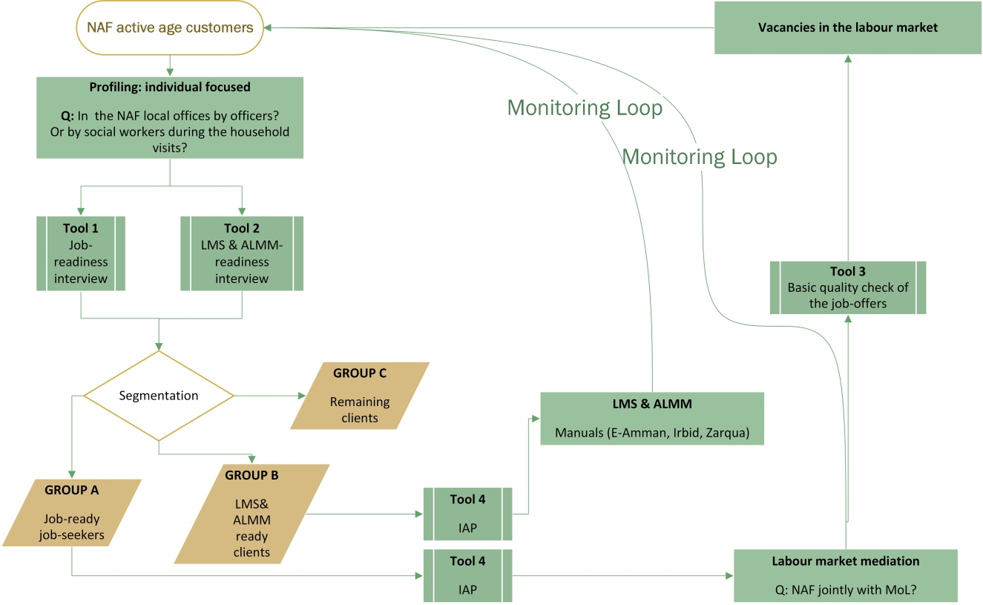

Chart No. 2.
Good cases studies for jobseekers’ profiling and segmentation

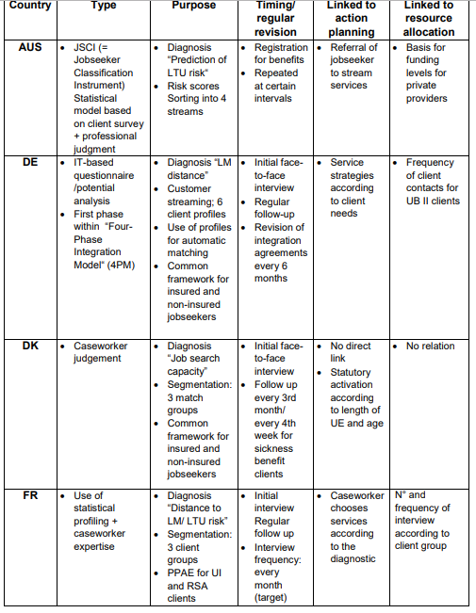

Job-readiness interview

During these more in-depth interviews, normally lasting 30 to 45 minutes, the employment officer will assist the jobseeker in identifying potential barriers to finding employment, discuss steps that can be taken to overcome these barriers, and assist them in developing a transition-to-work action plan (ILO, 2016).
Based on the key findings under activity 1.4.1. (see previous reports in the archive of the SEISP) the following interview structure is suggested for the NAF. In the daily reality of the NAF local offices have no 30 minutes for an interview therefore this interview was shortened and modified for the local needs.
Job-readiness interview Version 0.1 for NAF
Instruction: To be discussed with the individuals only not the heads of the households
requested time: 10 minutes
Access to the labour market
- Would you be able to accept a job and show up at the workplace within 1 week? Y / N
- Are you able to commute to and back to a workplace daily without the support of the government? Y / N
- Are you willing to work for the minimal wage? Y / N
- if no what is the minimum wage (monthly gross) you are expecting, please specify in JOD …………
- How would you describe your health statues? Good (able to work) / poor (not able to work)
Skills
- Do you have any occupation/ profession (trained or work experience)? Y / N
- if yes, please describe: ………………………………………
- How experienced are you in working field? Number of years: ……………………..
Care activities within the household
- Are you responsible for the daily care of kids/ elderly in the household? Y / N
- Are you able to be away from your household 10 hours per a day (including commuting time) Y / N
Notes for the case managers of NAF:
The aim of the job-readiness interview to make distinction between registered active age NAF clients are just ready to accept job-offers with realistic conditions and between those are not. For each questions a few additional comments are listed below;
Q1. NAF officer transfer client to the MoL or other private recruitment agency if the answer is yes without hesitation.
Q.2. First we are looking for own transportation of the client such as own car or public bus. Only take the client if the employers offer a daily transportation for free or the MoL/NAF could guarantee/ subsidize the transportation between the workplace and the home.
Q.3. The minimal wage is 220 JOD monthly before taxation. Just a reminder personal income tax (PIT) rate is 5% up to 5000 JOD yearly, additional 5% after every 5000 JOD up to 20.000 Jordan Social Security (JSS) on the individual’s side is 7,5% from the gross salary based on the Law. No. 1. 2014.
Q.4. Please ask for a monthly gross salary
Q.5. We are not looking for detailed medical records here only yes or no answers.
Q.6. Yes if somebody has a professional/ vocational or higher education training.
Q.7. Try to record the name of the profession/ occupation
Q.8. number of years of experience in the recorded occupation under question No. 7.
Q.9. If yes, please ask the number of people are and the responsibility of the client and the age of them
Q.10. even if answer was yes for Q.9. if Q.10 is yes the client can be taken as a job-seekers as somebody can handle his/her care responsibilities

LMS and ALMM screening interview

Labour market services and active labour market measures are important and powerful tools for labour market activation. These need to be used only with vulnerable groups. In a practical way if a NAF client fits to Group A as an outcome of the first screening interview most probably there is no need for LMS and ALMM. This second interview is designed for LMS and ALMM needs analysis.
Labour Market Services according the EUROSTAT are;
all services and activities undertaken by the Public Employment Service (PES) together with services provided by other public agencies or any other bodies contracted under public finance, which facilitate the integration of unemployed and other jobseekers in the labour market or which assist employers in recruiting and selecting staff (EUROSTAT, 2018).
Active Labour Market Measures provide labour market integration measures to those looking for jobs, usually the unemployed, but also the underemployed and even the employed that are looking for better jobs. ALMPs typically include labour market training, job creation in the form of public and community work programmes, programmes to promote enterprise creation, and hiring subsidies. ALMPs are usually targeted at specific groups facing particular labour market integration difficulties: younger and older people, women and those particularly hard to place such as the disabled (ILO).
version 0.1
Screening interview for LMS and ALMM need analysis of the NAF active age clients
Labour market information
- I know my occupational opportunities in the labour market. (e.g. job offers, wage offers, etc.) Y / N
IF the answer is no you may offer career information service for the client
- I cannot describe my career goals Y / N
IF the answer is yes please offer career guidance for the client.
Professional skills
- I need to gain work experience / sheltered work experience before I am able to find a vacancy in the open market. Y / N
IF the answer is yes you may offer apprenticeship for youth, sheltered work for adults or wage-subsidies.
- I have a profession. Y / N
IF the answer is no, please discuss training opportunities.
- I could run my own business for living. Y / N
IF yes please proceed for self-employment opportunities.
Commuting for jobs
- I would need financial support to commute for work. I / N
IF yes subsidy for work-commuting may be an option.
Once the clients were assessed (pre-profiled) and segmented against the labour market the next step is to discuss an individual action plan (IAP) and to issue a referral for labour market mediation or for labour market service, active measure. This cannot be done in groups as each individual requests a different approach and action. The current business process of the NAF is needed to be adjusted. After the NAF case worker did the screening interviews and made a decision of the customer segment of the client (A, B or C) he /she needs to discuss the next action steps with the client. For this purpose PES have been using the so-called individual action plan (IAP). The development of the IAP comes first, before any referral can be issued. The content of the IAP needs to be clearly discussed and co-developed with the client.

Individual action plan (IAP)

IAP is a tool for individual level activation and mobilization of the client towards the labour market. The key elements of an IAP are the followings;
Key elements of the action planning process are critical reflection, learning and holistic assessment A success factor in being able to empower job seekers is the application of a method of critical reflection and learning. "PES IAP context, the concept of experiential learning illustrates the learning processes of:
- Problem identification (that is, what is the main barrier to progression?);
- Making sense of the problem (that is, what did I do wrong?);
- Deciding what needs to be done to solve the problem (that is, what needs to be different?); and
- Moving to action ([that is], what do I need to do?" (EU PES, 2012)

The 4-phase IAP development (Ireland, 2012) (source: EU PES Network)

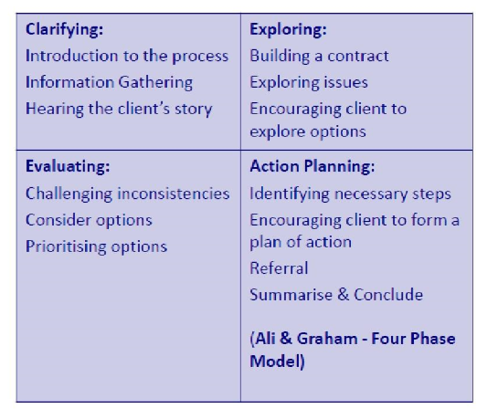

Key features of individual action plans
High quality IAPs should be individualised as far as possible, whilst maintaining a number of essential components The most important components of an IAP are as follows.
- Summary of the individual assessment, including relevant profiling results;
- Goals (or objectives);
- Steps towards the goals; ALMPs and other measures available to the jobseeker;
- Duties and commitments of both parties, the employment counsellor (and PES) and the jobseeker; Rights of the jobseeker;
- Rules and procedures concerning the application of sanctions; Information on the complaints and appeals procedure; and
- The individual action plan – all agreed steps at a glance.
Based on the European best practices and the current circumstances within the NAF we are suggesting the following IAP for NAF as a basic model.
version 0.1
IAP NAF
ID Number
customer segment A / B (no IAP is needed for Segment C)
goal: employment / LMS & ALMM
destination (where the client was sent by the caseworker based on the LMS & ALMM Catalogue)
deadline for the feedback (when the client needs to inform the caseworker about the results)
next appointment (if needed)

Referral forms to jobs or ALMM&LMS

Once the caseworkers are sending their clients for a service provider the bases for this contact is the IAP and the establishment of the contact is go thought the NAF caseworker first. Each referral must be individualized towards the service providers and no group selection is necessary or useful.
version 0.1
NAF referral form to labour market mediation (segment A) or LMS & ALMM (segment B)
ID Number (One referral per a person please!)
issue date
destination (name of the institution and address where the client was sent)
type of intervention request:
- labour market mediation after detailed profiling
- career information provision / career guidance
- apprenticeship
- pubic work
- training
- micro-financing
- etc.
deadline of the provider to send feedback to the NAF local officer

Basic criteria for collecting decent job offers

Decent work opportunities are essential in every labour market. The Jordanian labour market is highly segmented and often poor quality vacancies are reported to MoL and NAF. These institutions are also responsible for the quality of the vacancies and they have a role to play to save the jobseekers, customers from harmful placement. Therefore here we are suggesting a few basic criteria for vacancies.
- The employer is registered under the Social Security Corporation
- The work environment is not harmful for the health of the job-seekers
- The employer has a plan to support work related commuting
- New employees are registered under the labour code
- Based on the information of the local NAF/ MoL offices the employer is not abusing the workers. e.g. recruiting new people for the same job post ever 1-3 months.

Individual level data request for the testing

For testing the new workflow of the NAF as well as the new tools and protocols an individual level data collection would be necessary at the three locations (East-Amman, Zarqa and Irbid). The precise collection of data is important in order to monitor and evaluate the outcomes and it would provide opportunity for the NAF management to adjust the process later on. This is highly relevant even beyond the scope of the SESIP as the current World Bank project plan goes until 2021. For these reasons we are suggesting the following data by each individual to be collected;

National ID
Bibliographical data
age
gender
location (residence)
level of education
Labour market history
work experience, number of year
profession(s)
location of job-seeking (if different from the living place)
ever changed profession
Resources
has his/her own car or able to commute to work
Follow-up
grouped in Group A / B / C
When was the grouping made?
Where was he/she transferred? /When was the referral issued
Where was transferred? Name of the agency, such as MoL local office/ NGOs/donor, etc.
Outcomes (3 types)
- placed (wage level, name of the job post, name of the employer)
- or in LMS or ALMM (type of the LMS & ALMM, duration, expected outcome)
- standing

Annex Flowchart of graduation strategy of the NAF
labour market mediation
Q: NAF jointly with MoL?
LMS & ALMM : Manuals (E-Amman, Irbid, Zarqua)
transferring Group A & B to providers with IAP

feedback & follow up
Tool 4:
IAP
Tool 3:
basic quality check of the job-offers
Vacancies in the labour market
Remaining clients
GROUP C
Outcome 2:
LMS& ALMM ready clients
GROUP B
Tool 2
LMS & ALMM-readiness interview
Segmentation
Tool 1:
job-readiness interview
Outcome 1:
job-ready job-seekers
GROUP A
profiling: (individual focused)
Q: In the NAF local offices by officers? or by social workers during the household visits?
NAF active age customers

http://pandora.nla.gov.au/pan/33104/20030305-0000/www.workplace.gov.au/WP/CDA/Files/WP/att_segments.pdf
http://wapes.org/en/system/files/disc_pap_use_of_profiling_for_resource_allocation_action_planning_and_matching_re-format_jan_2013_0.pdf
https://www.ilo.org/wcmsp5/groups/public/---asia/---ro-bangkok/documents/publication/wcms_549678.pdf
http://taxsummaries.pwc.com/ID/Jordan-Individual-Taxes-on-personal-income
https://www.ssc.gov.jo/English/ElectronicLibrary/Pages/Releases.aspx?DocumentlibraryID=4a40b344-f169-4fca-8a05-2f2877c2dac6&DocumentID=da860519-c3c0-4ddc-8d1f-e0ceb5bdc12f
https://ec.europa.eu/social/BlobServlet?docId=14081&langId=en

