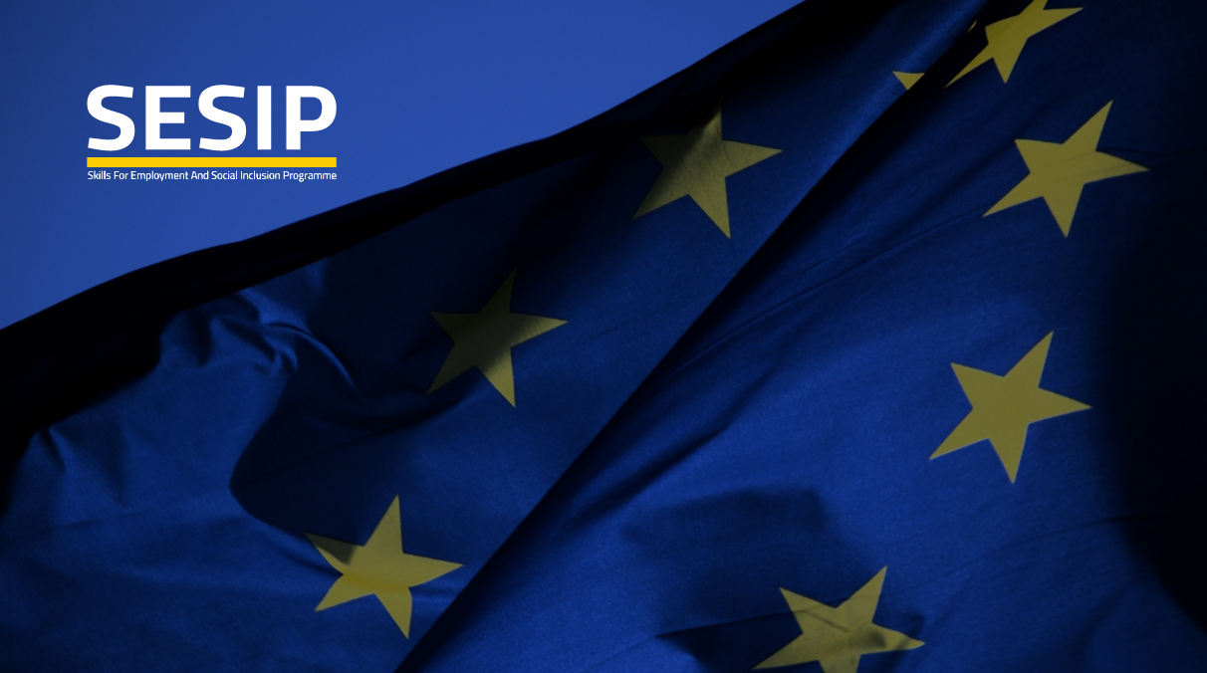
TECHNICAL ASSISTANCE PROJECT

“Skills for Employment and Social Inclusion Programme”

Working Groups Annual Meeting - Review Workshop
Amman, Geneva Hotel 19.02.2019

Background and methodology

- Introduction

SESIP as strategic project supporting the implementation of the sector strategies and national policies, under the Complementary Support component of the Financing Agreement between the Government of Jordan and the European Union, provides capacity building, support and technical assistance for ETVET line Ministries and their related institutions, CSOs and Social partners.

It focuses on actions referenced in the Financing Agreement between the Government of Jordan and the European Union, to implement the programme entitled Skills for Employment and Social Inclusion and keeping the indicators of support payments in the Agreement in force.

The TA SESIP serves 3 purposes:

- Provide advisory and technical assistance in the areas of Governance, Capacity building, Quality Assurance, Employability and Labour Market management, Intermediation and Information Systems, Social Inclusion for disadvantaged groups, Monitoring and Evaluation of the E-TVET strategy and sector action plans for the ETVET stakeholders in Jordan.

- Provide technical assistance, advisory and trainings for strengthening Social Dialogue, and partnership in the ETVET Sector.

- Provide support to the national ETVET authority to design and implement of communication and visibility actions related to the ETVET reform and the to achievements realised through the EU budget support and TA.

SESIP is expected to reach 26 results through 6 components.
The direct project beneficiaries are all represented in the Working groups.

- Implementation Approach

SESIP technical assistance mainly utilise Capacity building (CB) as “the ability of people, institutions and societies to perform functions, solve problems, and set and achieve objectives” (UNDP 2002).

Capacity Building’s dimensions comprise (i) human resources skills development; (ii) changes in organisations and networks; and (iii) changes in governance/institutional context. It is a process whereby individuals, groups, and organisations enhance their abilities to mobilize and use resources to achieve their objectives on a sustainable basis.

To optimise the effectiveness of capacity building, TA SESIP has opted for the Working Group approach as key to:

- allow all the ETVET key stakeholders receiving technical assistance and capacity building,
- validate the outputs of the TA to the Budget Support,
- directly participate to the implementation of the ETVET reform pillars as laid down in the sector National Strategies
- report on the results to their senior management and disseminate them within own institutions.

- The shape of the second Working Groups annual meeting

The second TA SESIP Working Groups annual meeting takes the shape of a review workshop. Working Groups have been used in development cooperation as a capacity building strategy. Working in small groups or collaborative working, as it is often referred, is basically a group formed to discuss a particular issue or perform a particular task.

Collective, collaborative, peer, reciprocal, or team learning, refer to learning that involves group members in working with others and learning together on a foundation of member-member interaction together with the concept of learning from each other and learning from sources of knowledge external to the group.

In the case of the EU TA SESIP, Formal groups are established to complete specific tasks in several sessions over many months, (e.g., activities under the 4 Components).

TA SESIP is well aware that the dynamics of the 4 Working Groups, though formed by professional with different degree of seniority and responsibility in the respective institutions, do not differ by those of every group formed to better achieve complex tasks.

The Working groups needed time and support to form’ or come together going through group stages that literature has denominated as:

- Forming – The group comes together and gets to initially know one another and form as a group.
- Storming – A potentially difficult period when roles are developed, leadership is contested and there is a trialling of group processes.
- Norming - A consensus is reached on how the group operates.
- Performing - The group become effective and almost self-managing and works to meet its shared objectives.

Then, as the WGs action progresses, the TA will continue to assists in:
- reviewing how they perceive that the group is functioning and redefining group objectives and task criteria if necessary,
- monitoring on a systematic and regular basis to sensure that the WG remains “on track” and each WG is aware that has isolated from the work of the other WGs.

- The Working Group Option

TA SESIP supported the establishment of 4 Work Groups with participants from the line ministries and related institutions, social partners (employers’ and workers organisations) and Civil Society Organisations (CSO) involved in the E-TVET reform in Jordan. They are:

- WG1 E-TVET Governance reform and Performance Management.
- WG2: Curricula Development and Training of Trainers/Teachers (ToT).
- WG3: Quality Assurance, Accreditation and Relevance.
- WG4: Inclusive access to E-TVET and Labour Market Information System (LMIS).

4.1 The Members of the WGs and their role

- The four (4) Working Groups, established in July 2018, involve more than 80 members who are staff of the Institutions members of the ETVET Council. Upon request of the ETVET Secretariat, they have been formally designated by the respective institutions on the basis of their competence and functions.
- Each WG member is accountable to, and will inform and report to own senior management
- The WG members provide their contribution to achieve the agreed objectives in line with their area/s of expertise.
- The WG members disseminate the outputs in their organisations and promote awareness of the issues tackled by the WG to wider target audience
- The WG members collect feedback from own organisations on WG outcomes implementation
- The WG members are committed to the tasks agreed within the WG

4.2 The role of TAT and ETVET Secretariat

The SESIP Technical Assistance Team, together with the ETVET Secretariat, facilitates and steers the process through which technical contents relevant to the thematic areas of the reform are produced and disseminated. In particular:
- TAT is a member of the WG and share the workload with the other members.
- it supports the WG to set the action plan (AP), clarify the objectives, set
- the deliverables to be achieved, indicate the milestones for monitoring progresses, and allocate responsibilities among the WG members.
- TAT and the ETVET Secretariat monitor the AP implementation and when necessary, its amendments.
- TAT and the ETVET Sec help the WG identify if the processes and results can become sustainable beyond SESIP life span.
- The ETVET Secretariat submits the outputs of the WGs to the validation of the ETVET Council and pursues the adoption by the institutions that are members of the ETVET Council

4.3 Working Groups implementation process

The WGs are involved in the planning, implementation and assessment of the activities under the project component for which the WG is established. In particular,

- Each Working Group implements a plan of action under the coordination of the Secretariat of the ETVET Council and with the support of the Key experts and short-term experts.
- TAT submits a technical documentation and alternative options for discussion.
- The WG as whole or Sub-working groups, if formed, analyse, study and make proposal for specific points of the item under examination.
- The WGs produce recommendations for adoption and will formally submit them to own institutions for revision and approval.
- The ETVET Secretariat, with the support of the TAT, is responsible for the preparation and circulation of the reports of activities undertaken under each component.

- Objectives of the Working Groups Annual Meeting-Review Workshop

The overall purpose of the second annual meeting organized by the ETVET Council Secretariat and the EU TA SESIP is to review if the adopted participatory approach by which all members of the ETVET Council formally appointed their staff to be part of four Working Groups mirroring the thematic areas of the ETVET reform, is effective and can be further improved.

The specific objectives of the meeting-Review Workshop are to:
- review the results achieved in the period July-November 2018,
- present the expected results of the activities to be implemented in the planning period December 2018-May 2019,
- assess the effectiveness of the Working Group approach and identify ways to improve the process
- share information among the 4 WGs and learning from each other.

- The Methodology of the Working Groups Annual Meeting-Review Workshop

Each Woking Groups engages in a group work discussion for a1:30 hour duration, on the following 3 topics:
- the results achieved in the last six months of implementation;
- the activities and results expected in the coming six-month period.
- what can be improved in the Working Group process and products.

To facilitate the discussion KEs will make reference to the following:

- With regard to topic 1, results achieved in the six months of implementation June-November 2018, main source is the draft Second Progress Report that KEs have contributed to for the Component under their responsibility. KEs have reviewed and already discussed the implementation of the 6 monthly workplan, the deviations and changes, the activities undertaken and results achieved within the respective WG.
- Topic 2, activities and results expected in the coming six-month period, December 2018-May 2019, are captured in the planning timetable by component that the KEs have prepared for the draft Second Progress Report and that have been presented and discussed within each Working Group.

- Topic 3 concerns what can be improved in the Working Group process and products. The modality of the discussion within the 4 groups to find a balance between process and products is left to the discretion of the KEs. Nevertheless, the following simple tools may be utilised if deemed useful:

- Proposed indicators of effective management of Working Groups:

- KEs and WG Leader provides clear objectives
- KEs and NKEs prepare well
- KEs and WG Leader are not over-controlling
- KEs and WG Leader promotes equal contributions
- KEs and WG Leader attends to non-participants and promotes engagement
- WG sessions allow adequate time for group discussion
- KEs and NKEs demonstrate cultural sensitivity and inclusive exchanging.
- Group members are prompt and attend well
- Groups or group members prepare well
- Group members implement the agreed tasks of

- The WG members self-assessment

Rating |  | Comments, Examples, Explanations, etc.
Group Participation
Attends meetings regularly and on time.
Time Management & Responsibility
Accepts fair share of work and reliably completes it by the required time.

Adaptability
Displays or tries to develop a wide range of skills in service of the project, readily accepts changed approach or constructive criticism.
Creativity/Originality
Problem-solves when faced with impasses or challenges, originates new ideas, initiates team decisions.
Communication Skills
Effective in discussions, good listener, capable presenter, proficient at representing and documenting work.
General Team Skills
Positive attitude, encourages and motivates group, supports group decisions, helps team reach consensus, helps resolve conflicts in the group.

Technical Skills
Ability to create and develop materials on own initiative, provides technical solutions to problems.

Scoring  For each category, award yourself and each member of your team a score using this scale. | 3 – Better than most of the group in this respect  2 – About average for the group in this respect  1 – Not as good as most of the group in this respect  0 – No help at all to the group in this respect

The presentation of results and recommendations for WG future work

The Leader of each WG Each WG presents in plenary the results of the group work discussion on the 3 topics. for a maximum of 15’.

The KEs in charge of the WG/Component draw a conclusion and recommendations.

Q&A by other working Groups members,

Luca Azzoni
Amman 19.02 2019

